UBM-DB Ubuntu 12.04 Installation

12-24-2013

Create VM on ProxMox Node 2

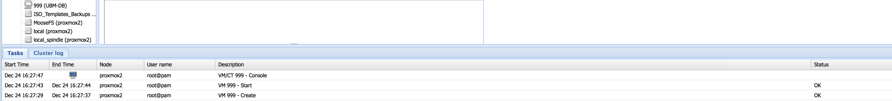

Click Start to Start vm

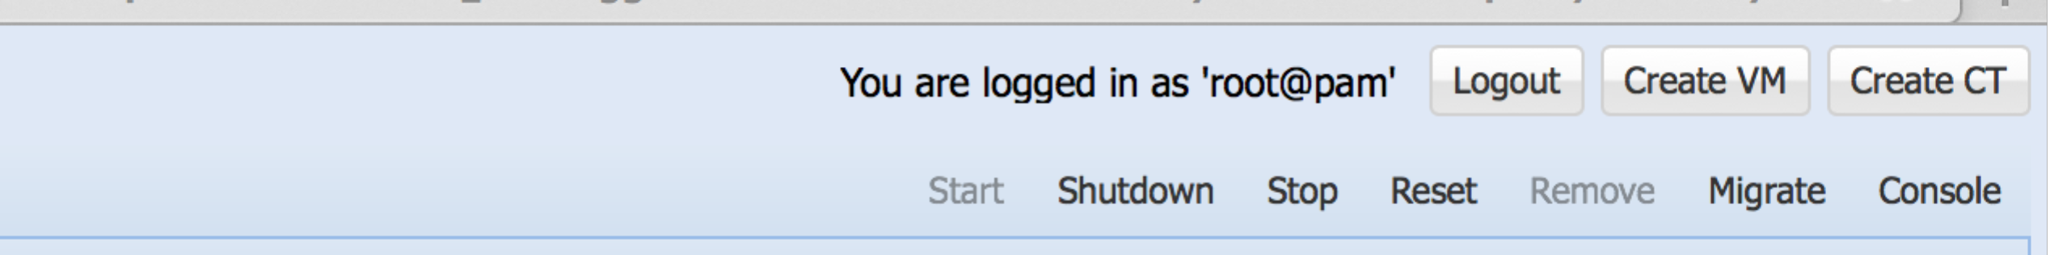

Click Console

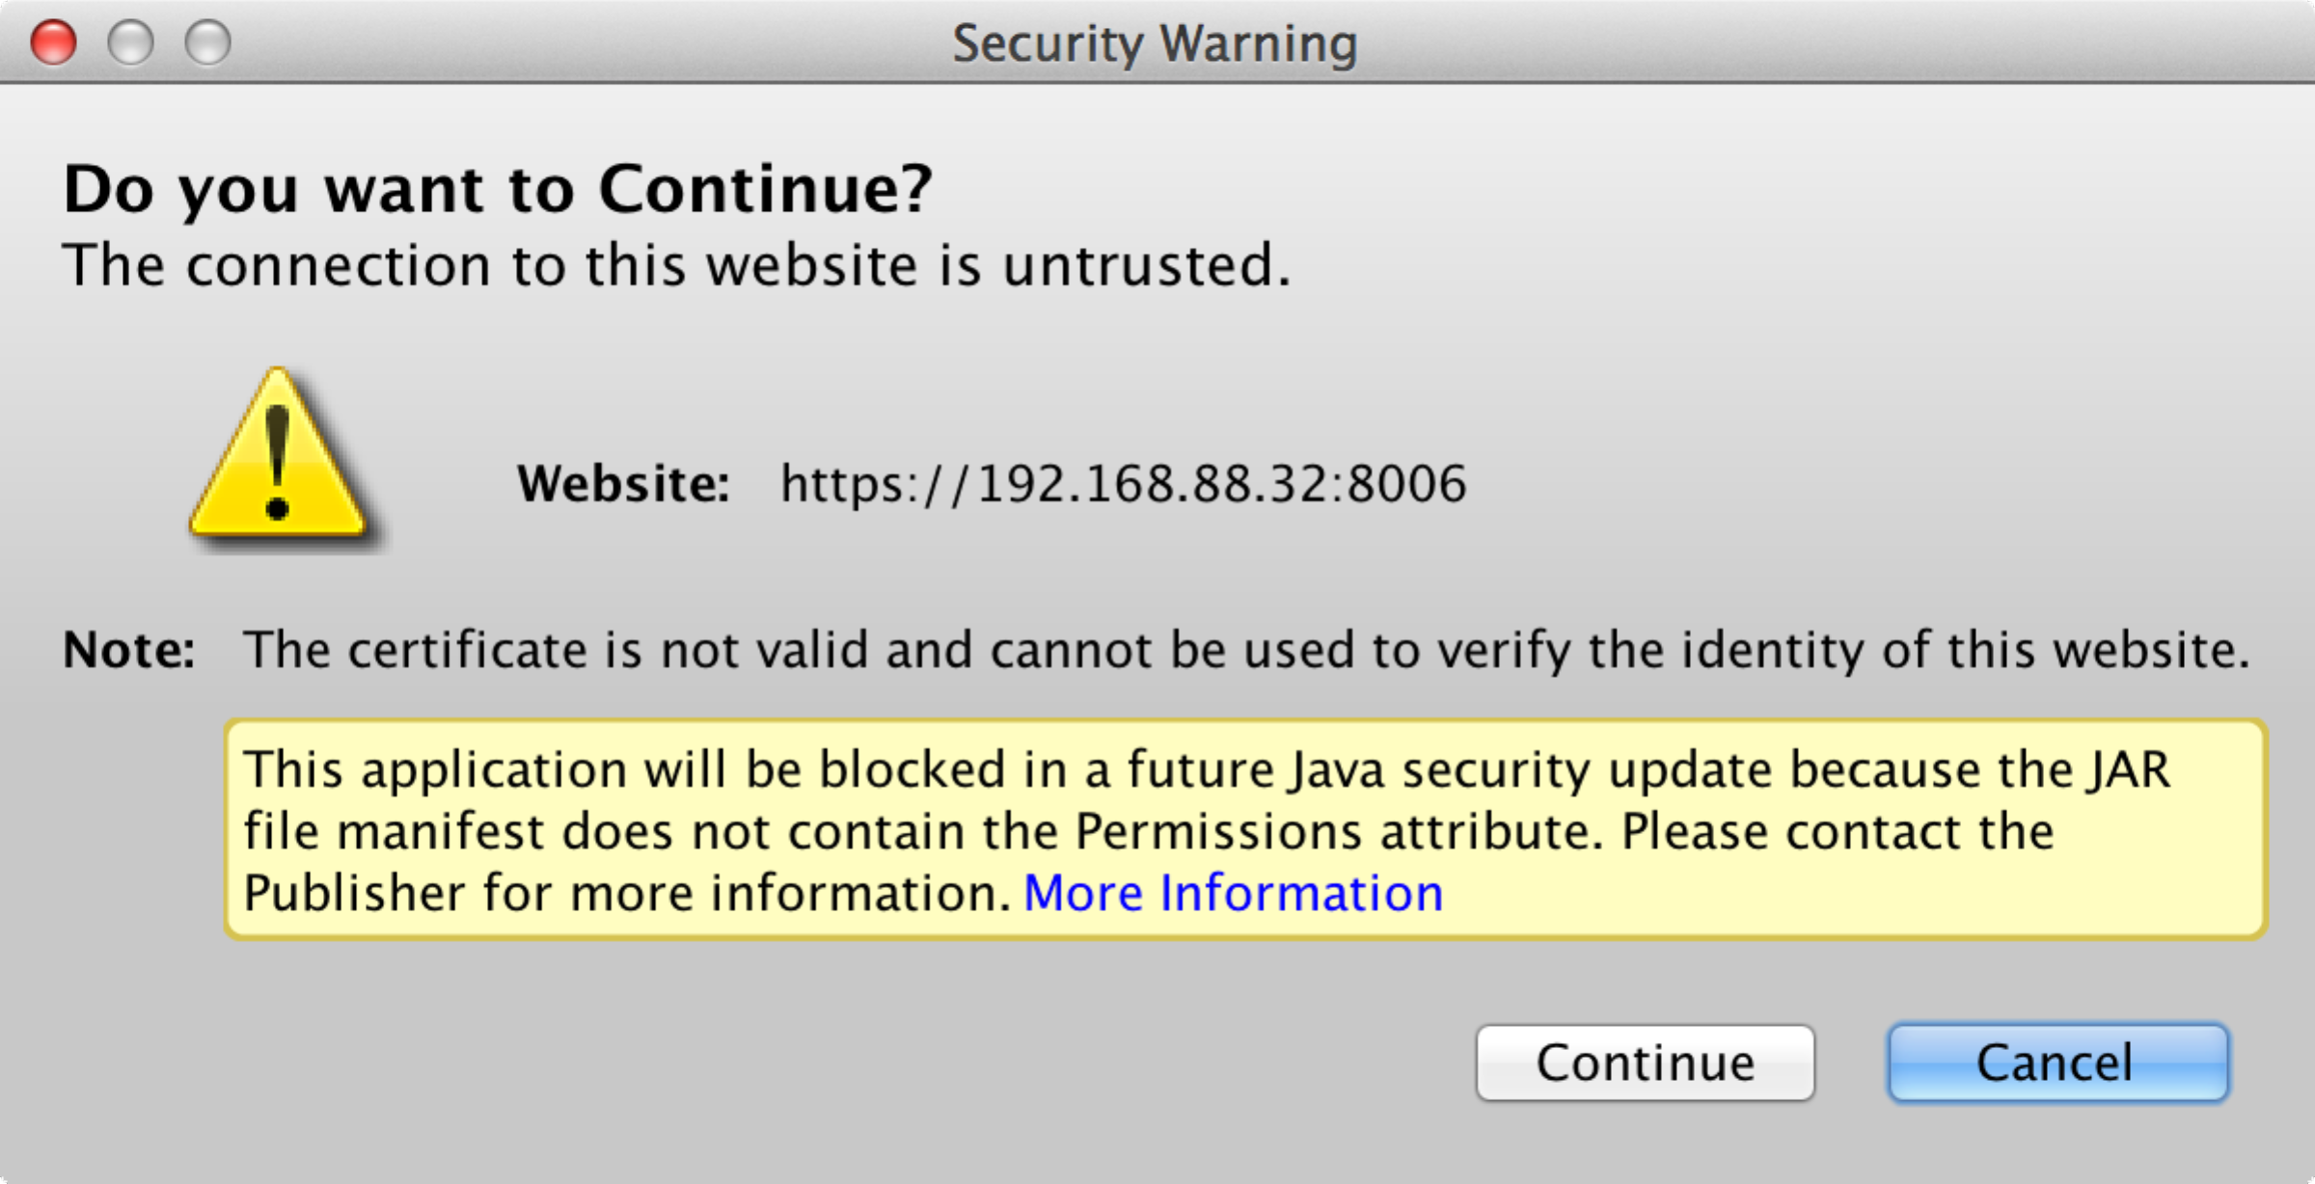

Click Continue

Now Click I accept… Then Run

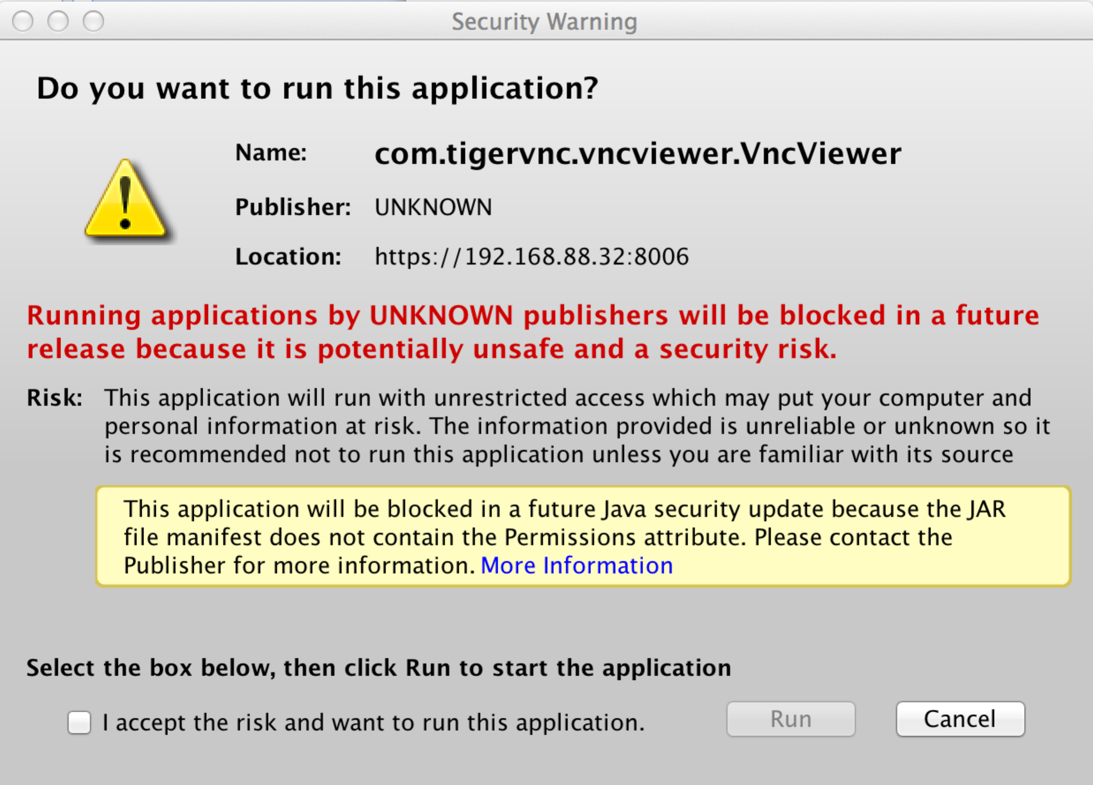

Now Click Allow

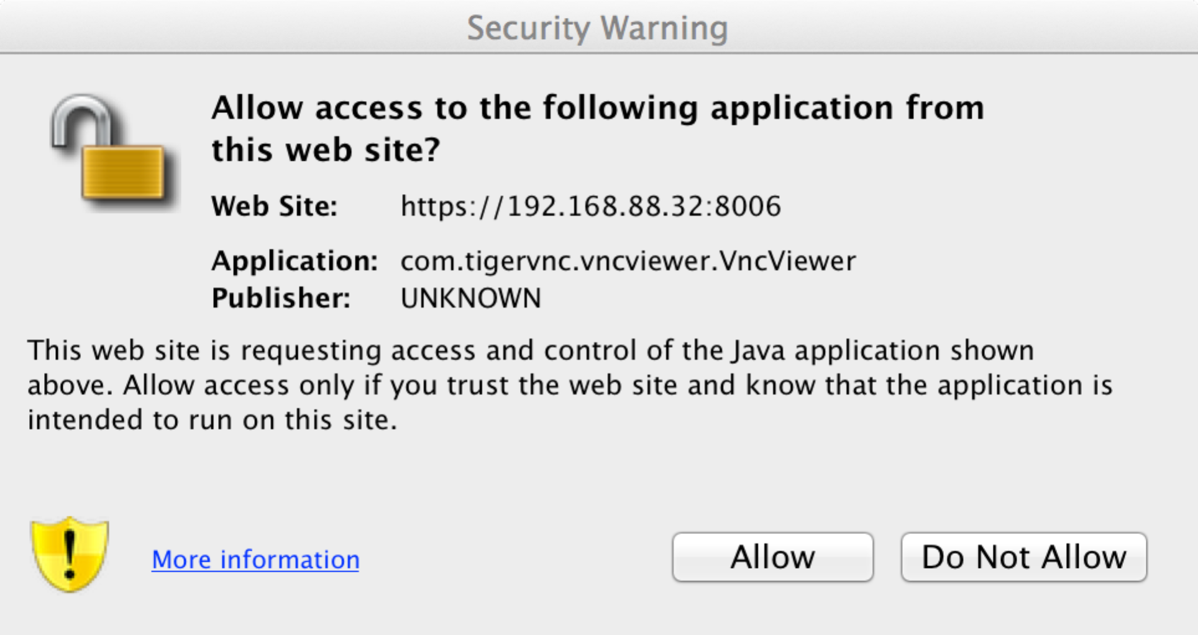

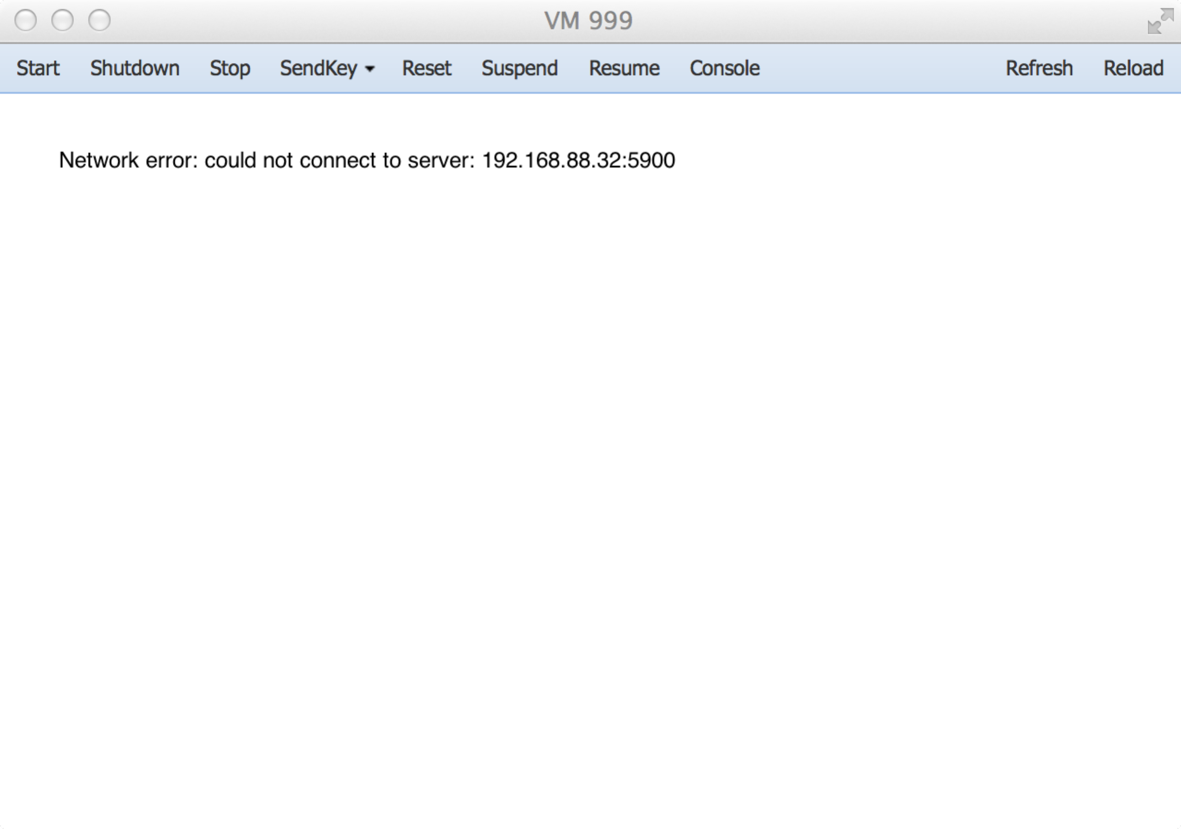

If you get this network error screen, click reload.

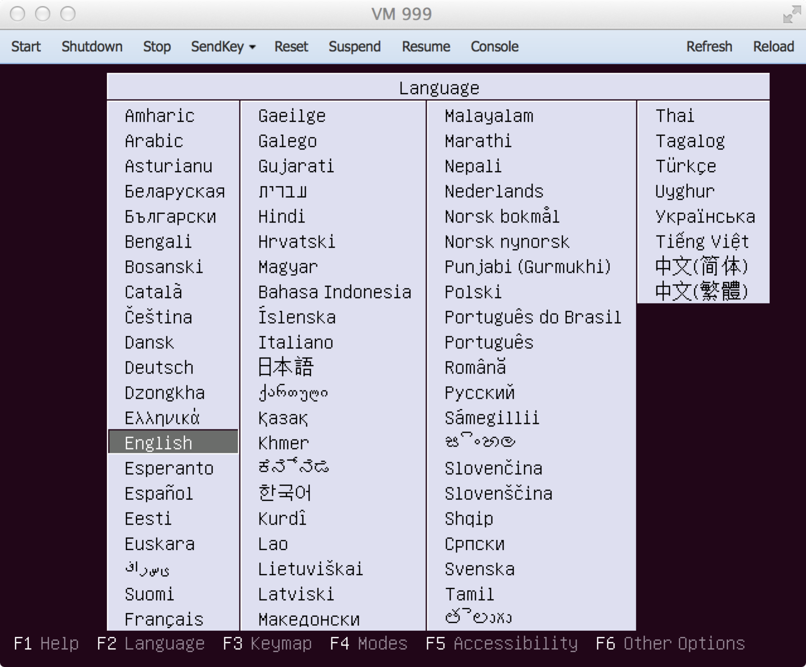

Select English, then press the <return> key

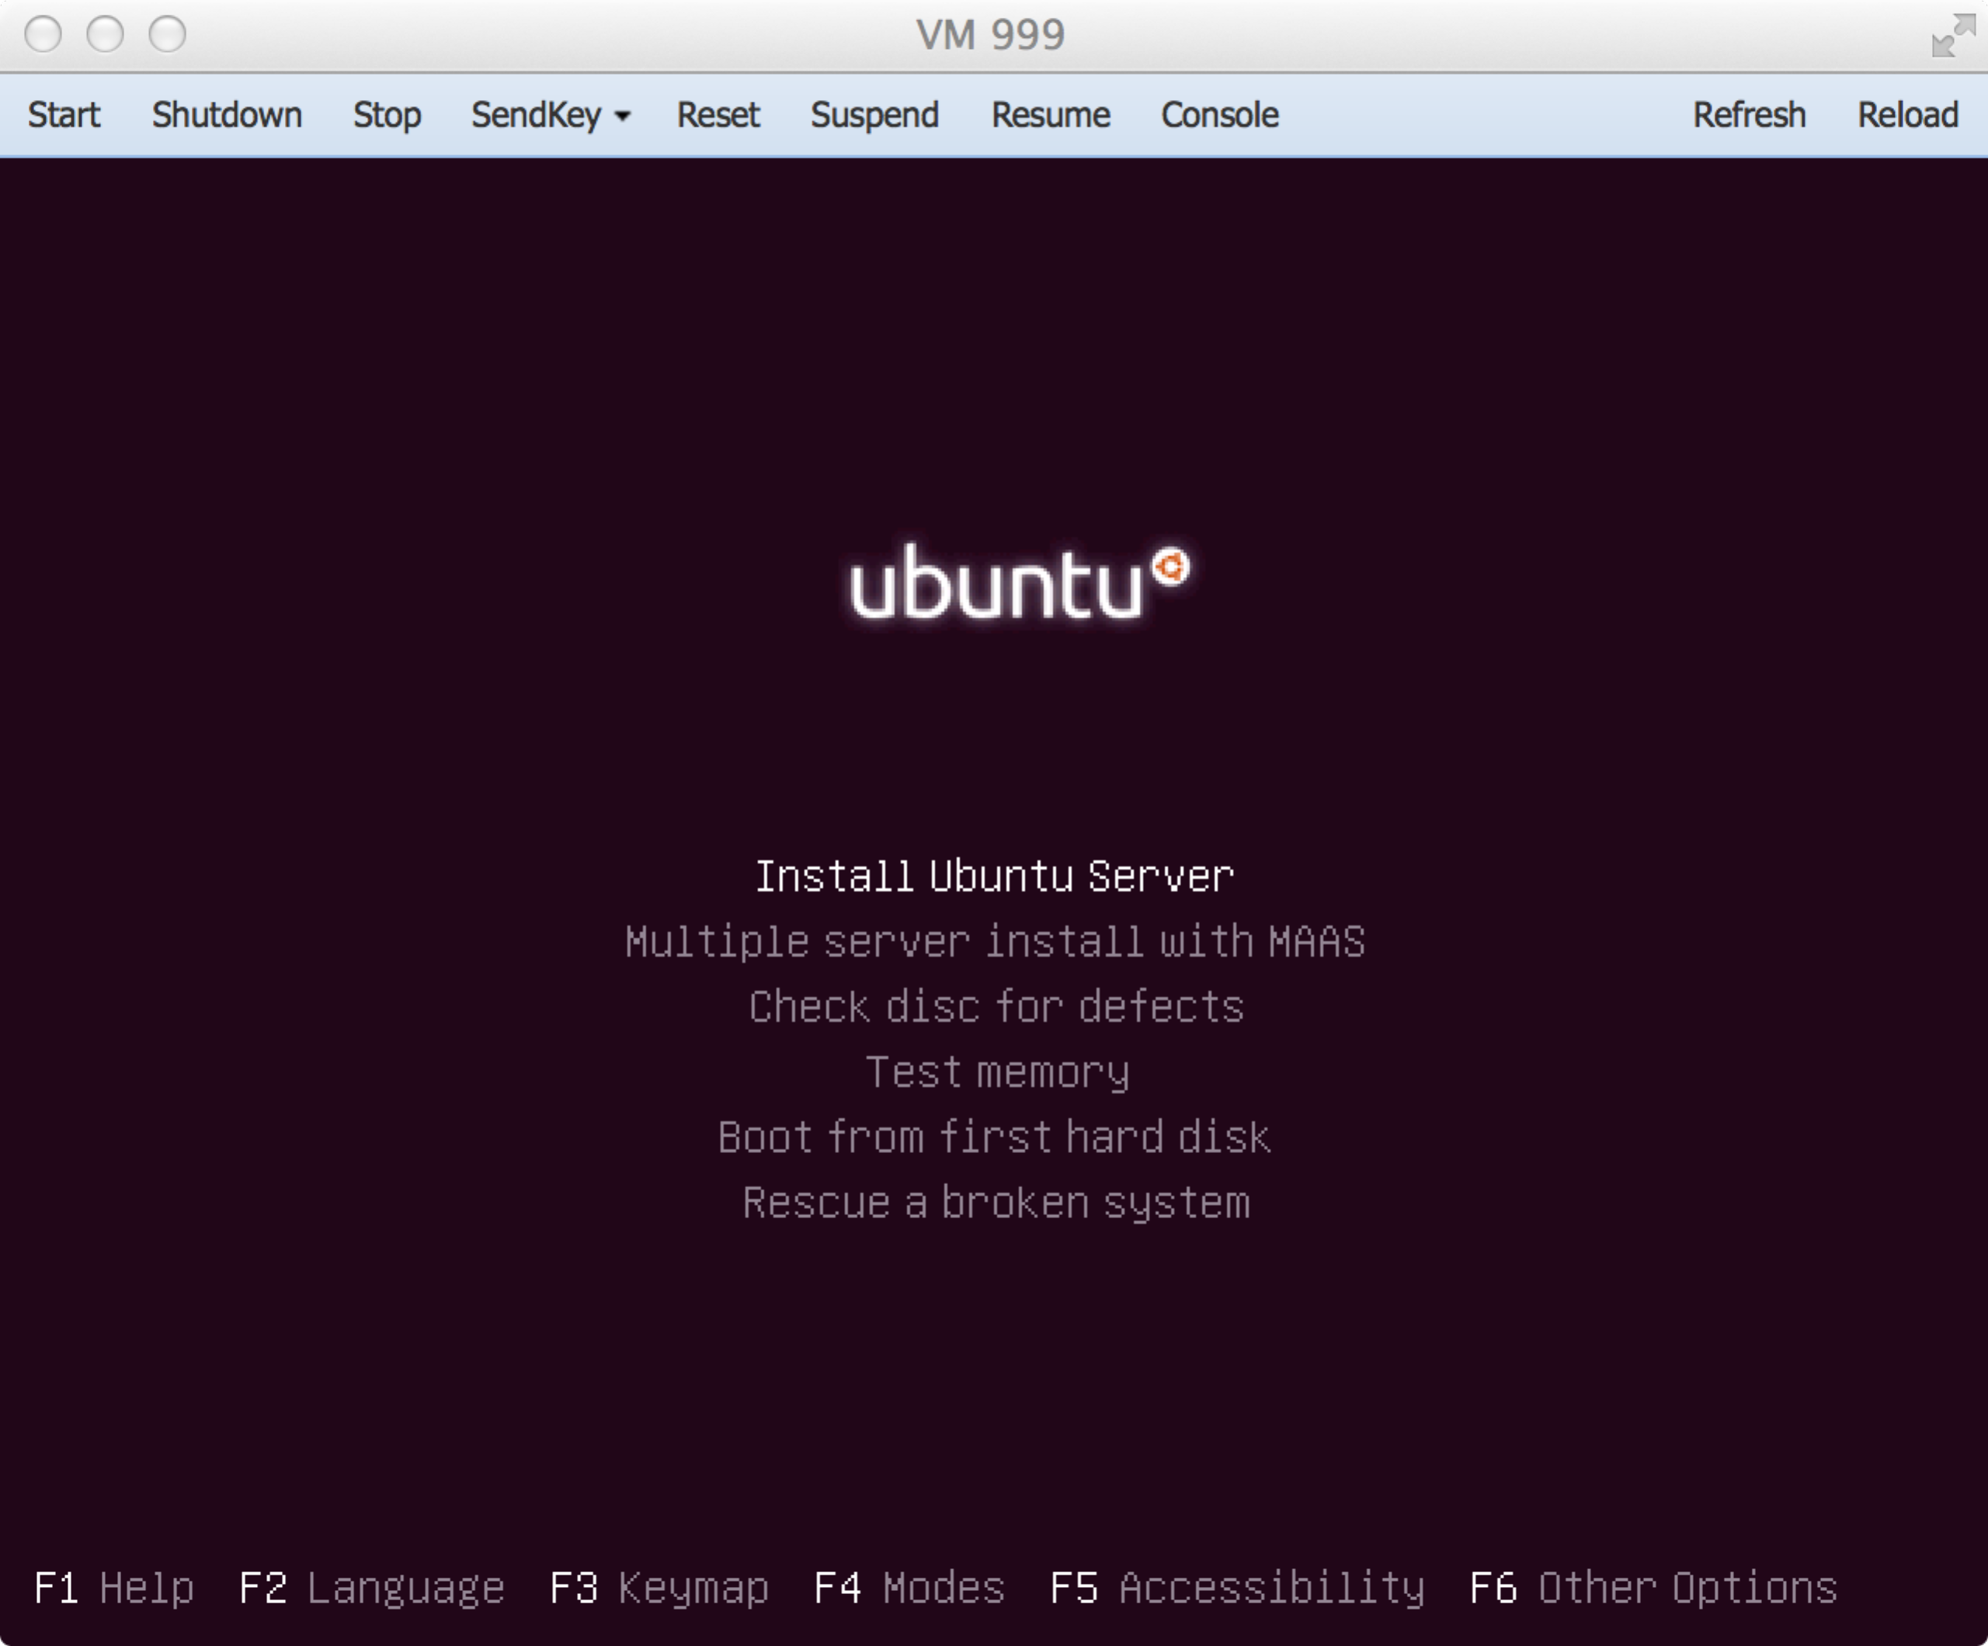

Select Install Ubuntu Server

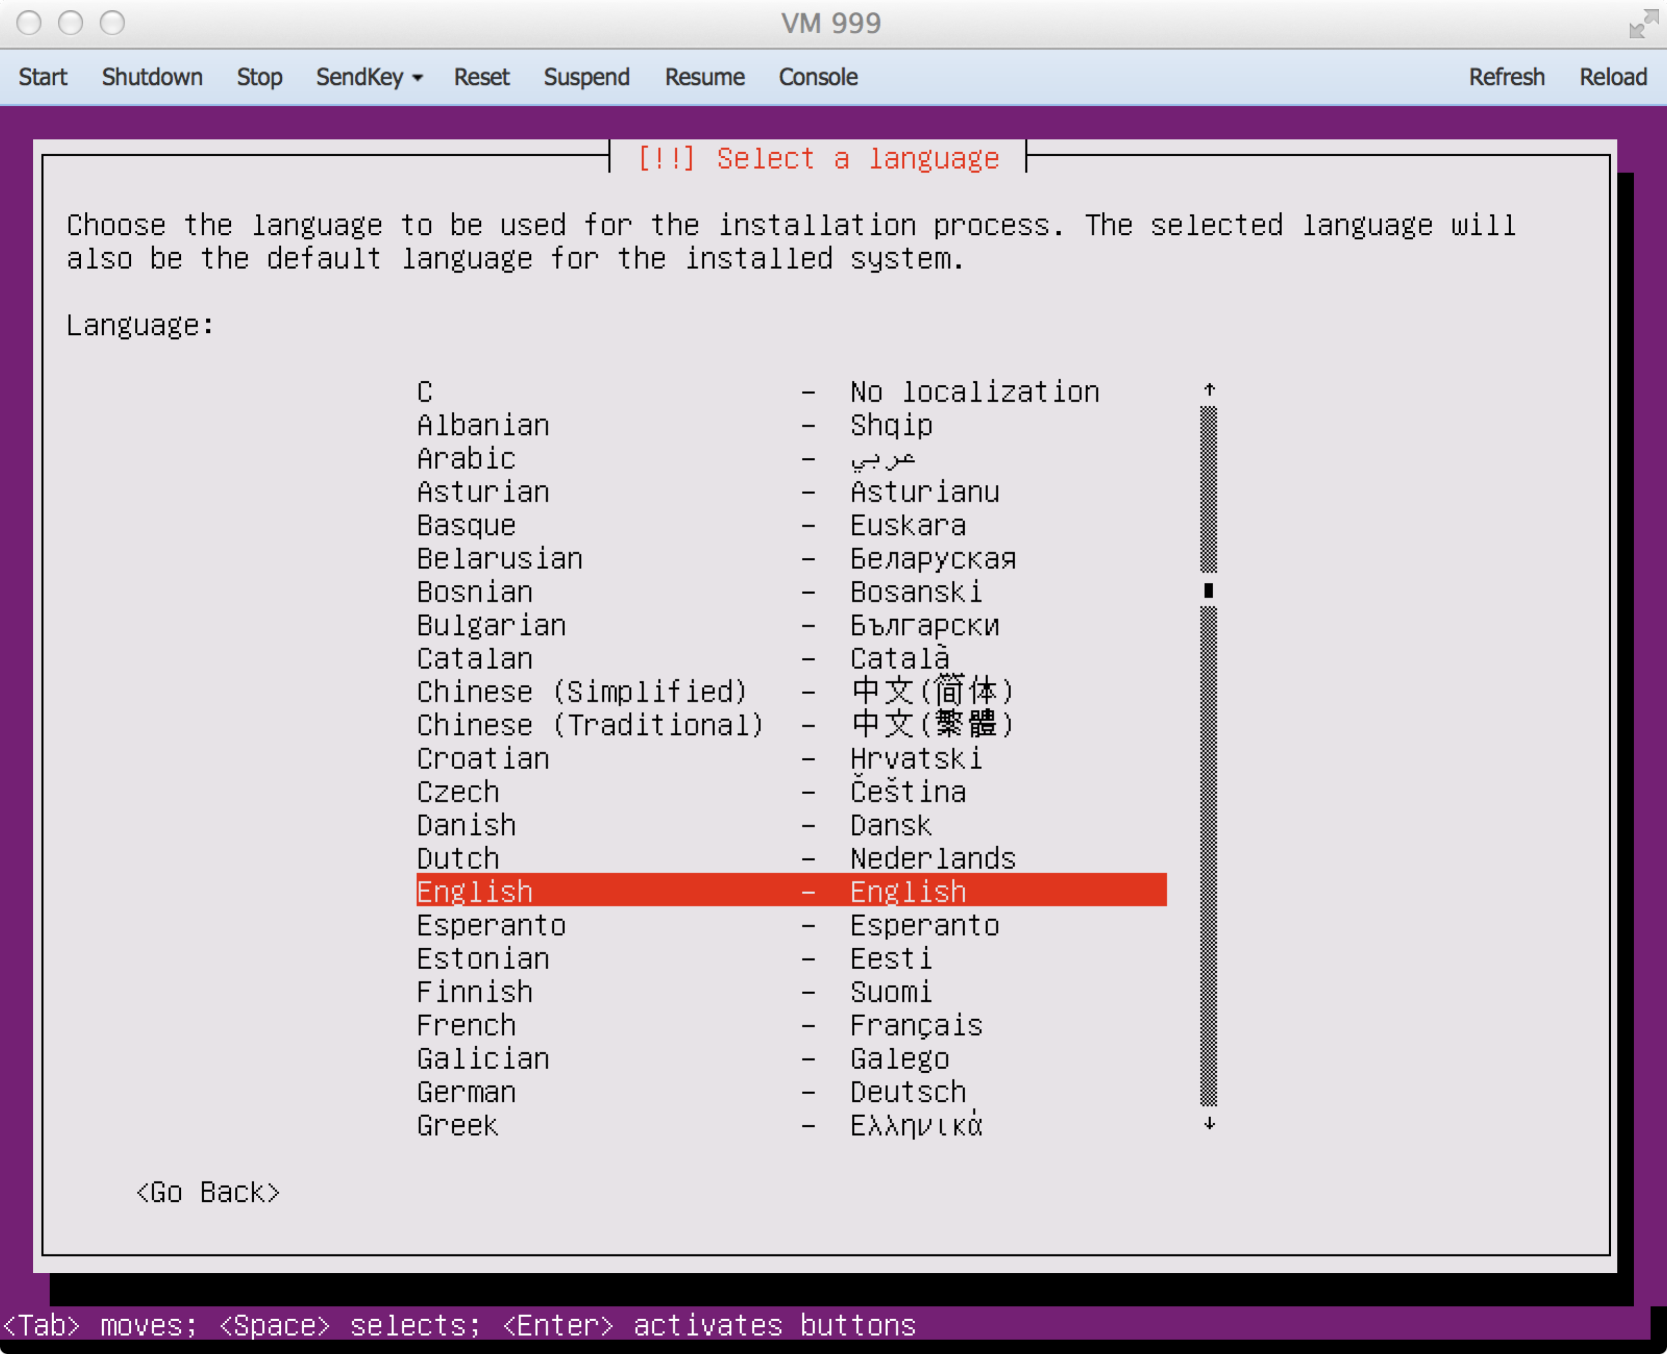

Select English

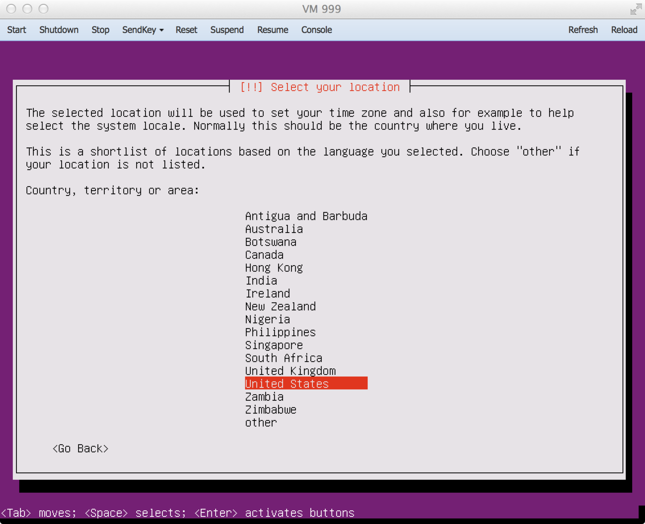

Now Select United States

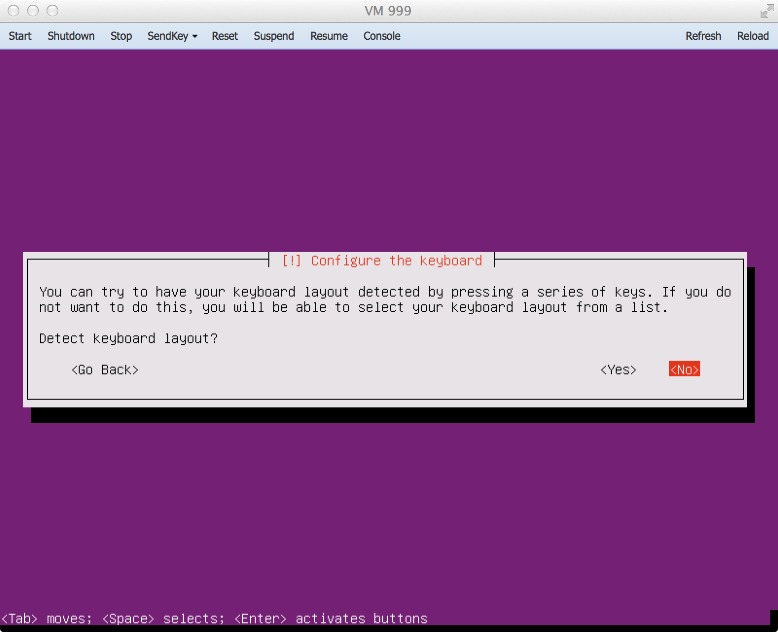

Select No

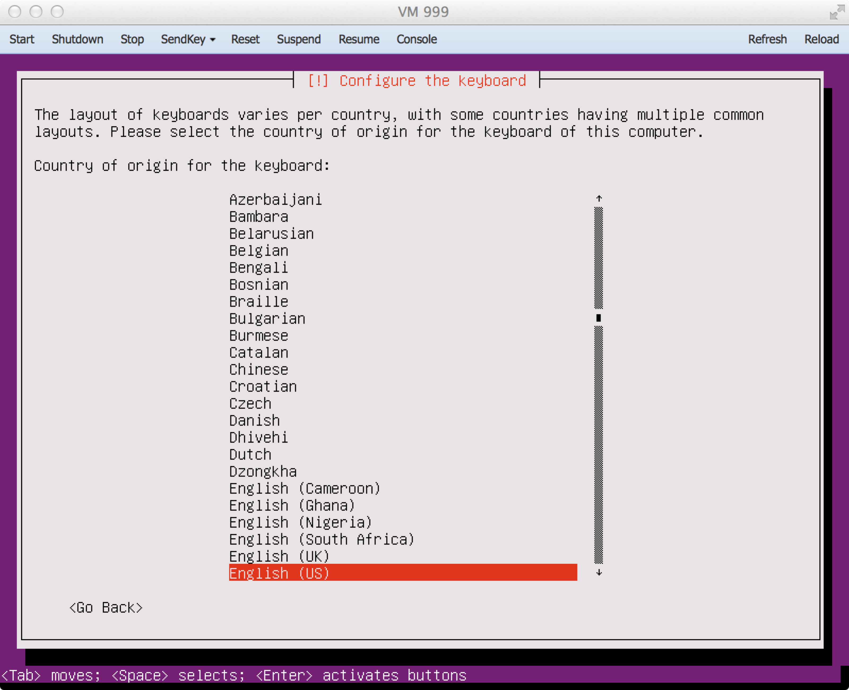

Now Select English

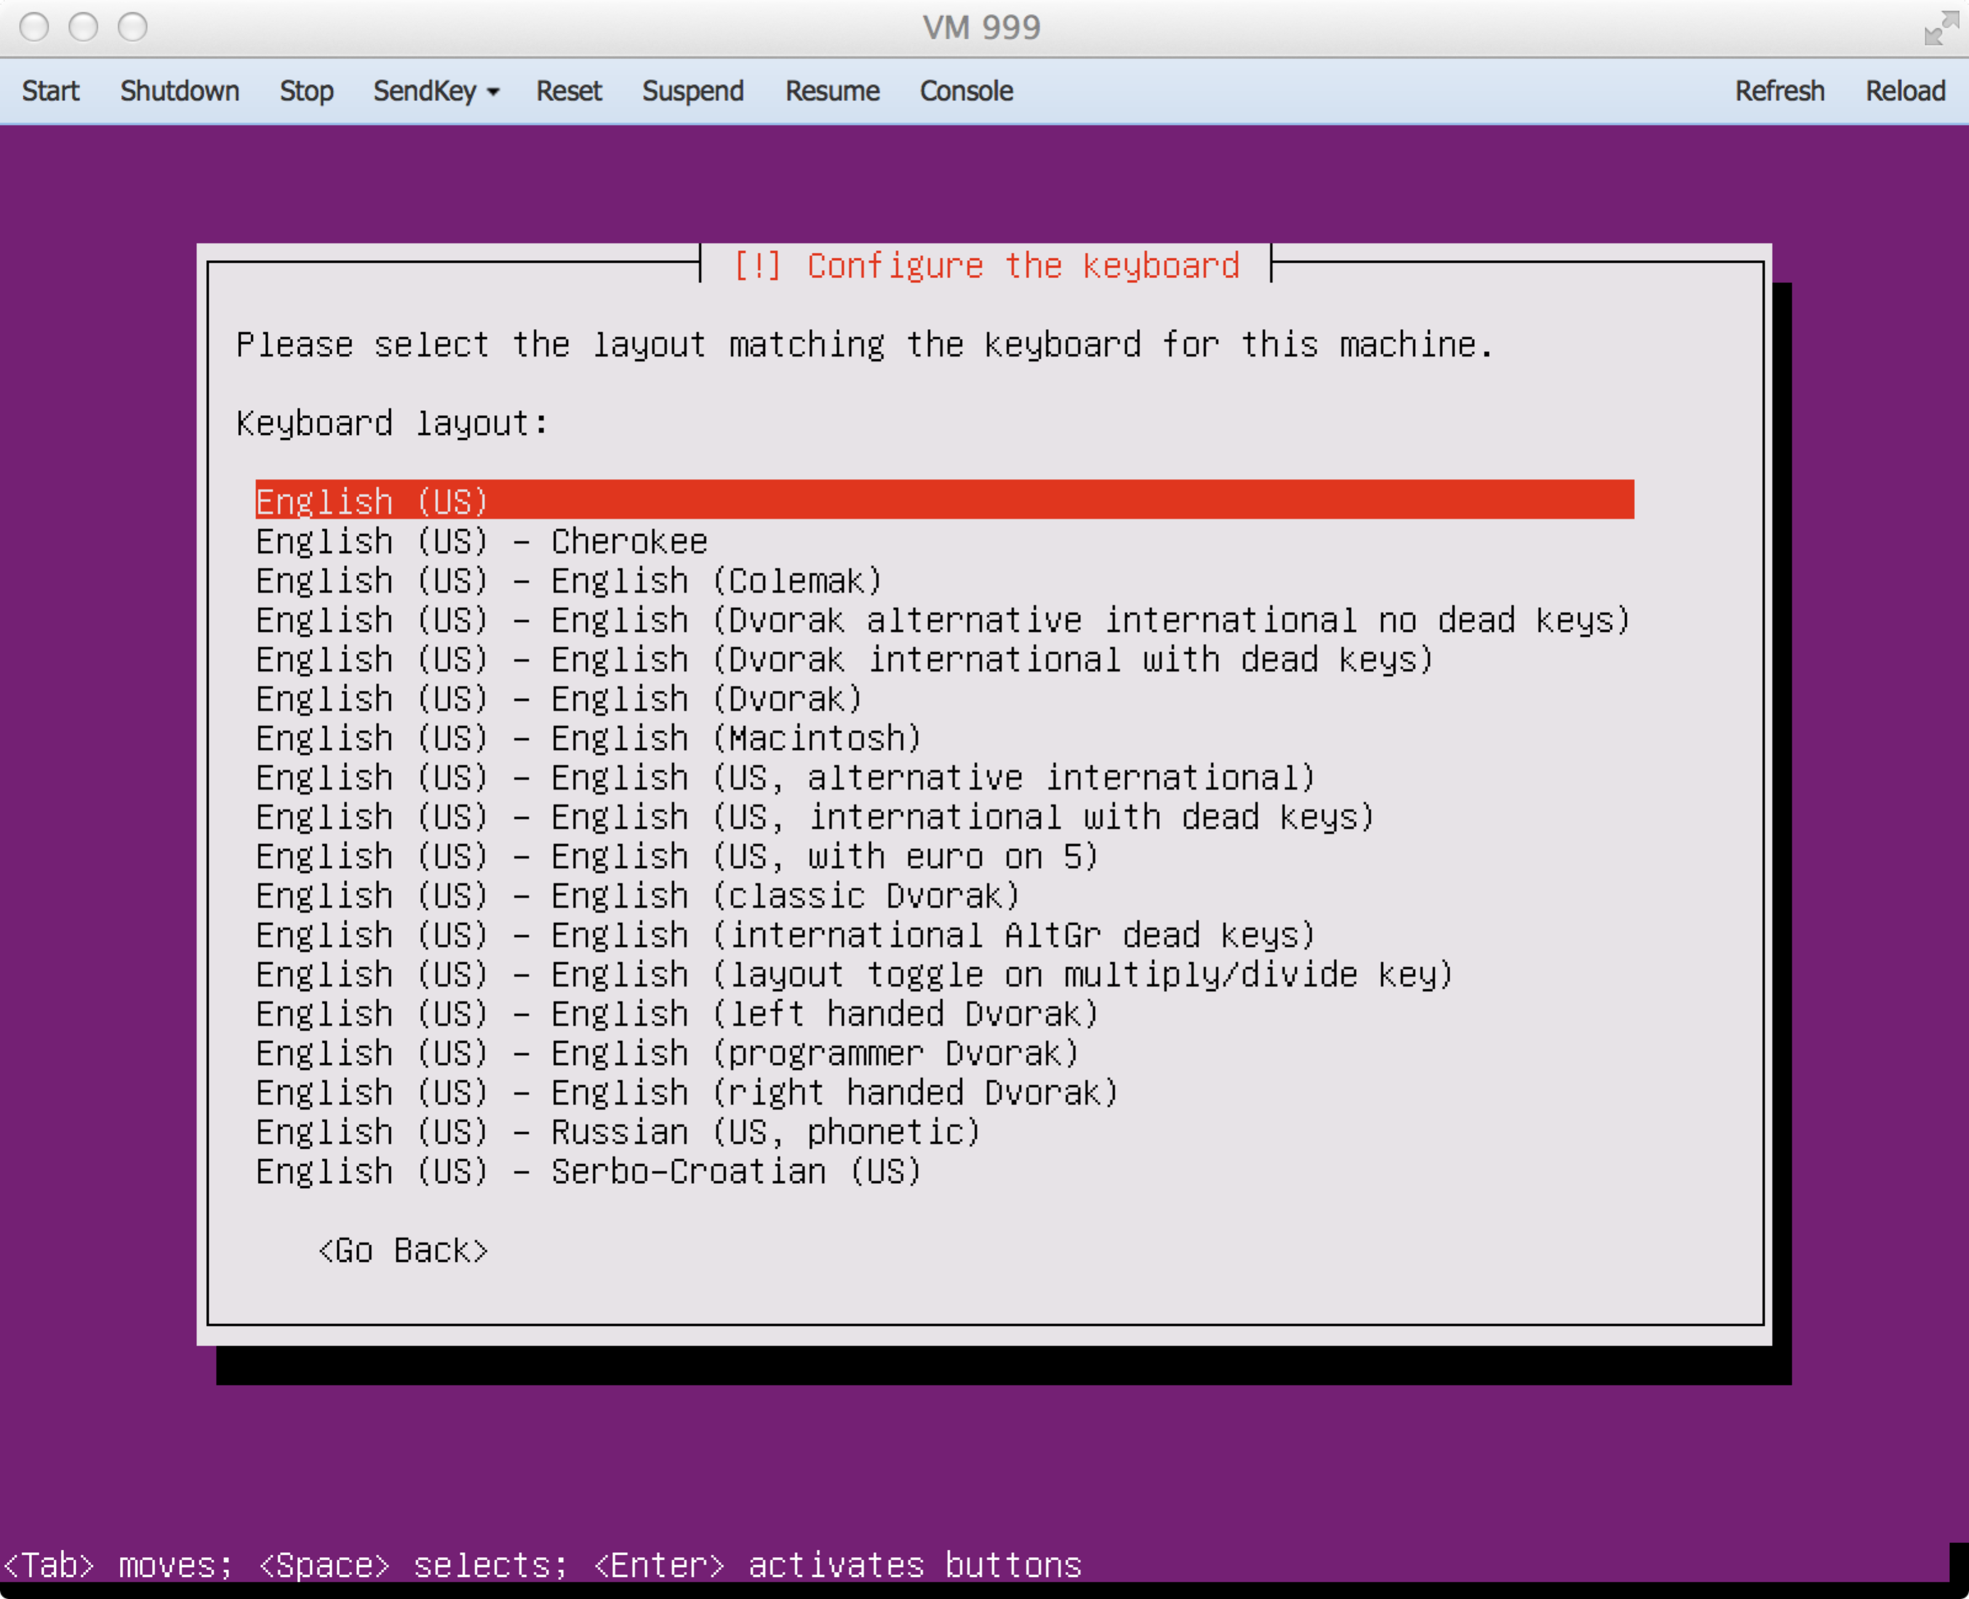

Now Select English (US) for the keyboard layout.

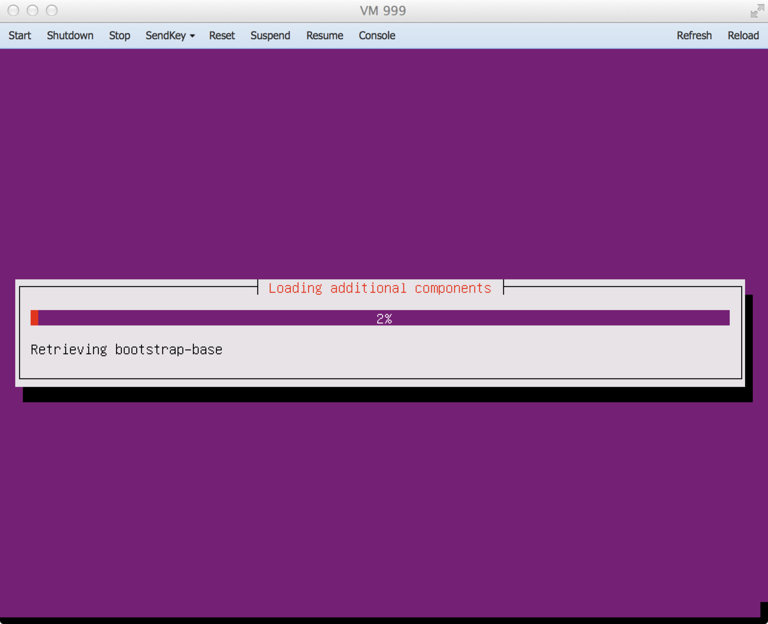

This installation will proceed, several progress bars will appear and disappear very quickly.

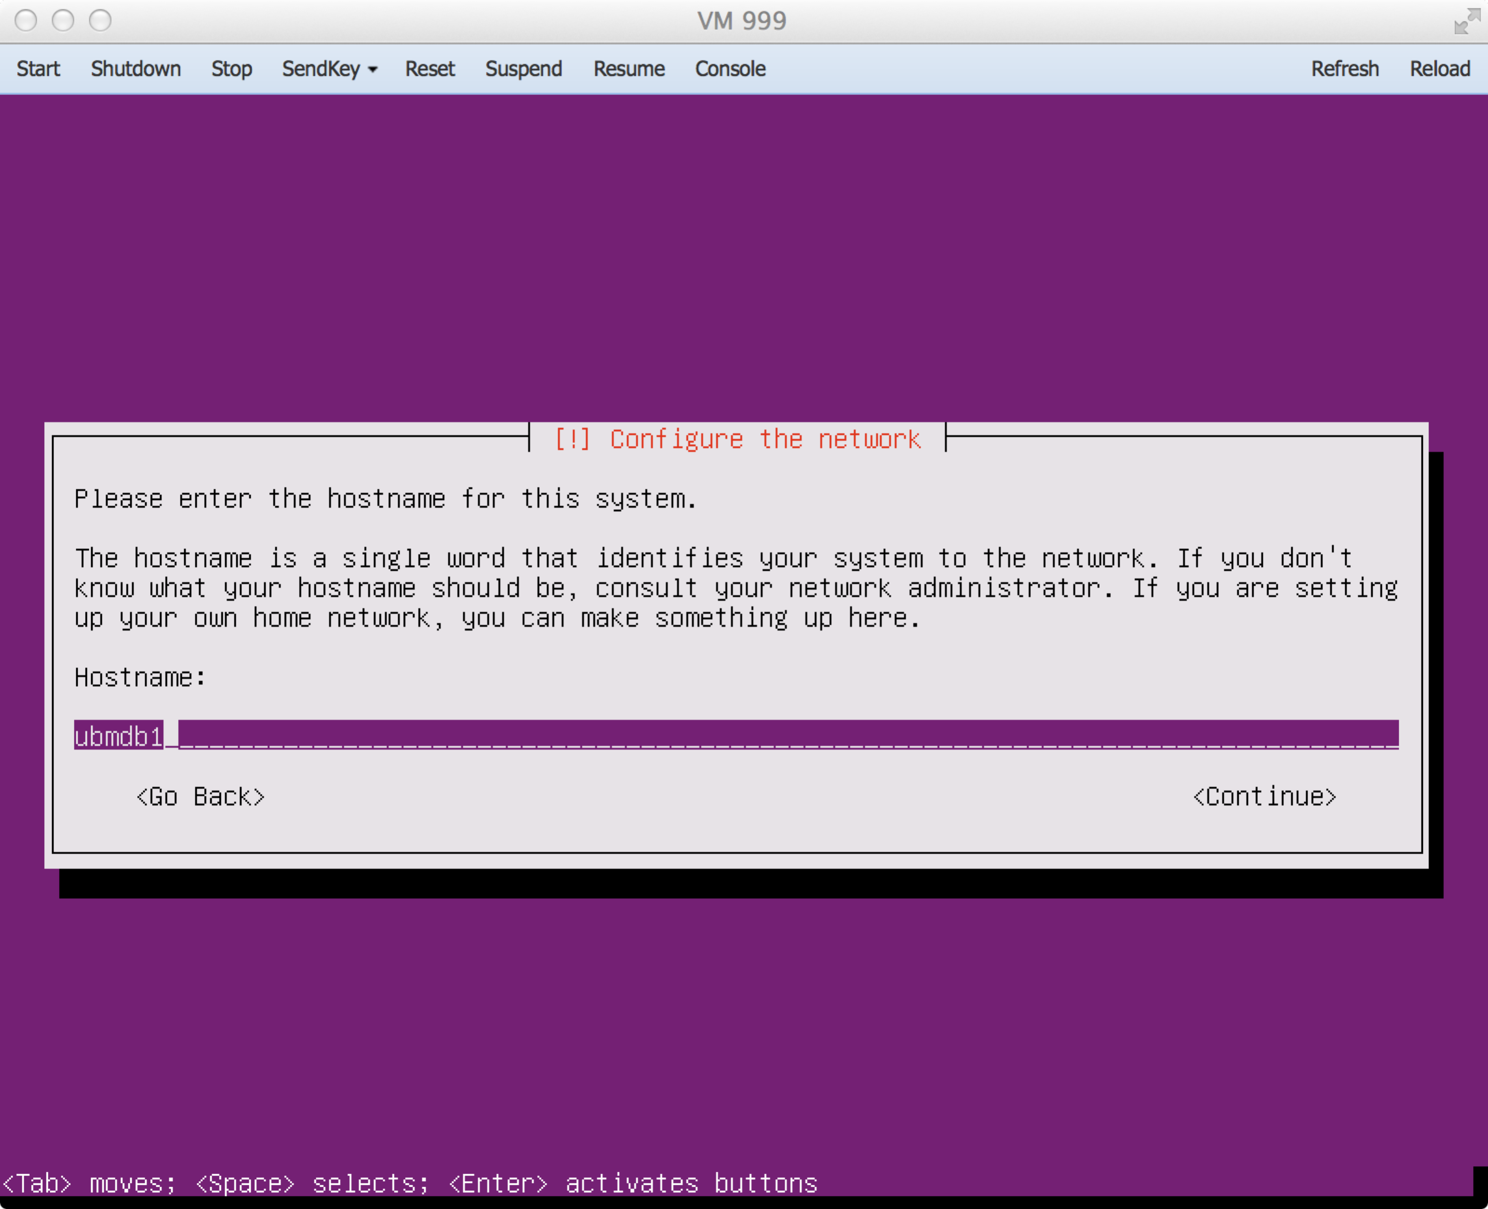

Now enter the hostname for the new server. In this install we entered <ubmdb1> for our hostname.

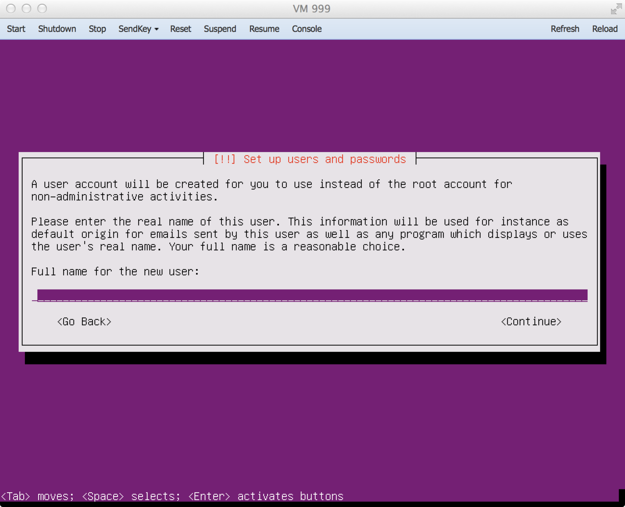Now enter an administrator User First Name.

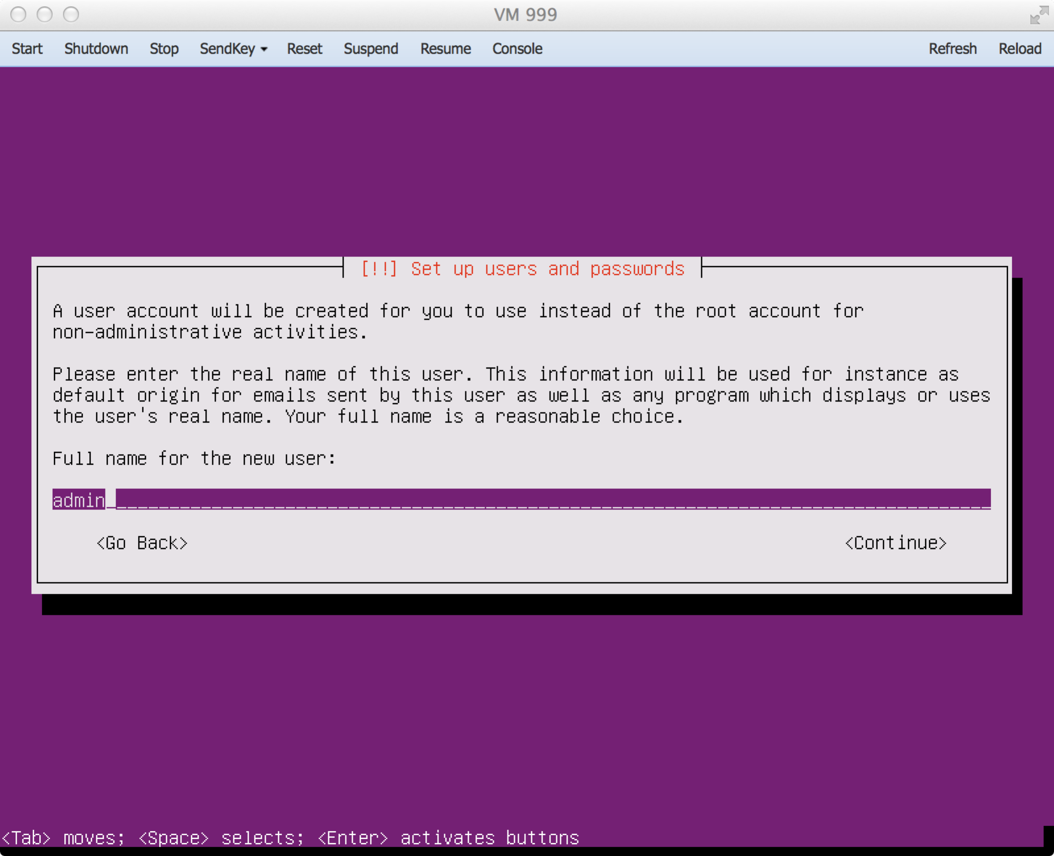

In this install we chose <ubmadmin> for our username.

Now Select Continue and then press <Enter>

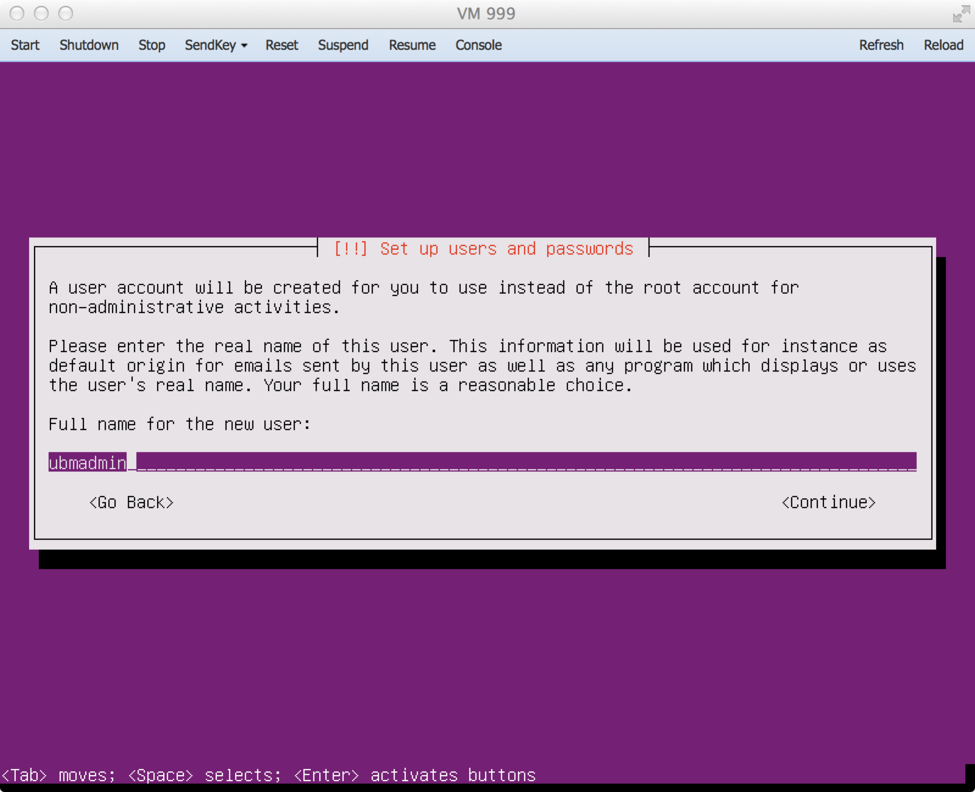

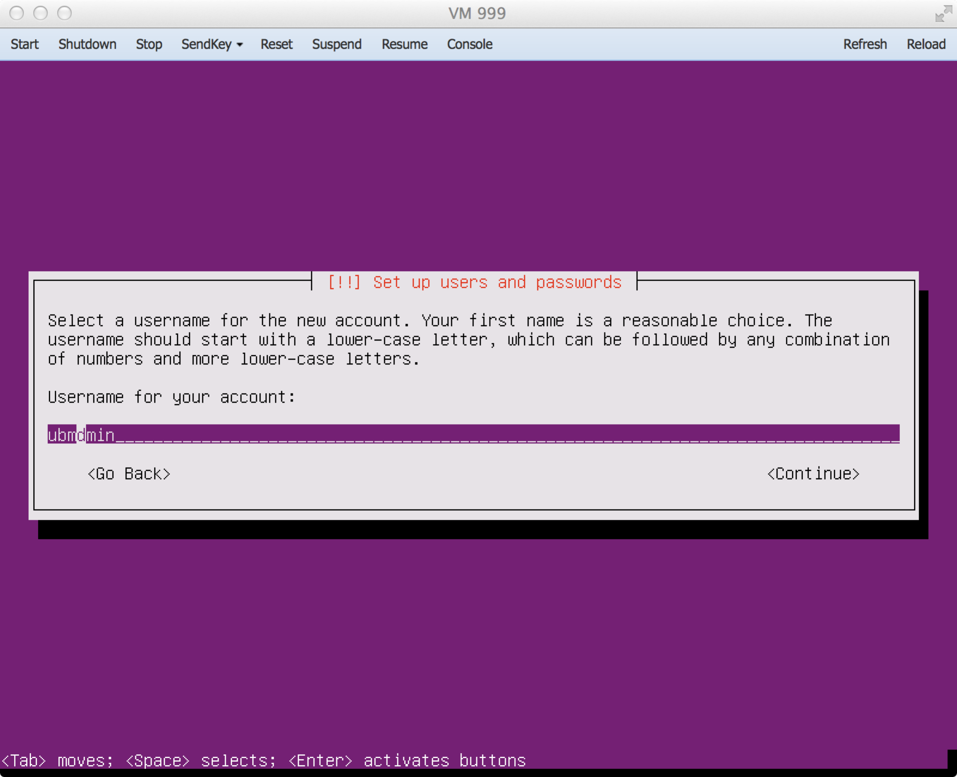Enter ubmadmin for the first name, then select continue and push enter.

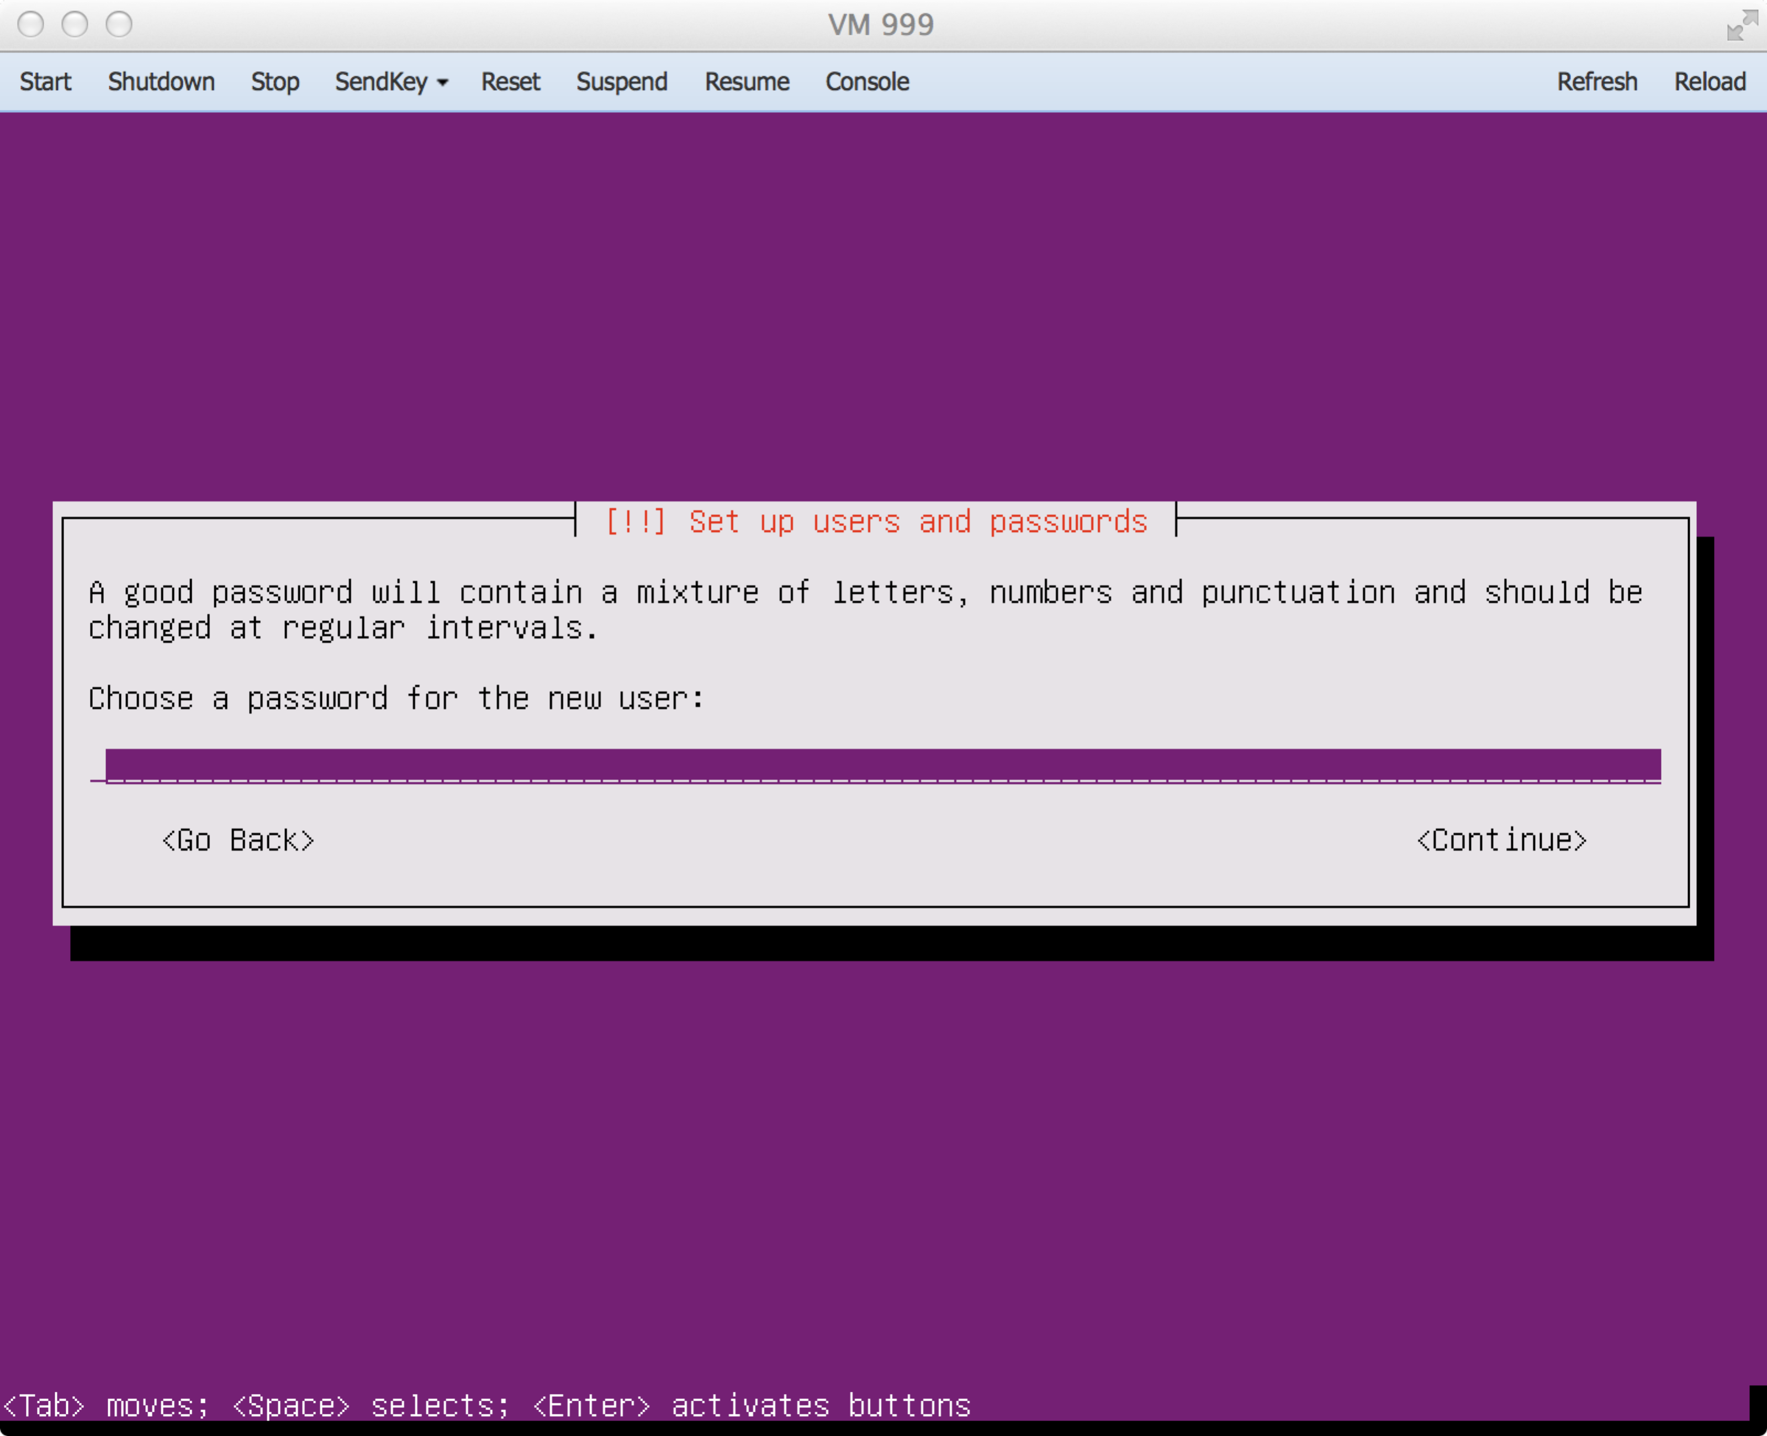

Now create a password for <ubmadmin>

Here is the password we used.

Un1v3rs@lBM

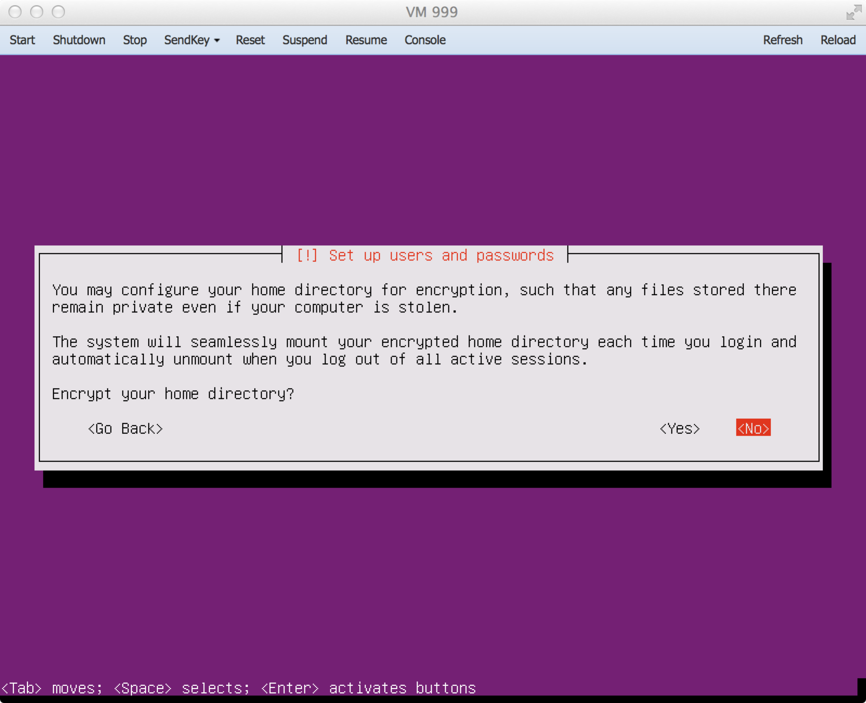

Select No, to encryption of the home directory.

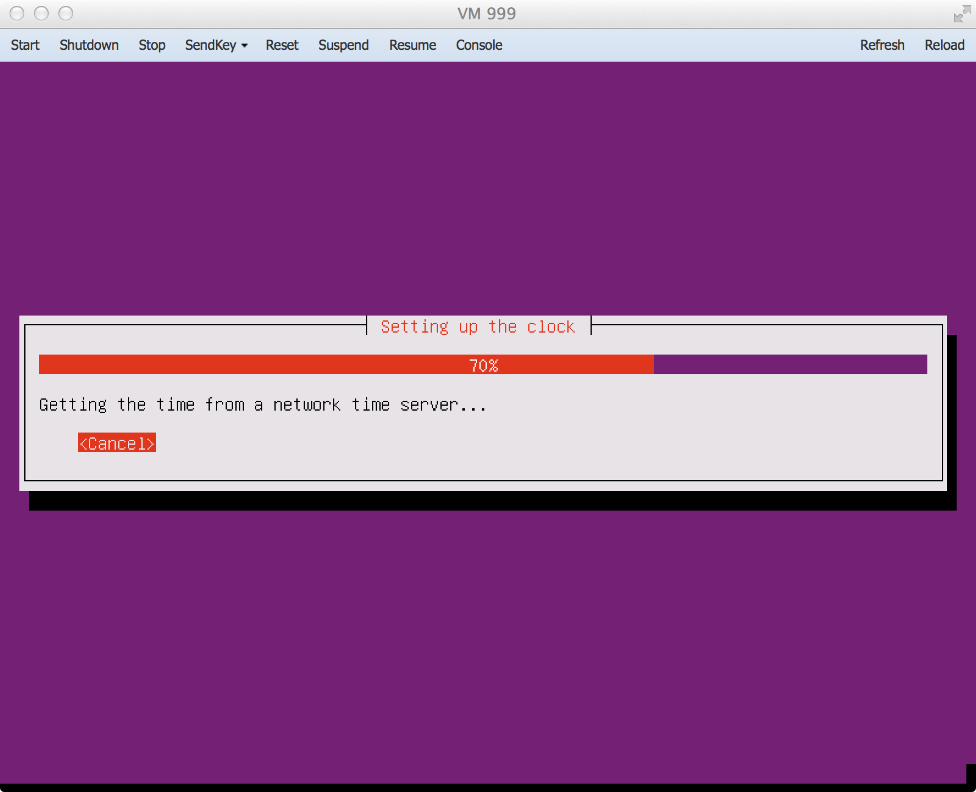

This progress bar will complete on its own.

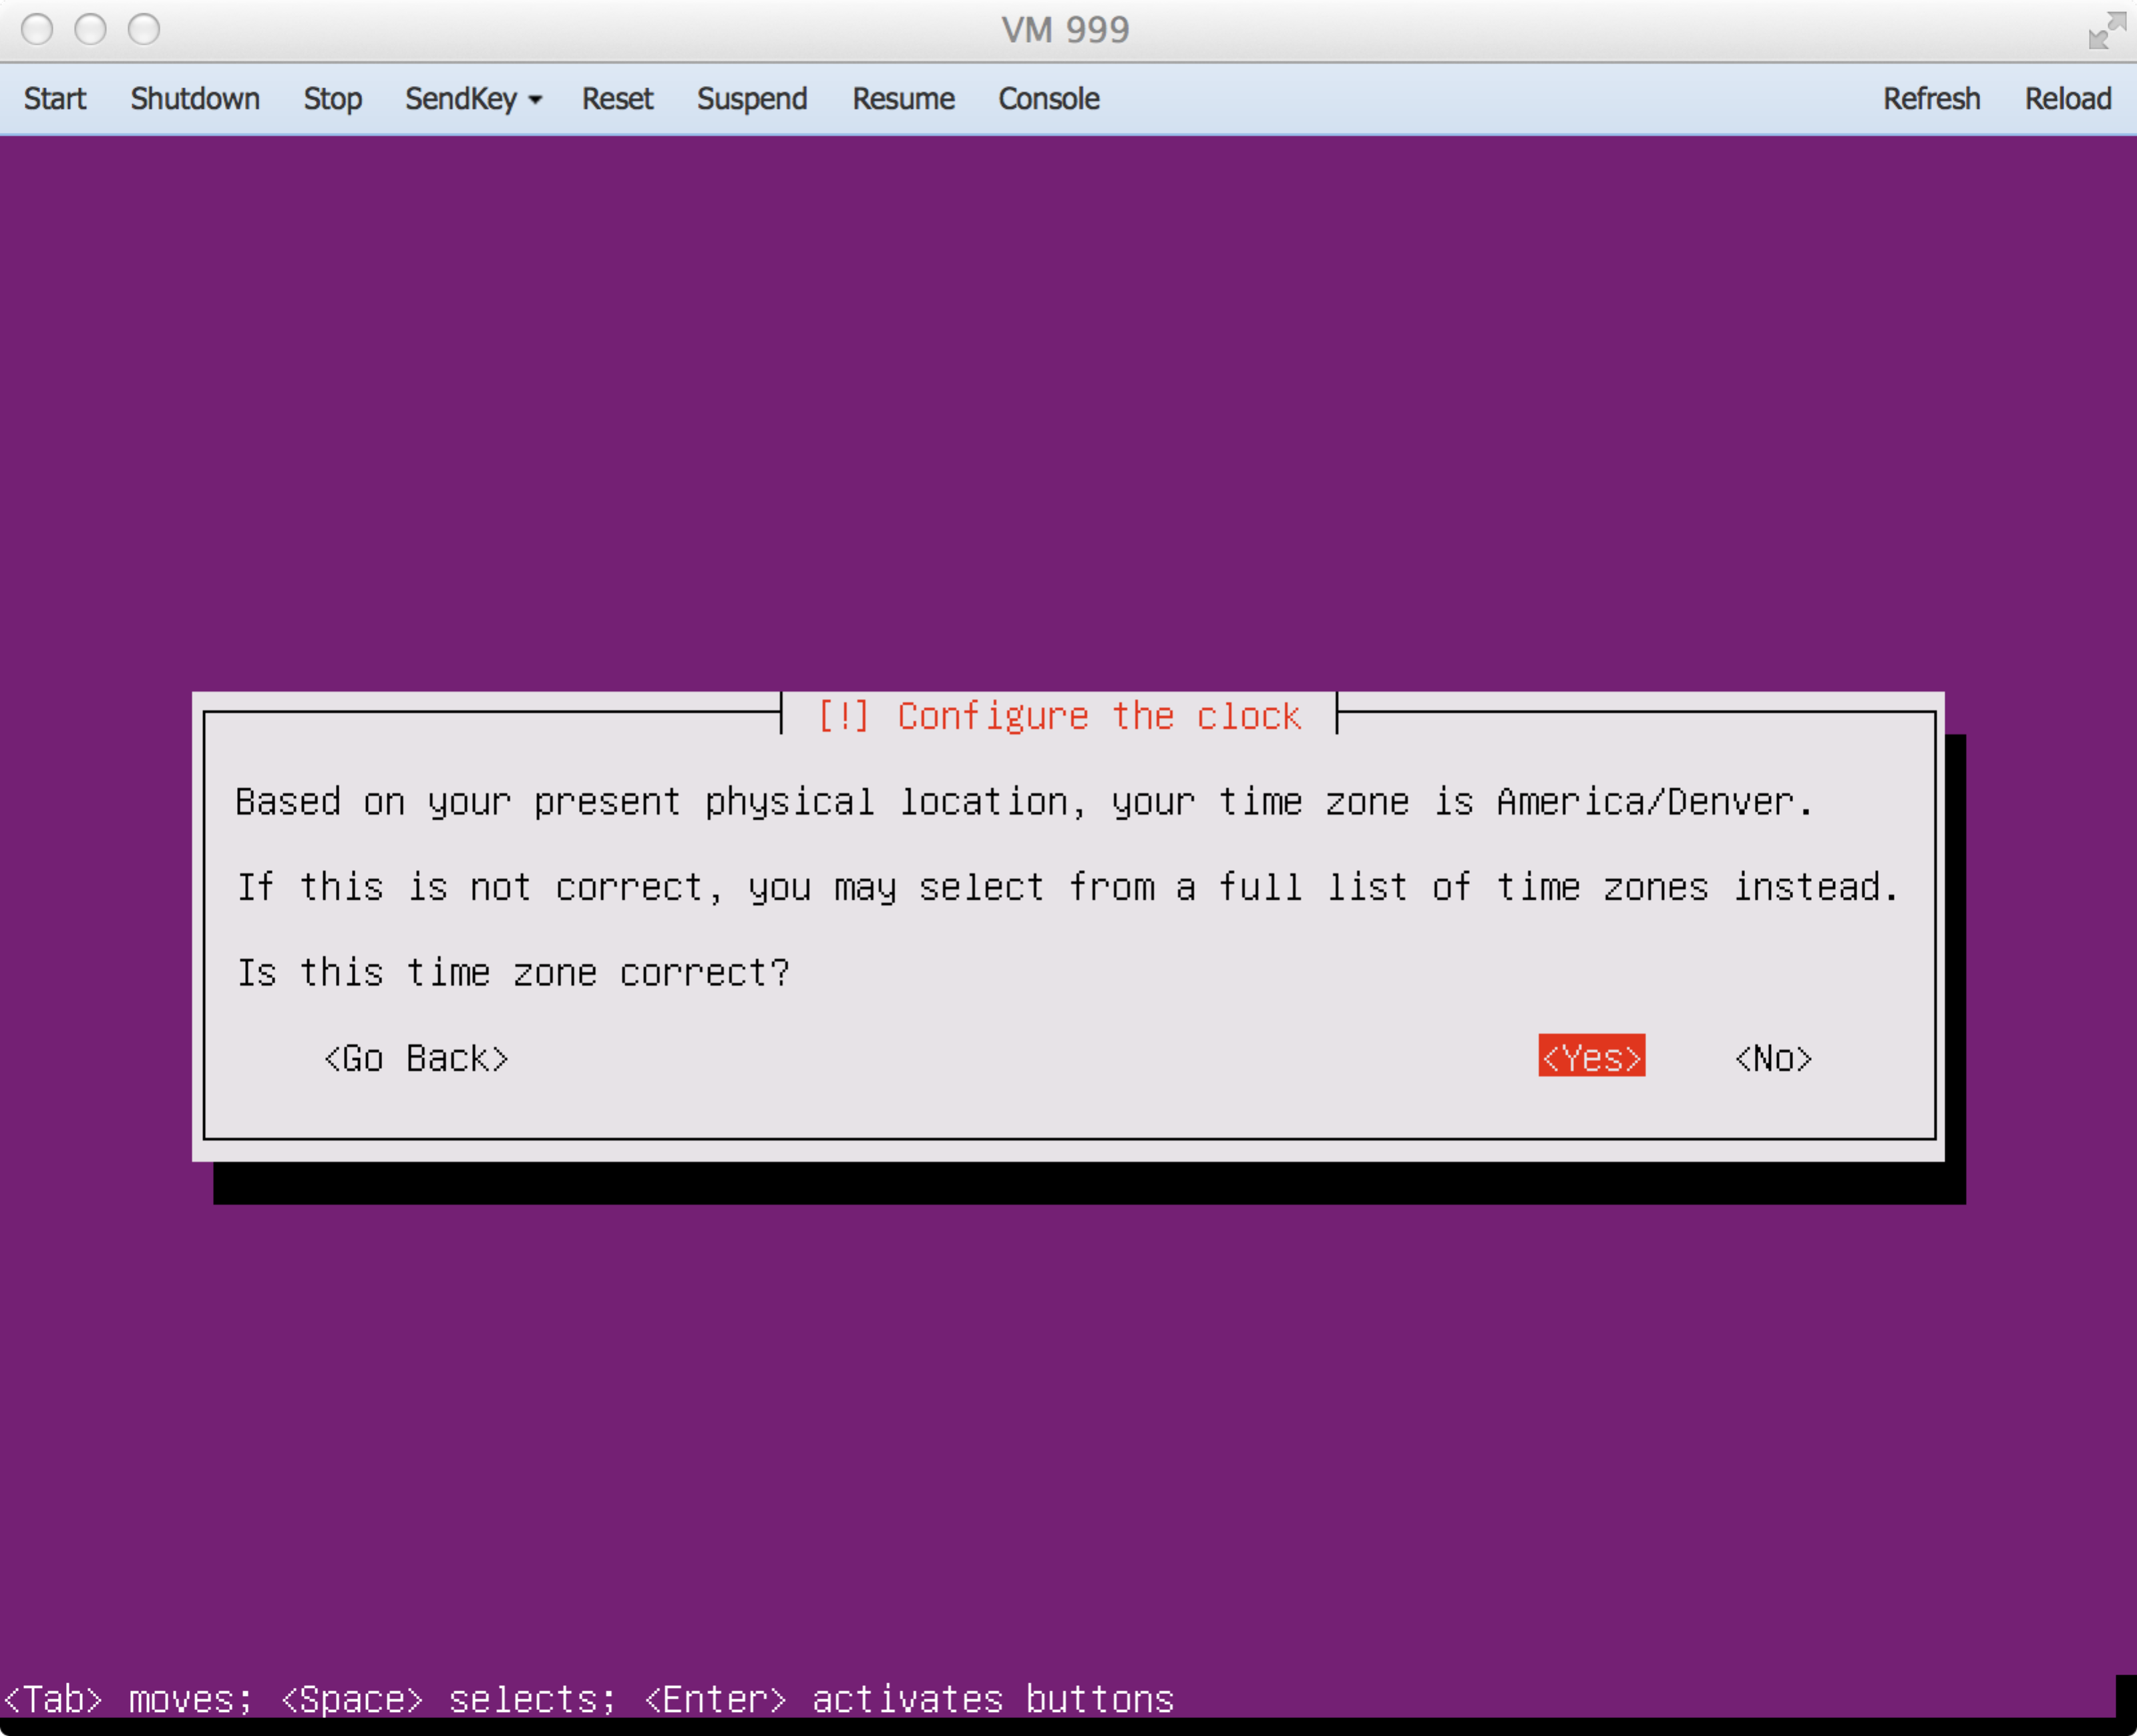

If the timezone detected is correct select yes, We will select Yes.

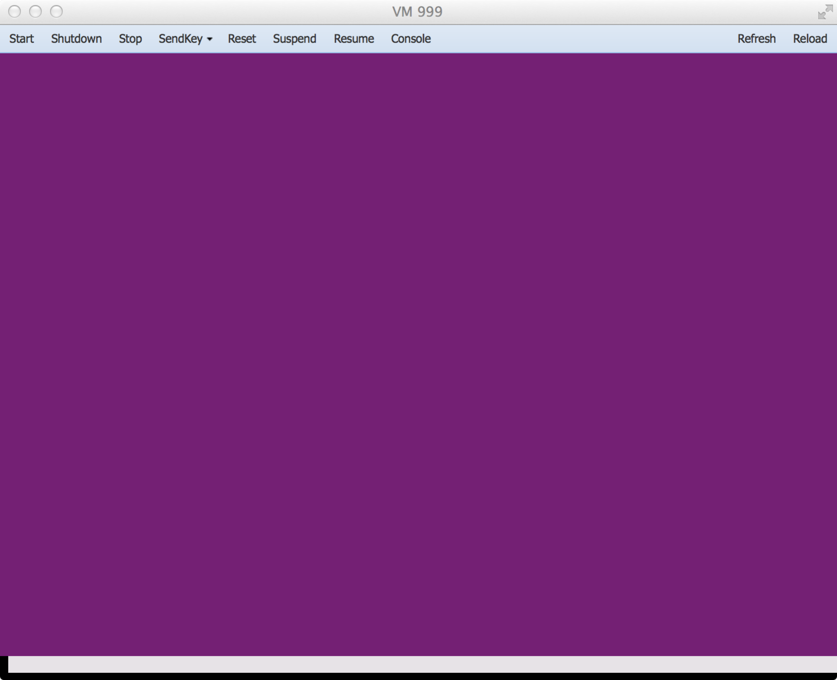

This progress bar will complete on its own.

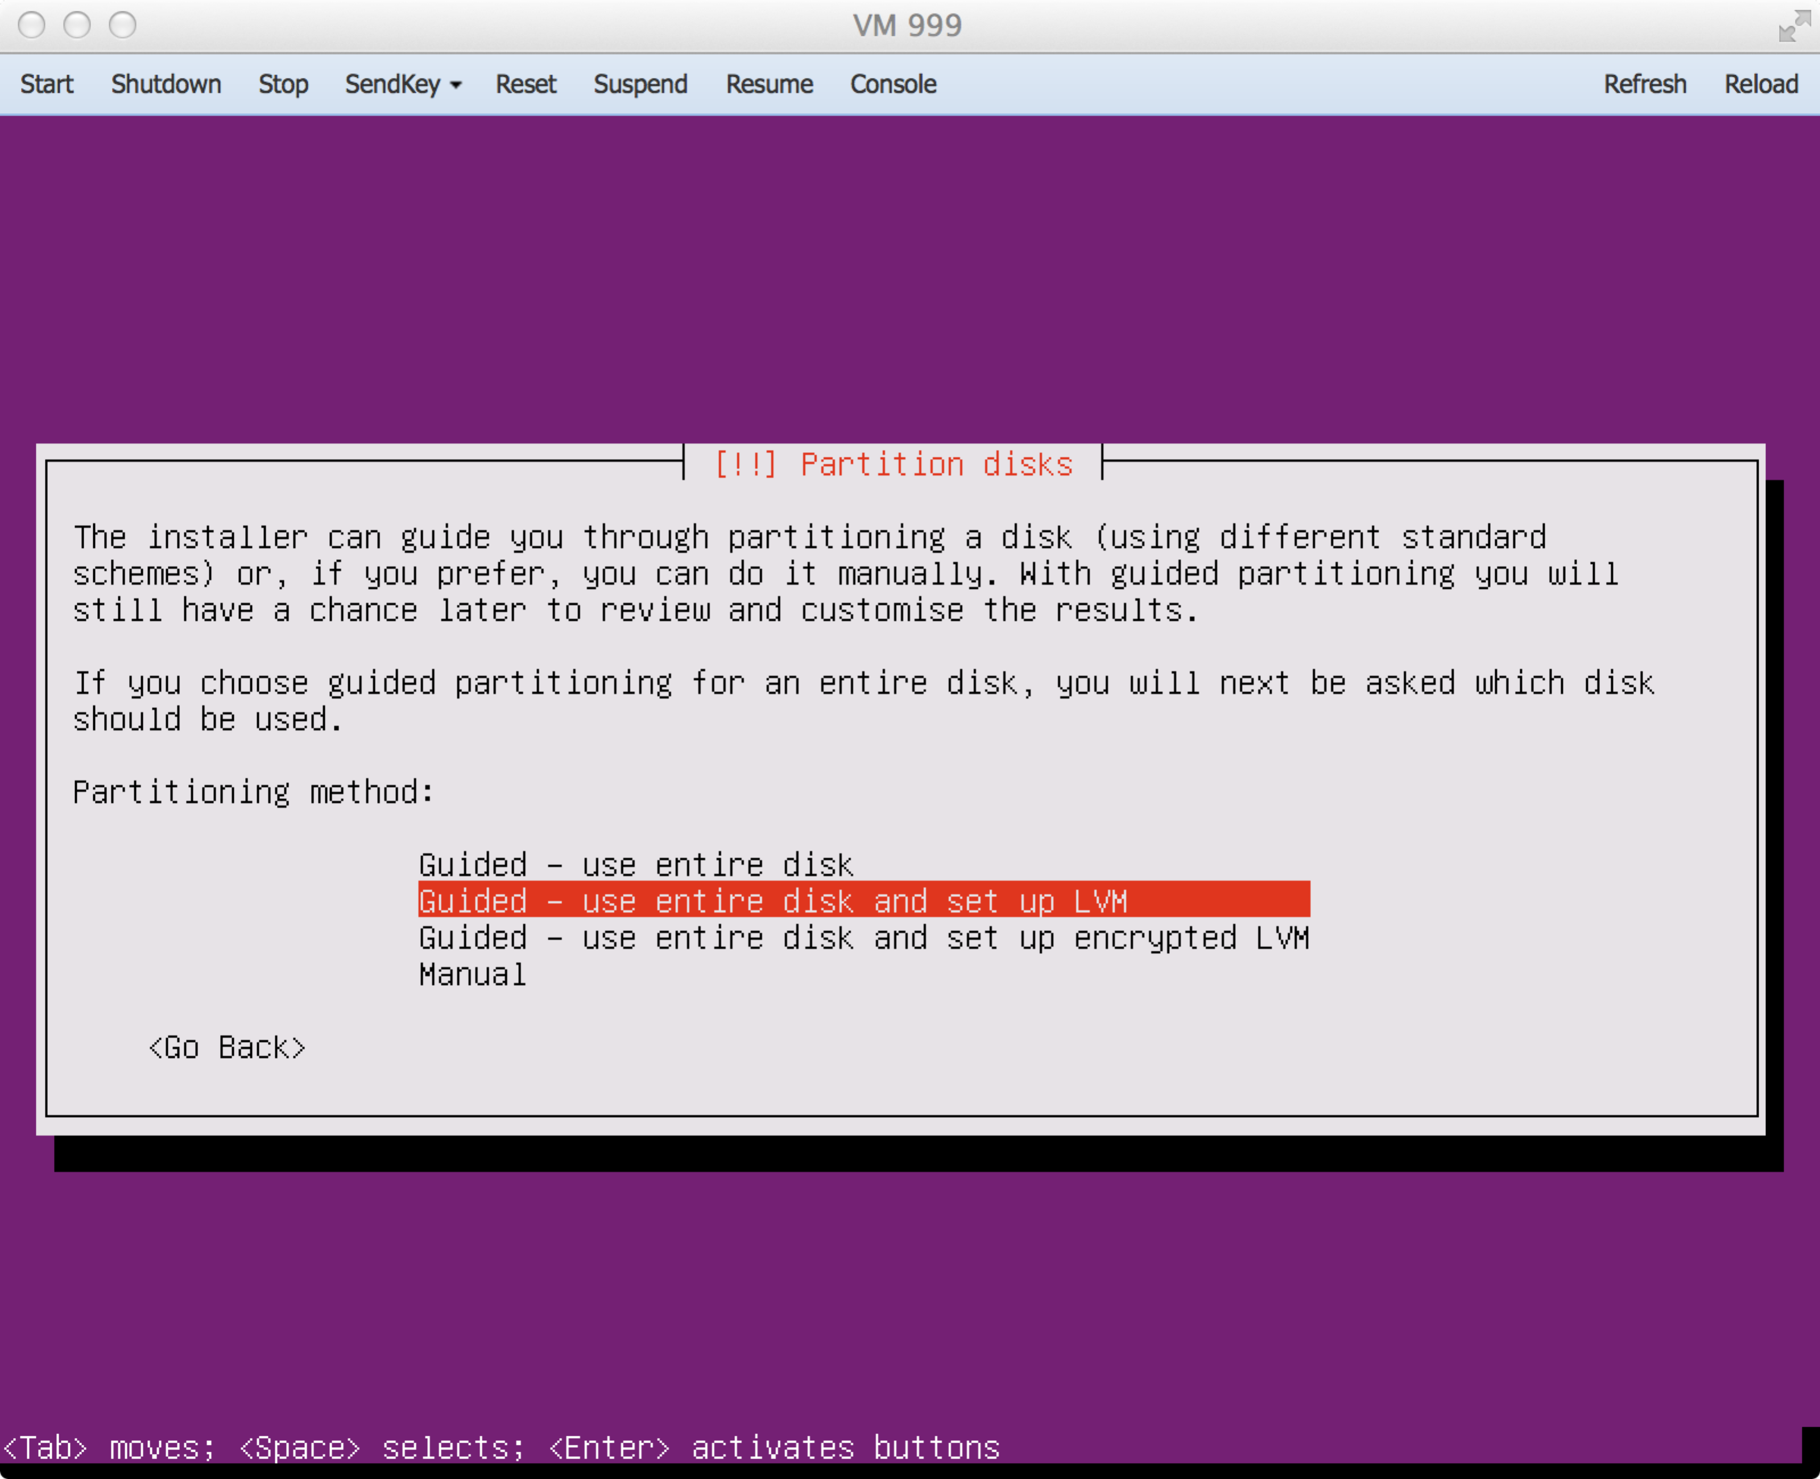

Now Select <Guided – Use Entire Disk and setup LVM> then press <Enter>

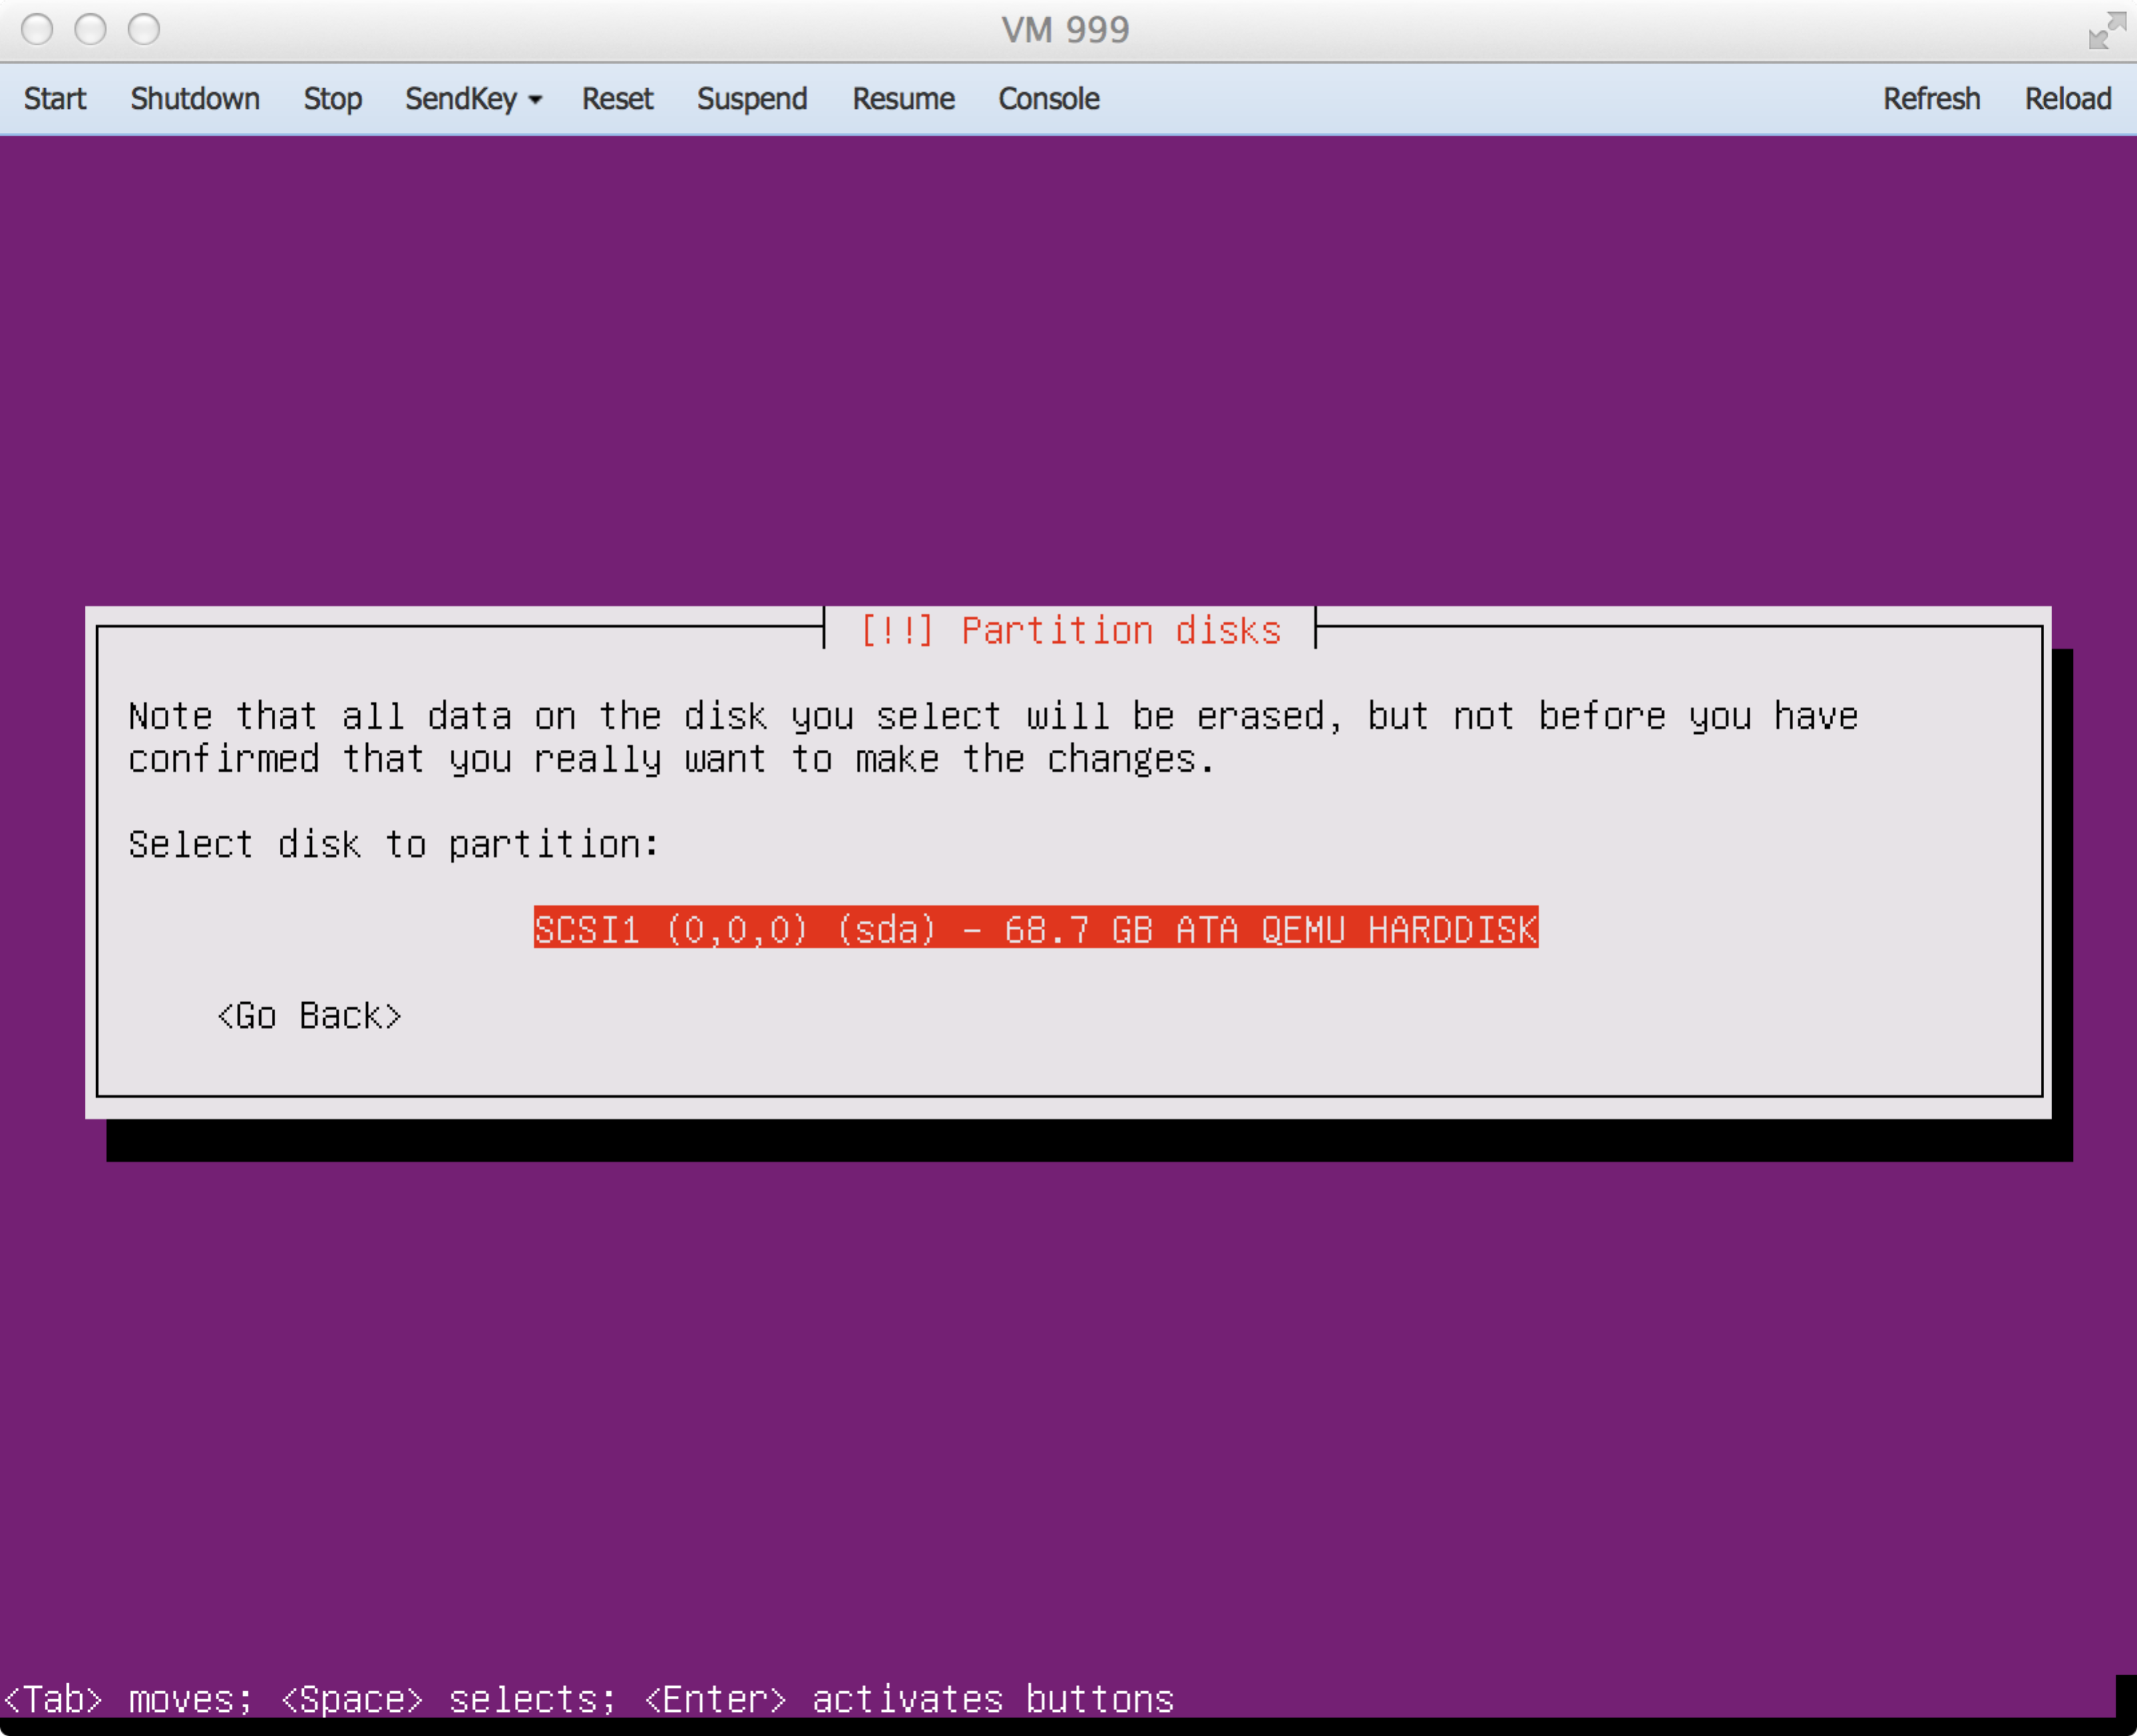

Now Press Enter again to select the disk to partition.

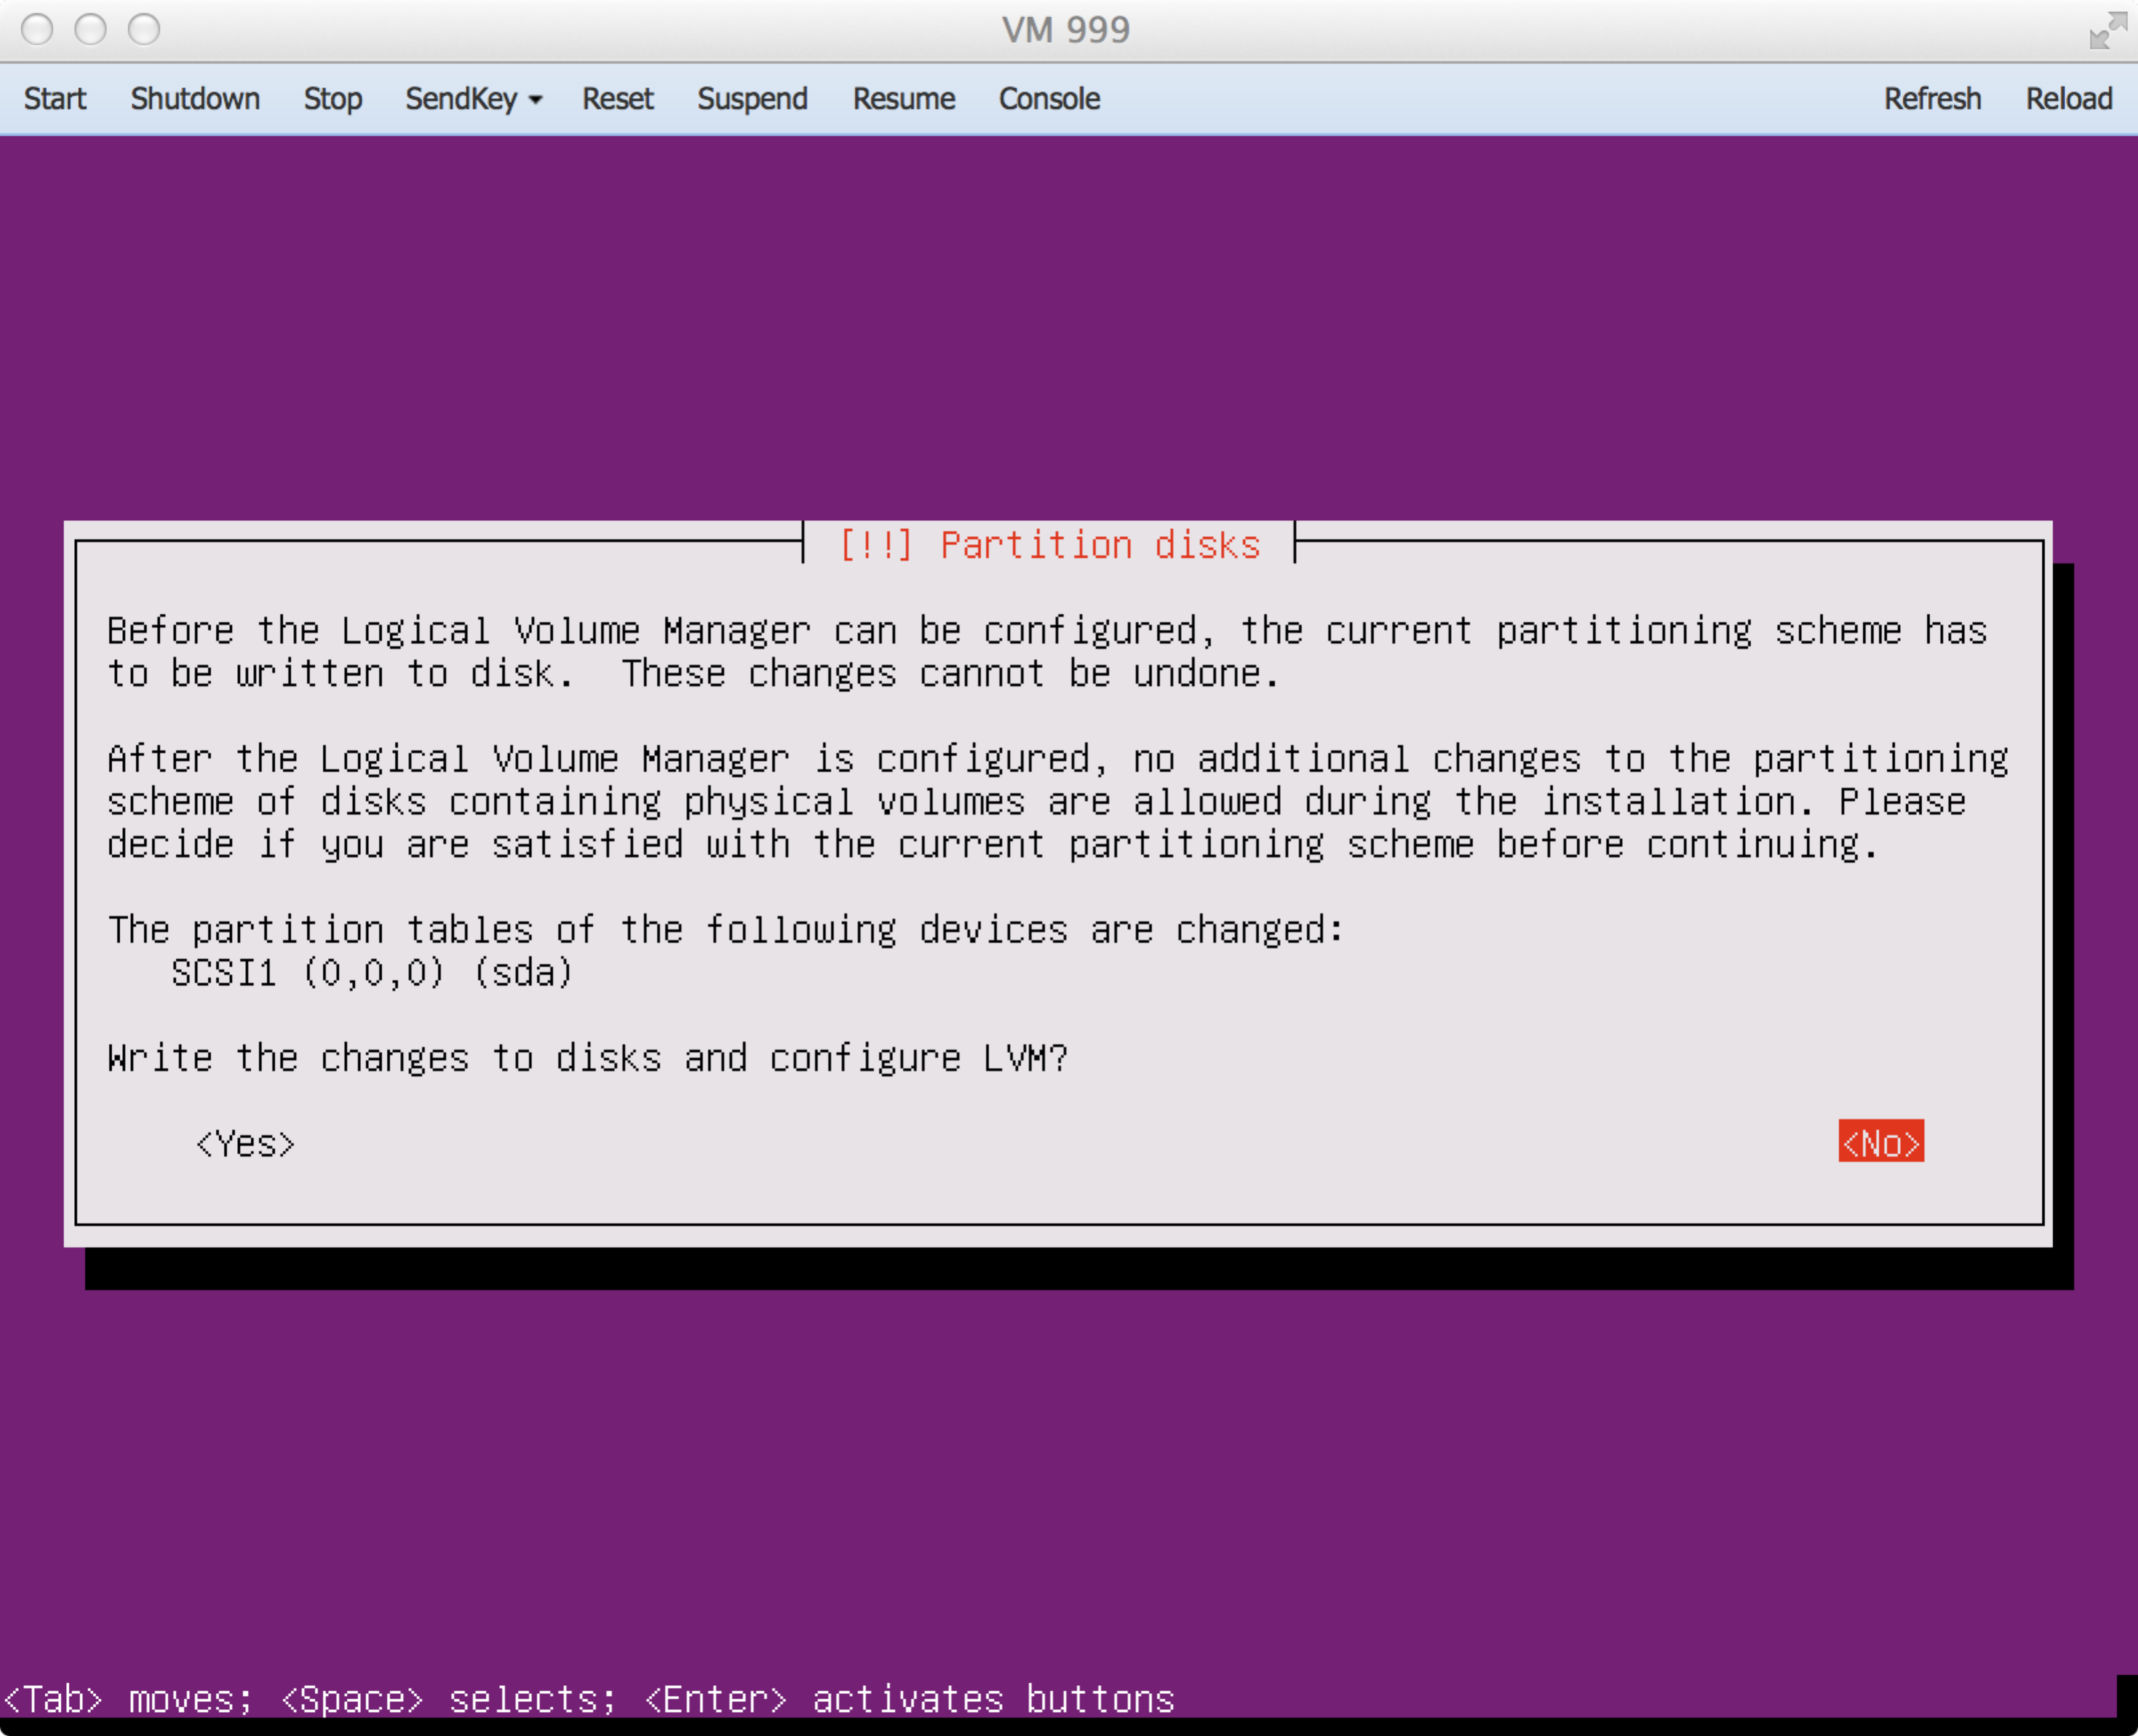

Select Yes to write the changes to the disk.

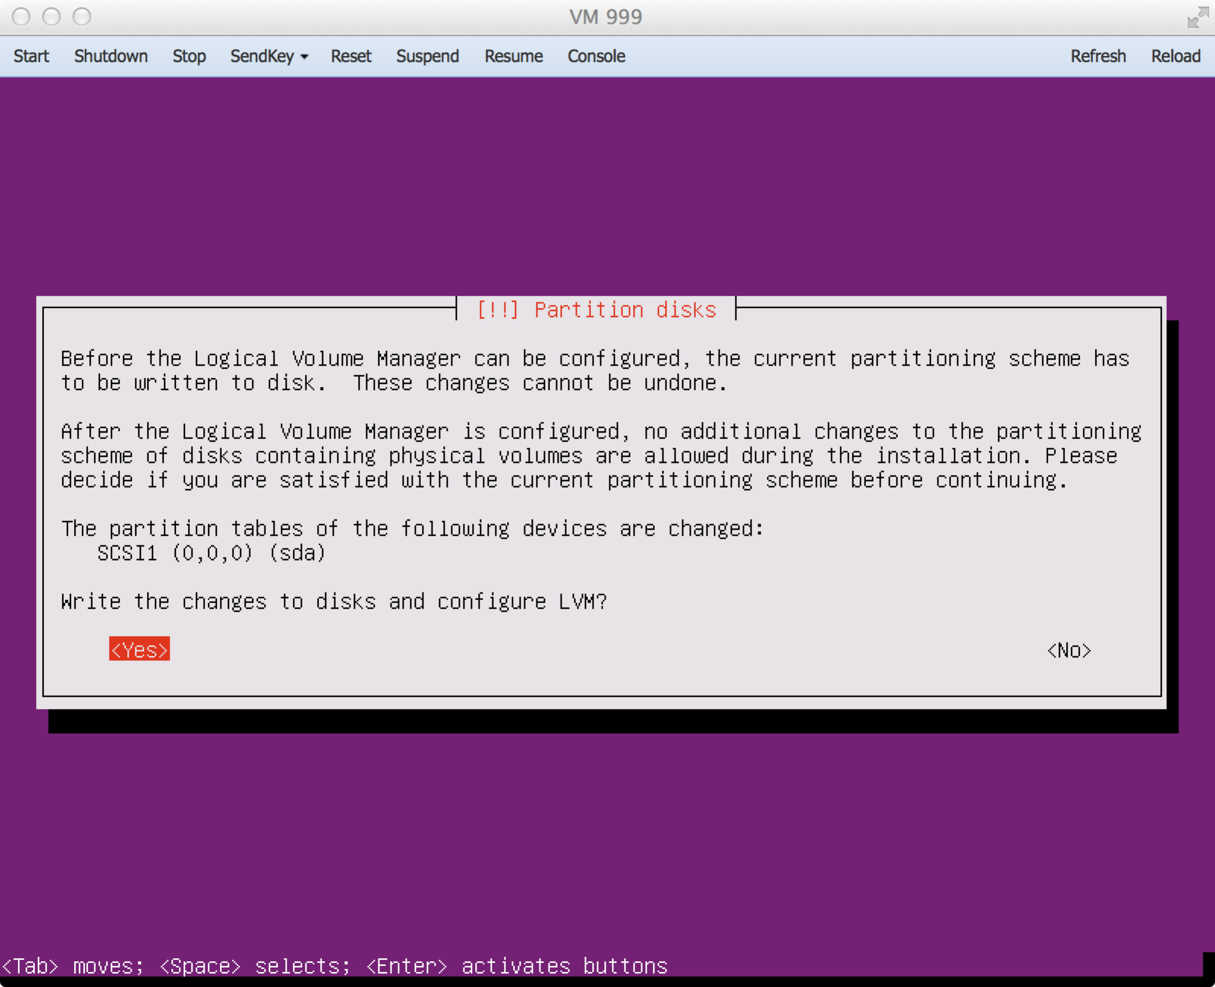

Press <Enter>

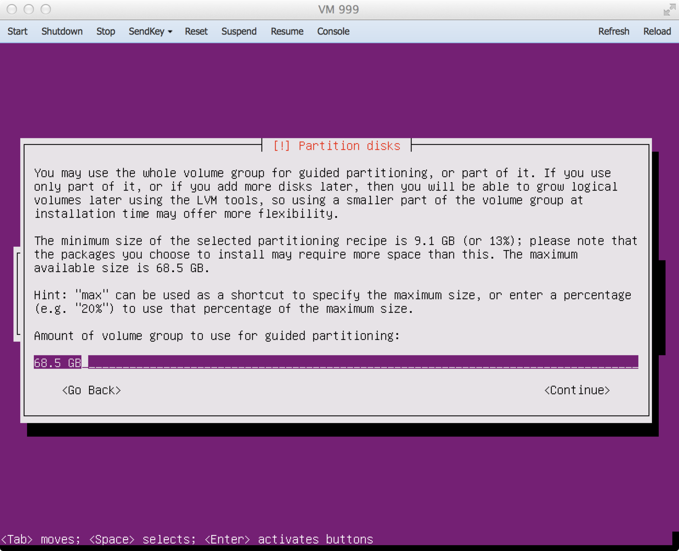

Enter the size of the partition you desire. Then Select Continue, and Press <Enter>

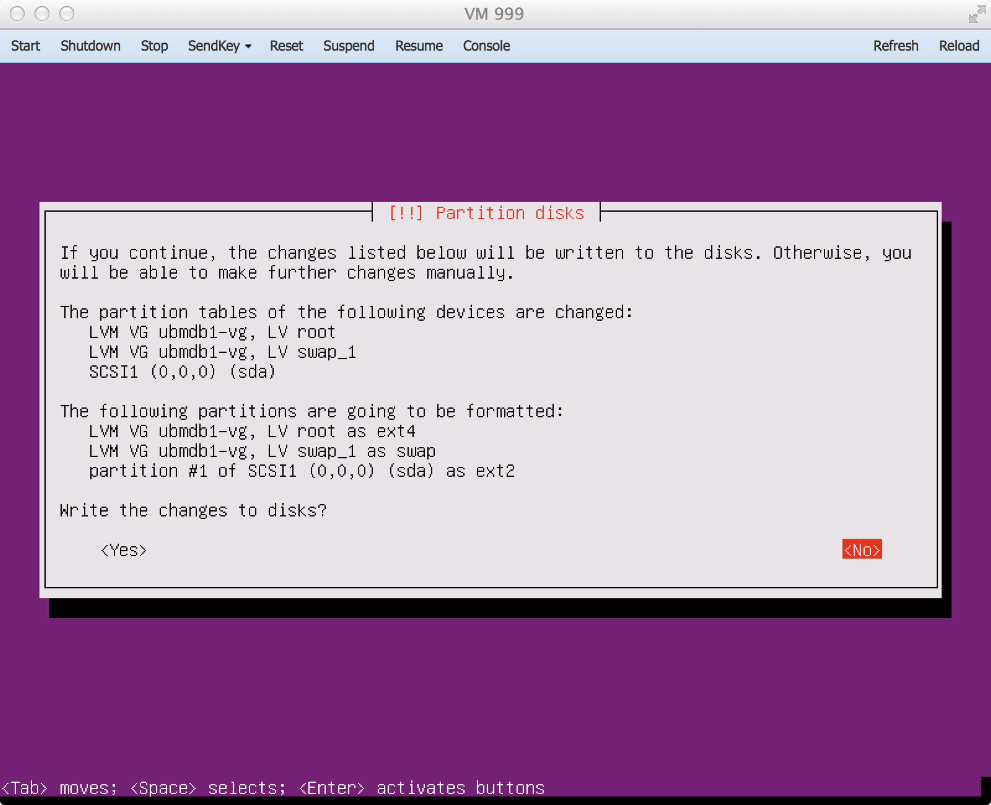

Now Select Yes to write the displayed changes to the disk.

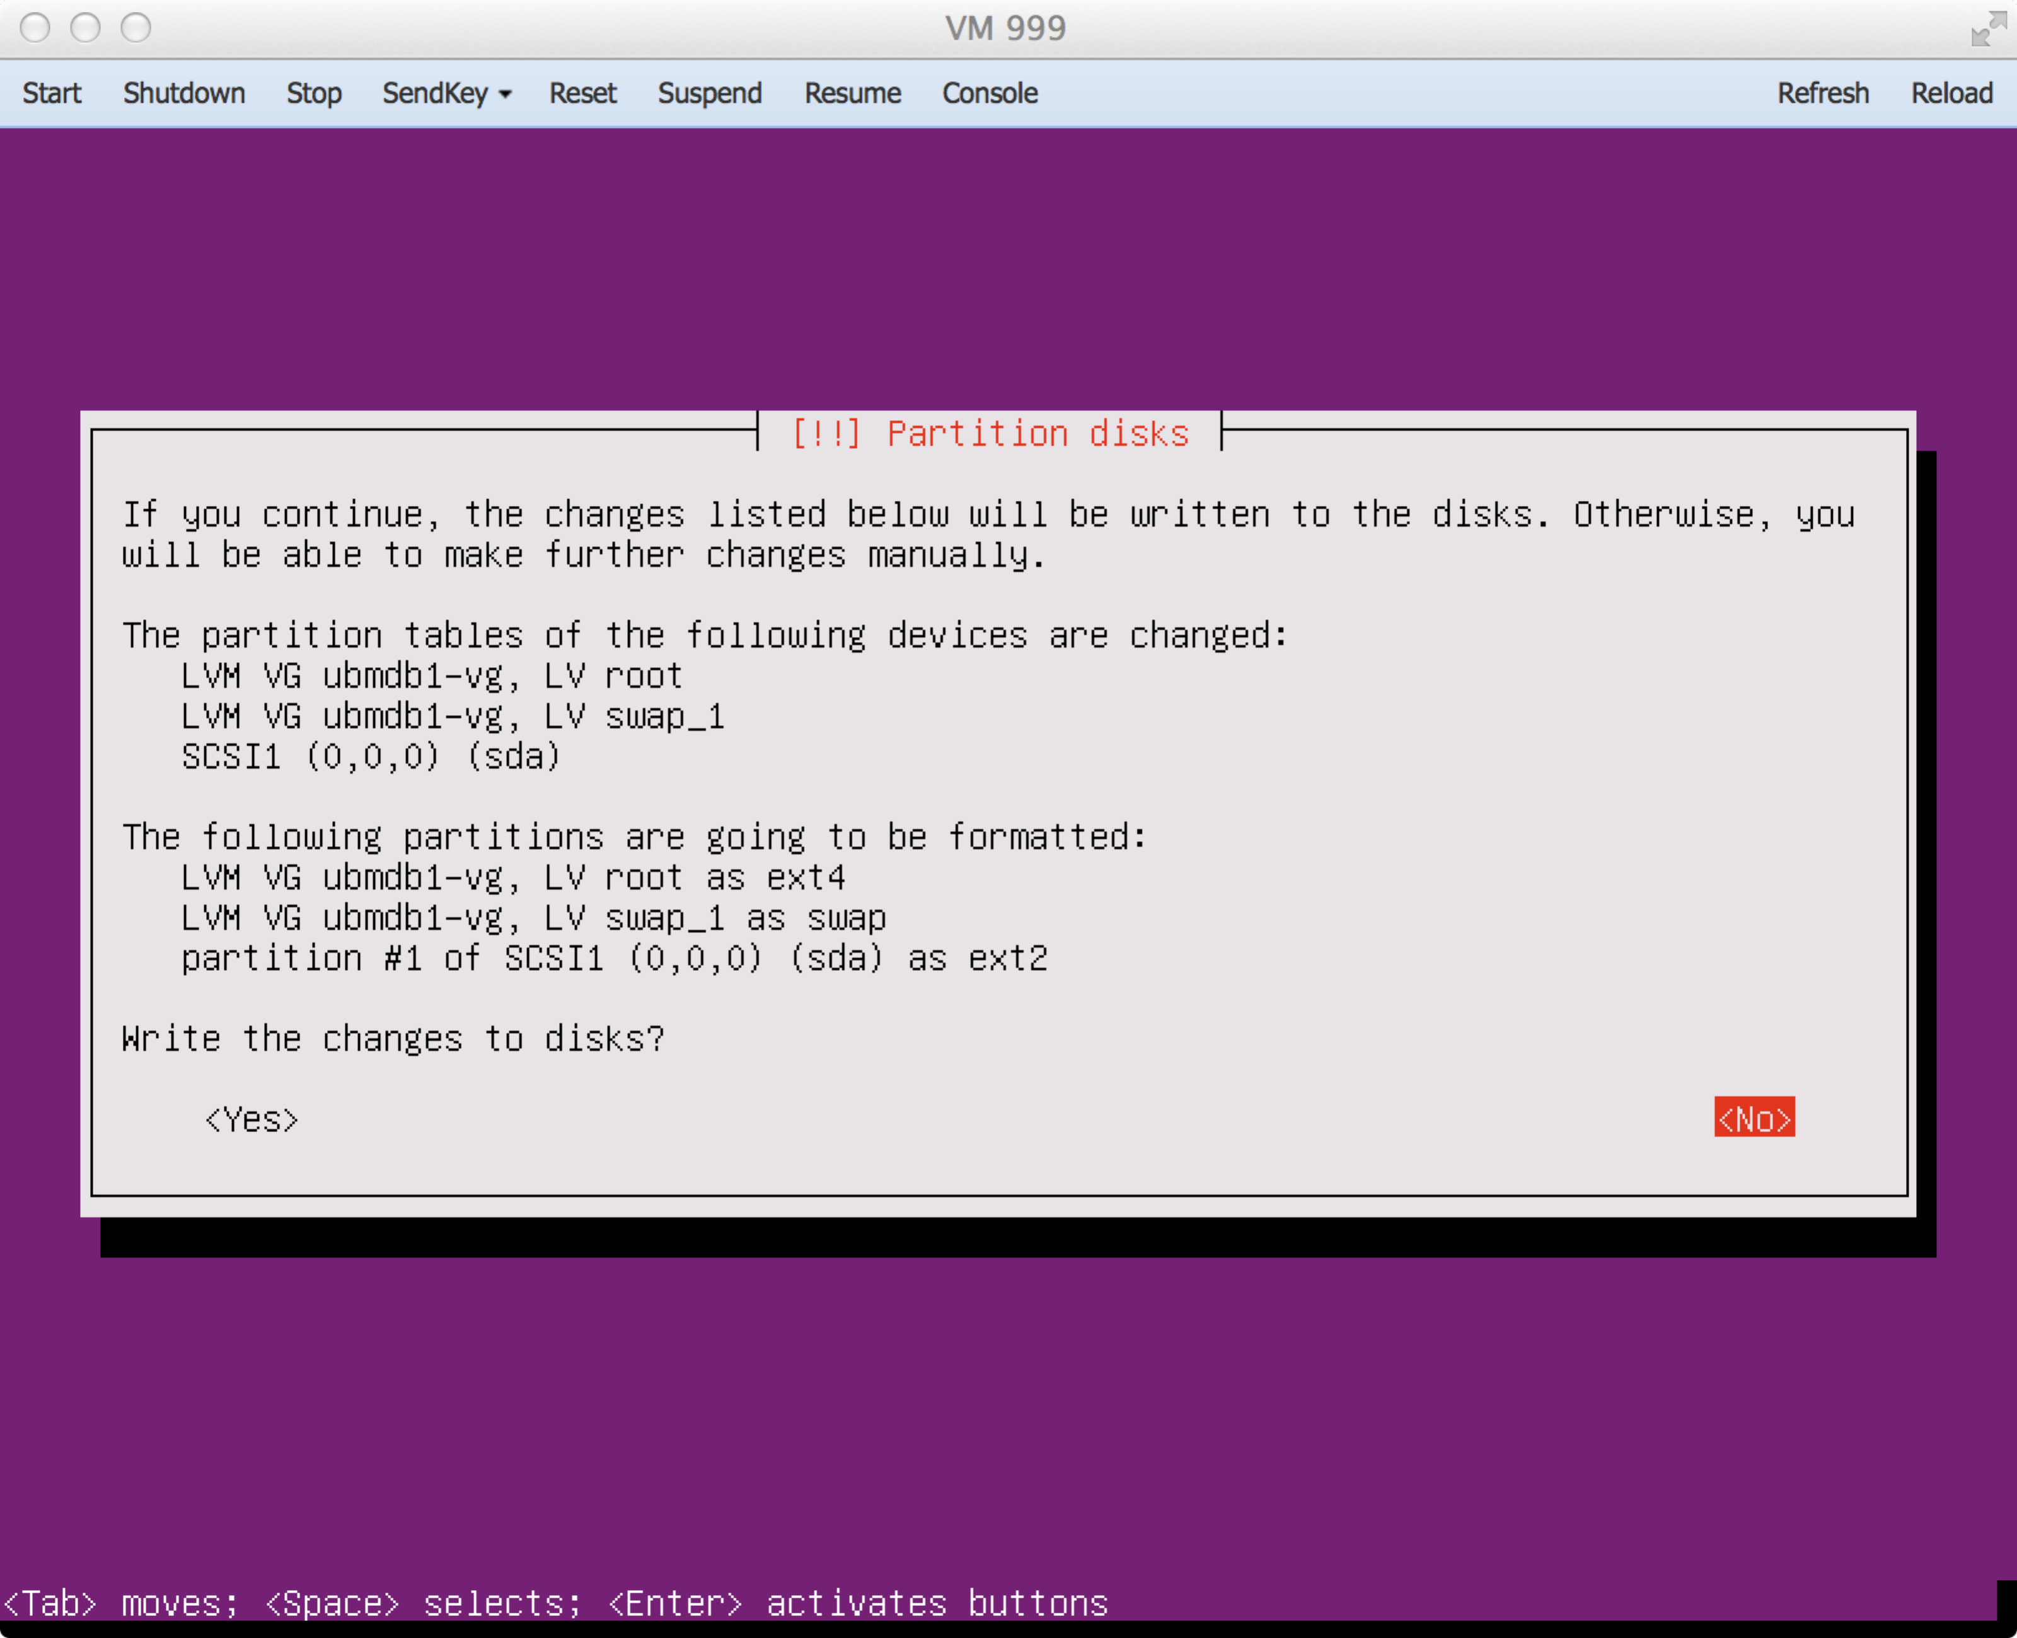

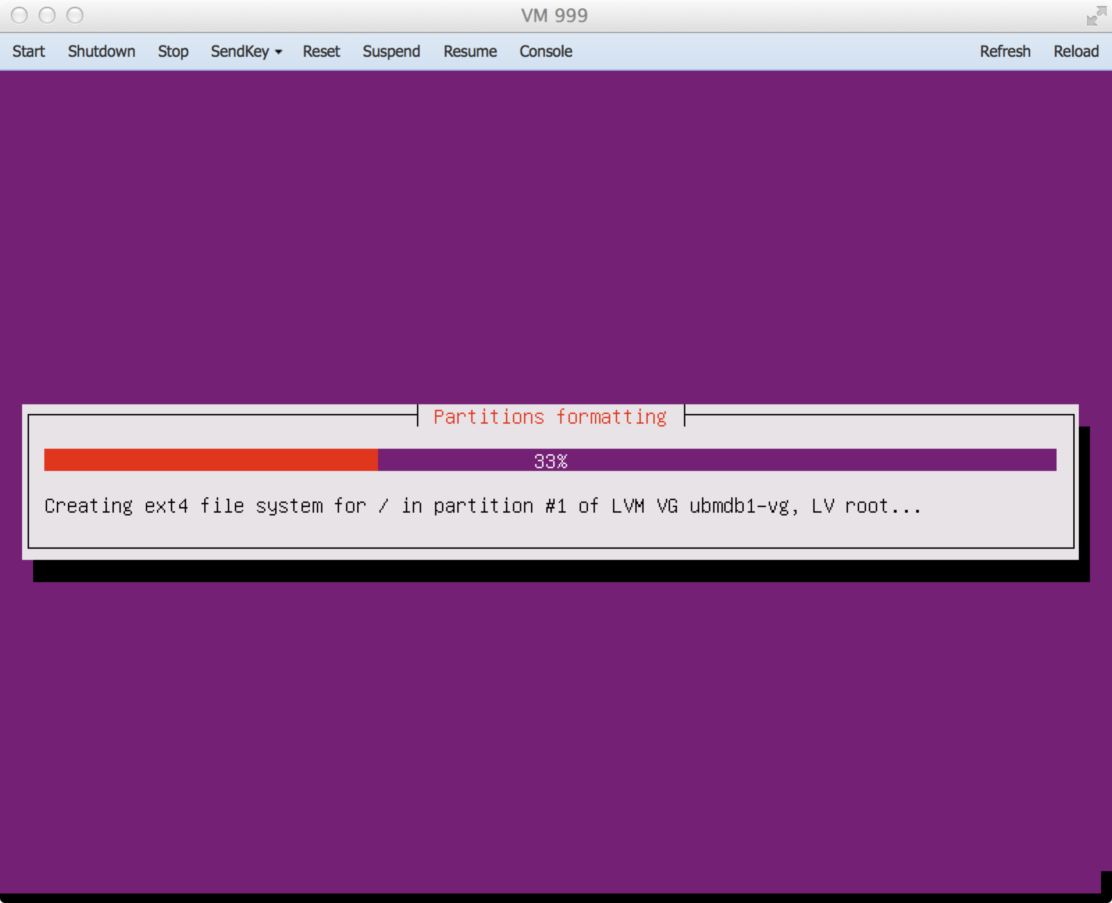

This progress bar will complete. And the Ubuntu 12.04 installation will begin.

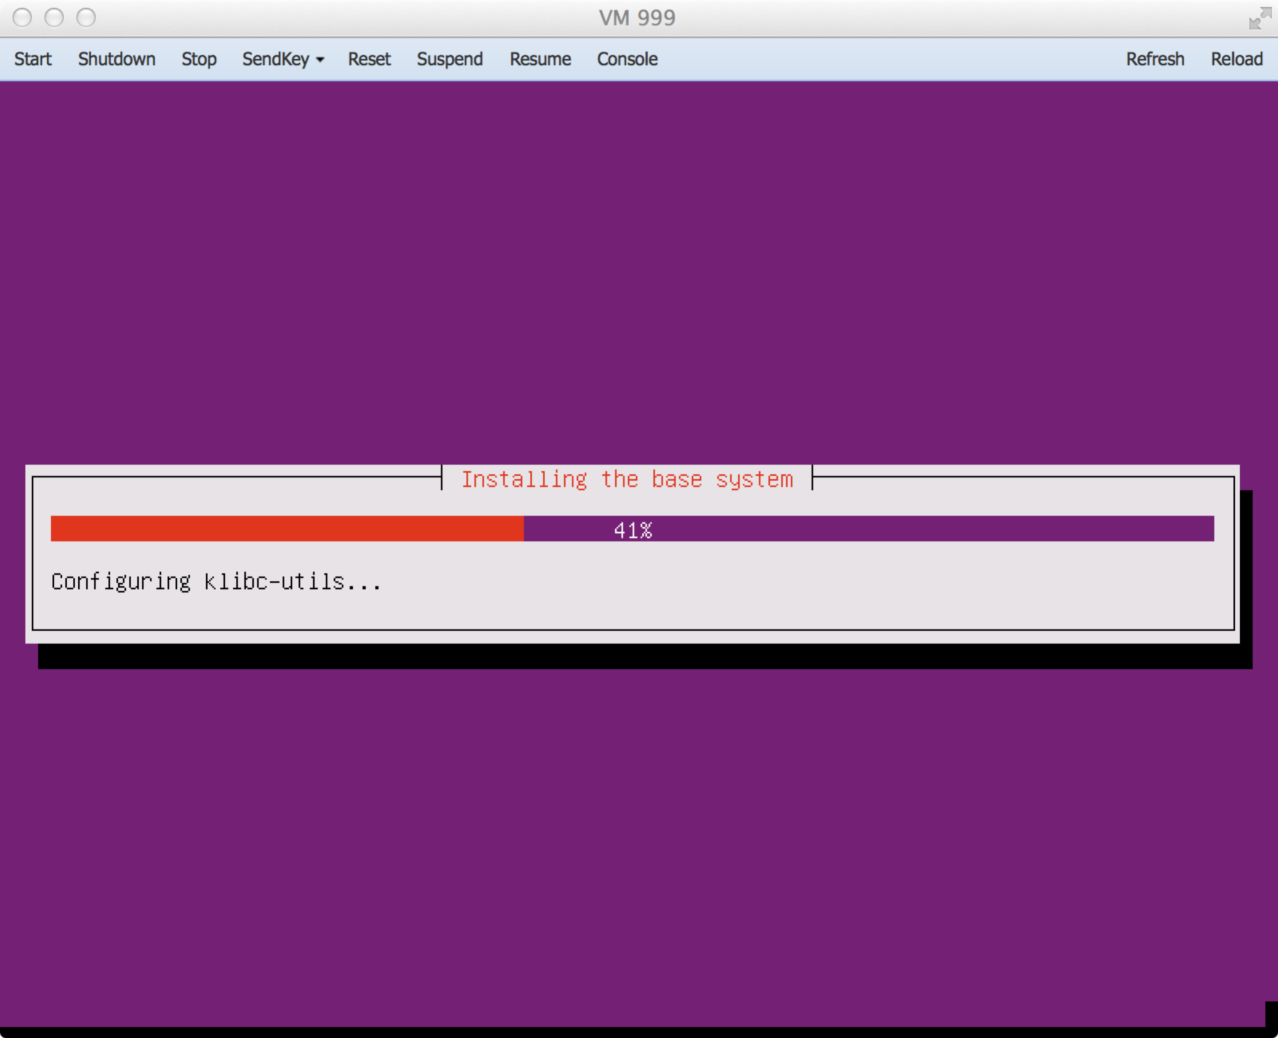

This install will probably take a few minutes.

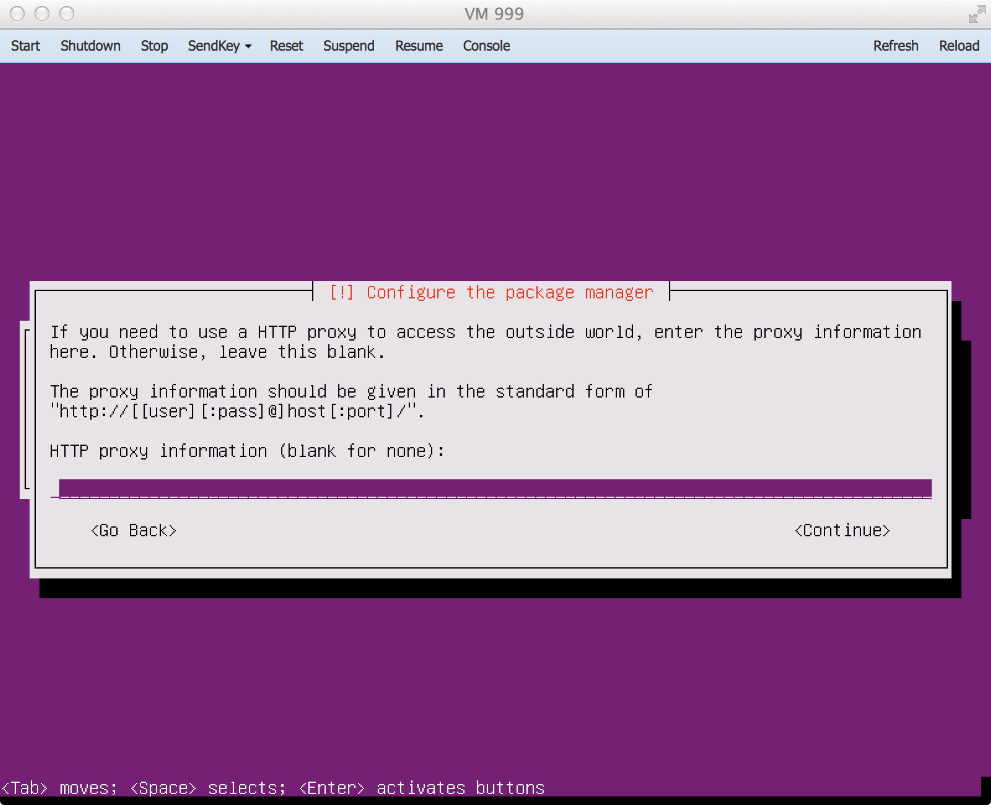

If you are using a proxy server, enter it. We will leave it blank in this install. When finished, Click Continue.

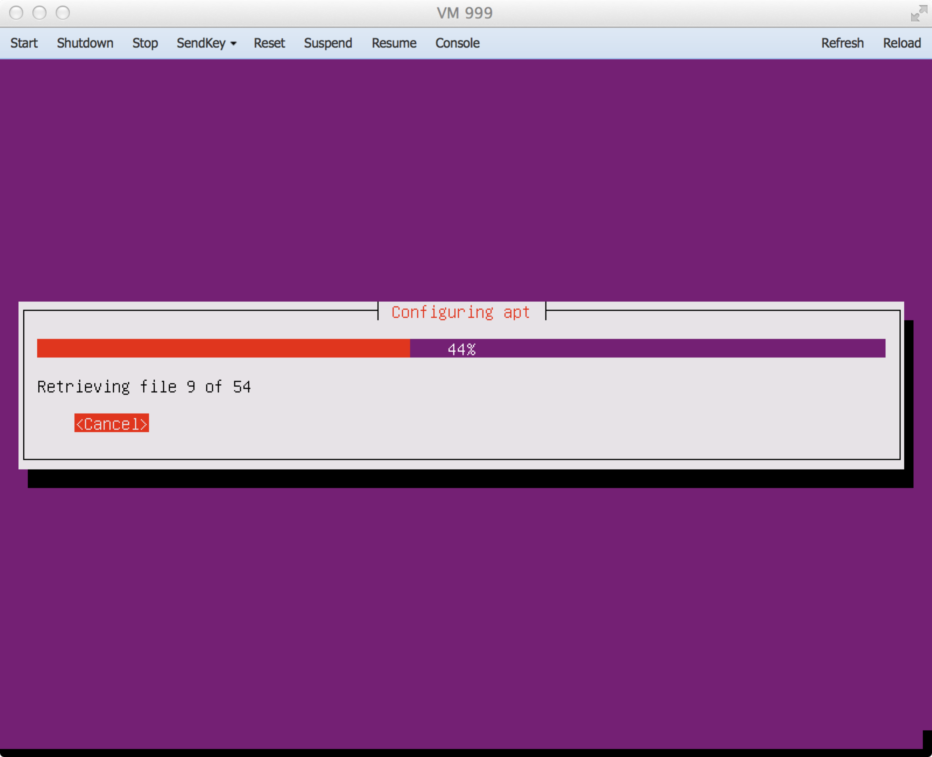

The installer will now automatically configure apt so you can use apt-get…

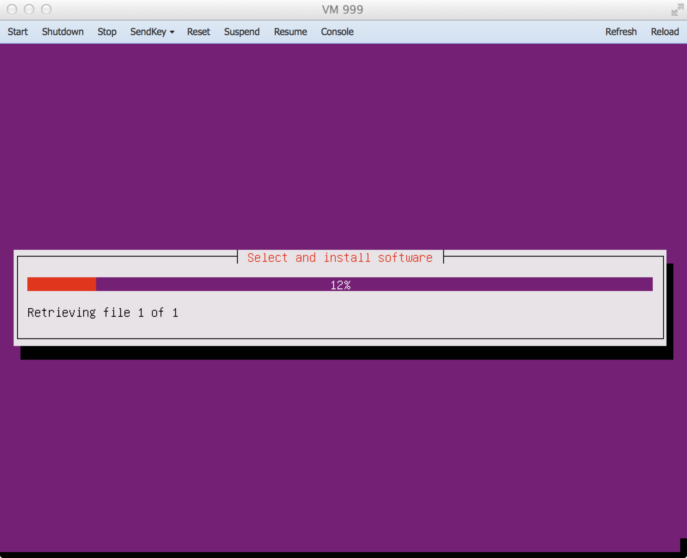

This progress bar will continue.

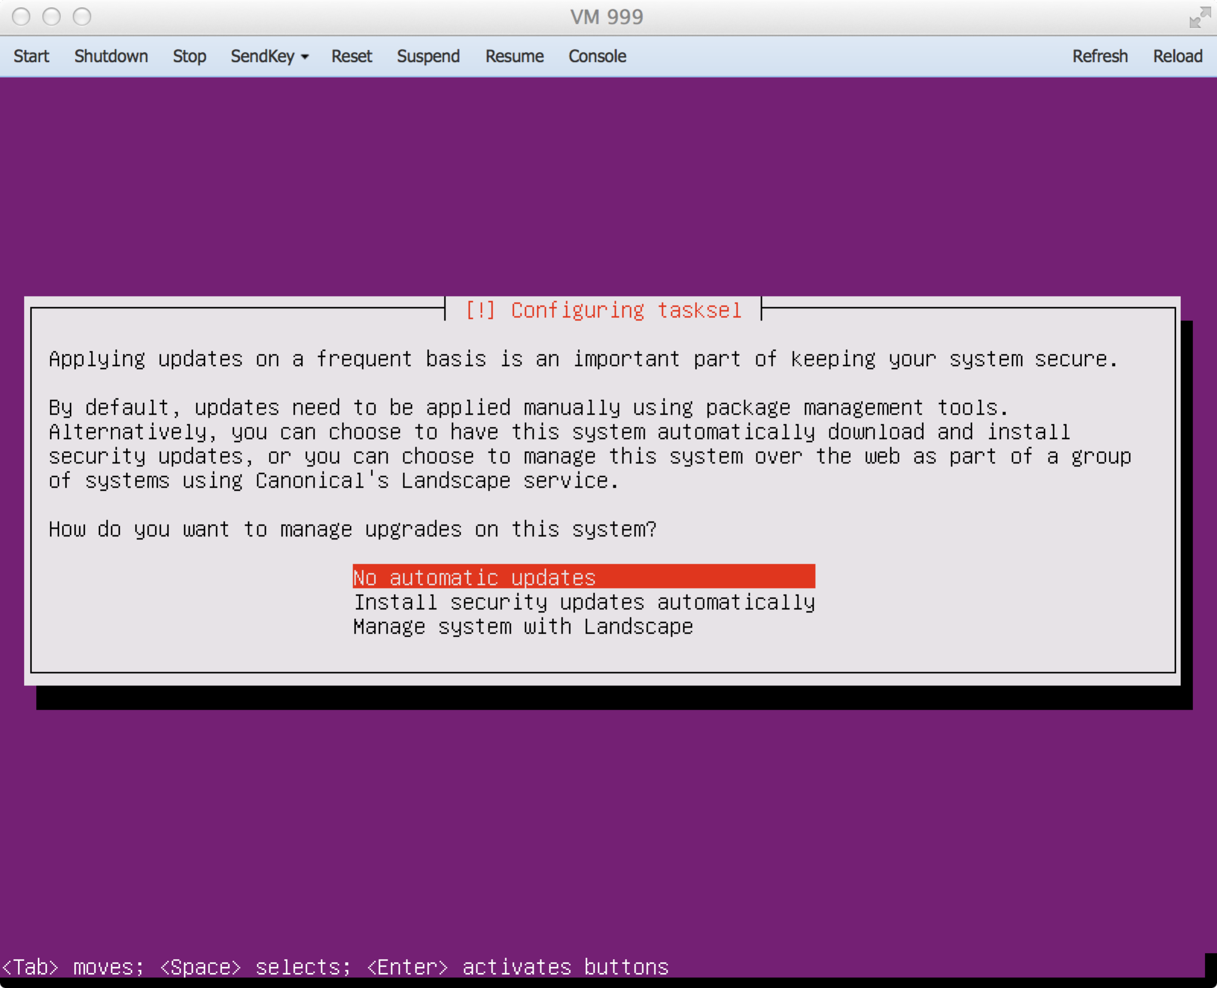

We will then select, <No Automatic Updates> to manually manage updates on this system. Now press <Enter>

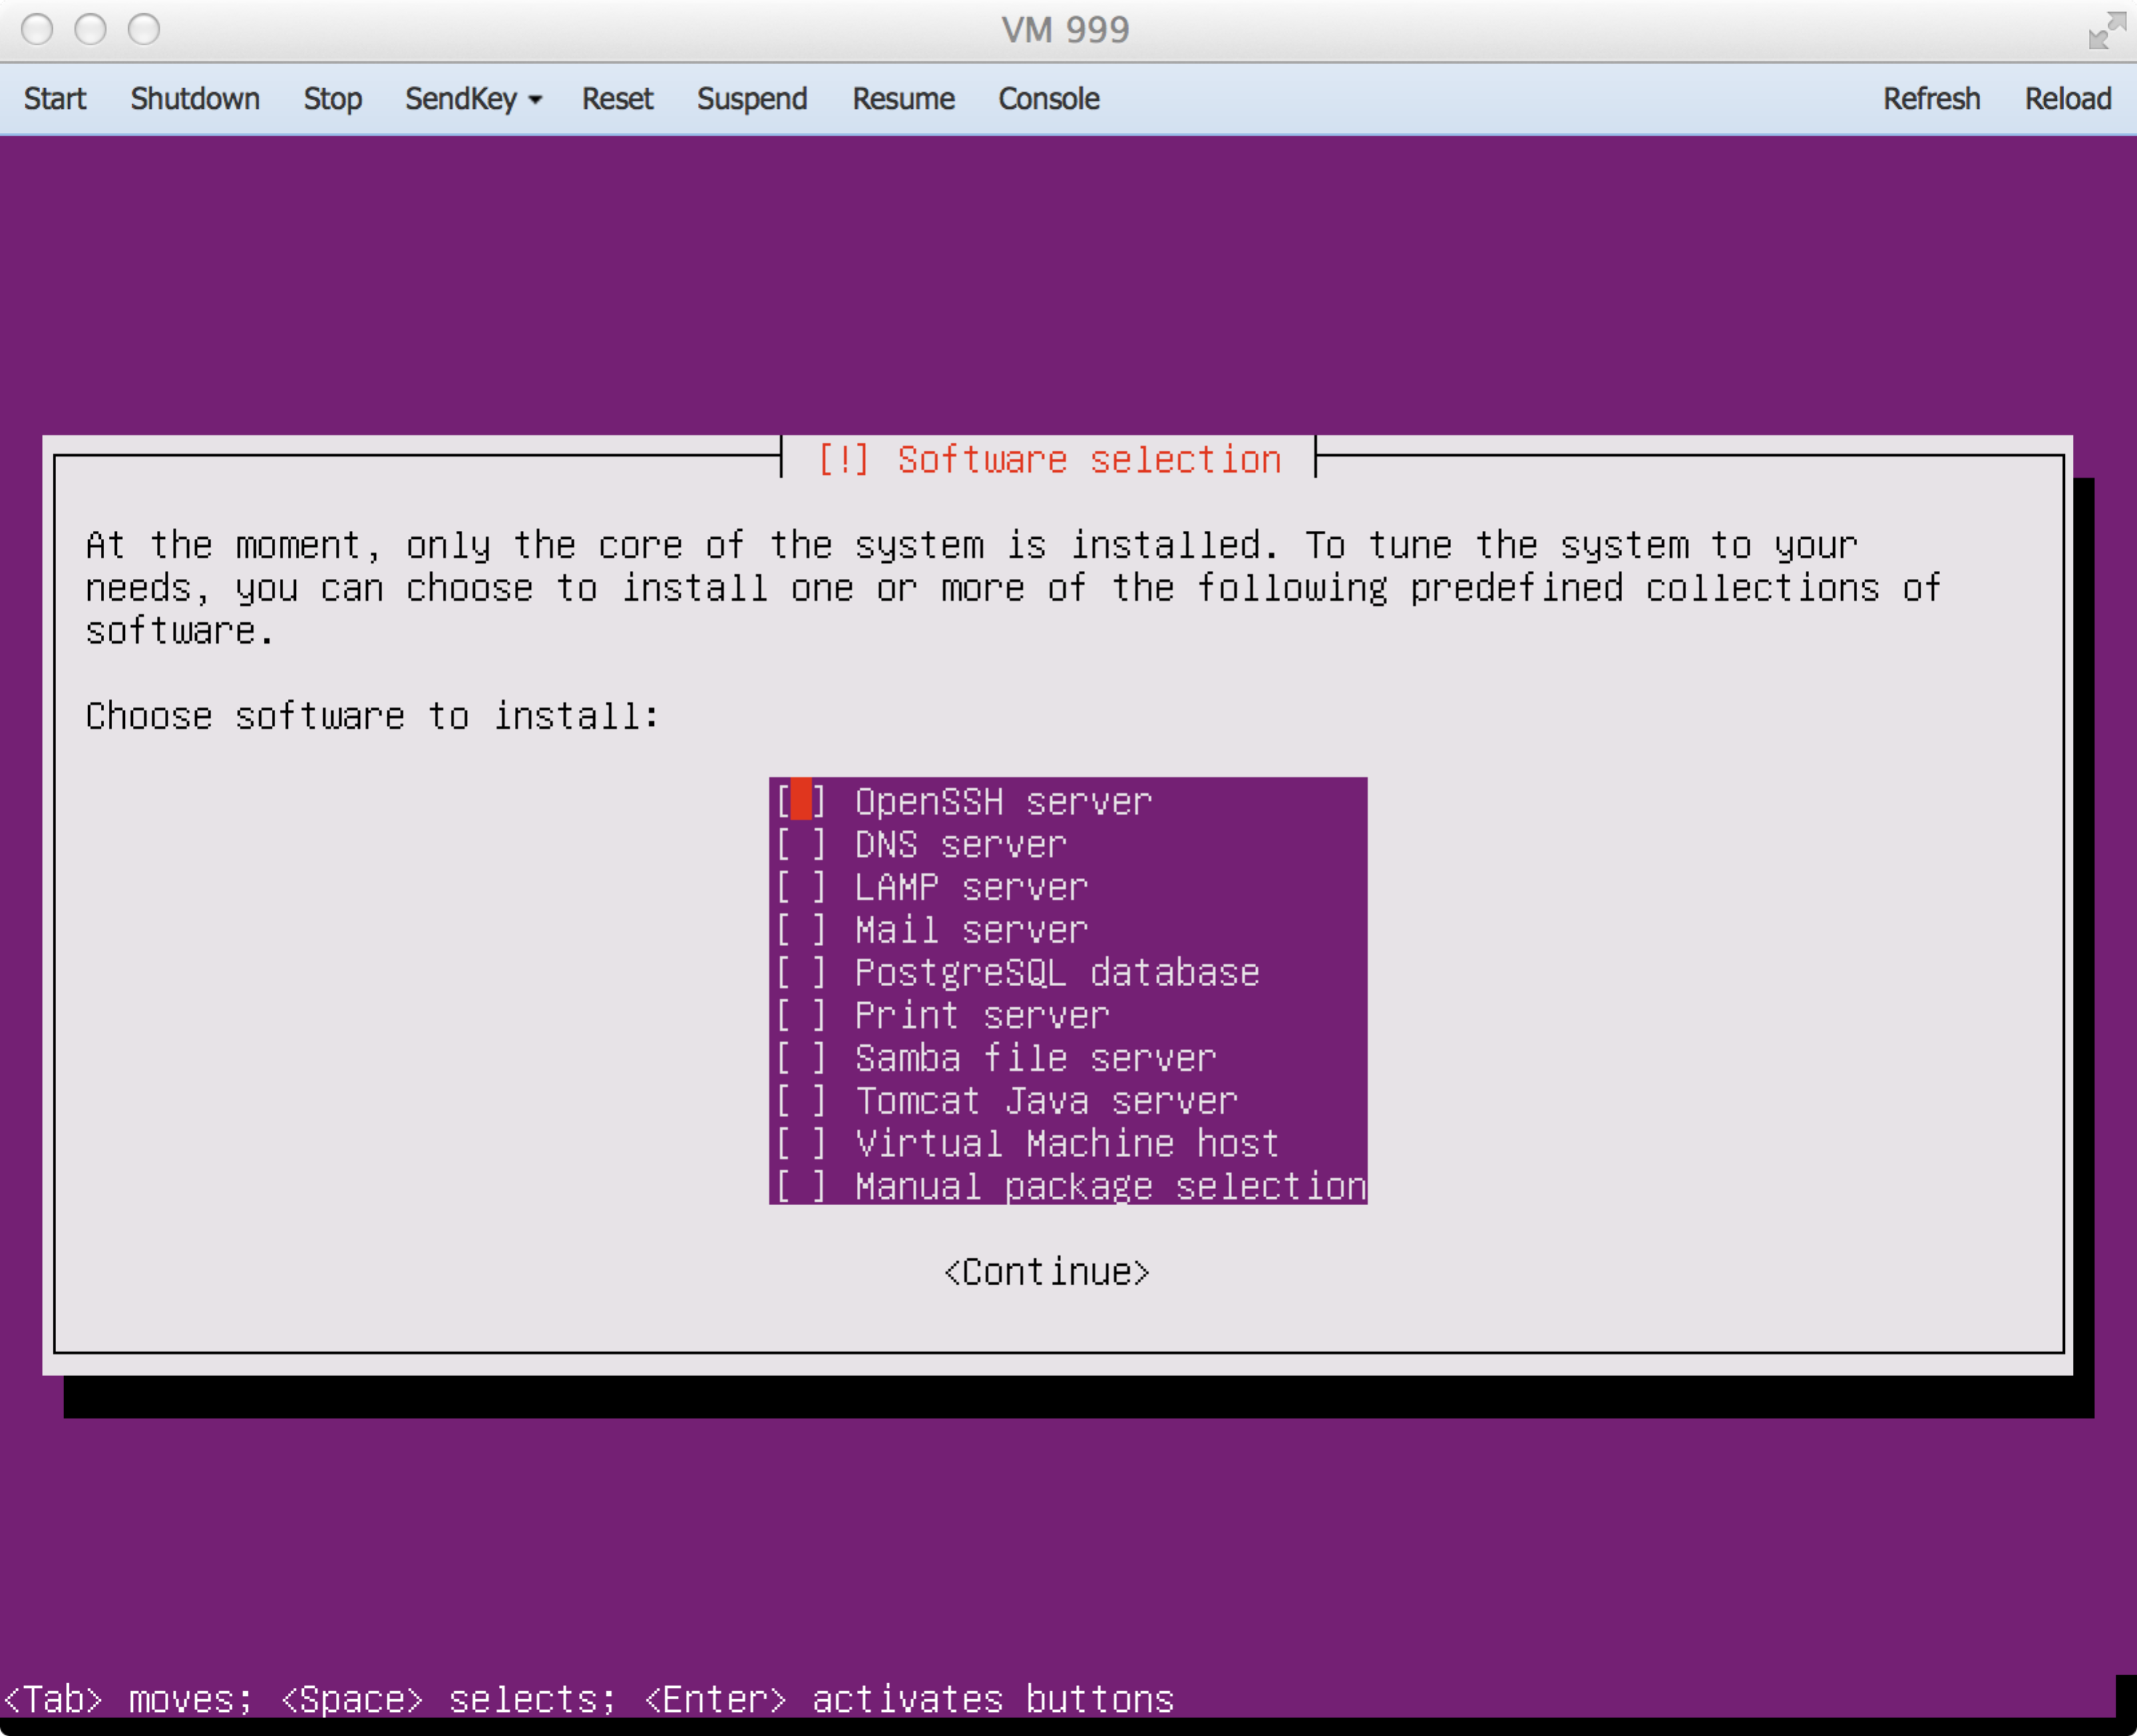

Now we will select the software we want to run on this machine.

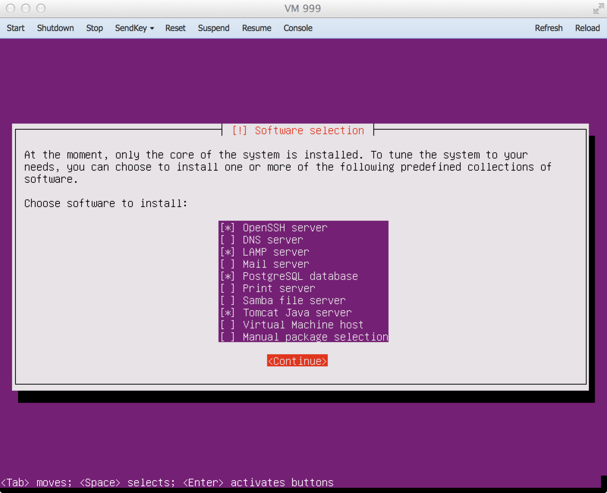

We will select:

OpenSSH Server

LAMP Server

PostgreSQL database

Tomcat Java server

For this installation.

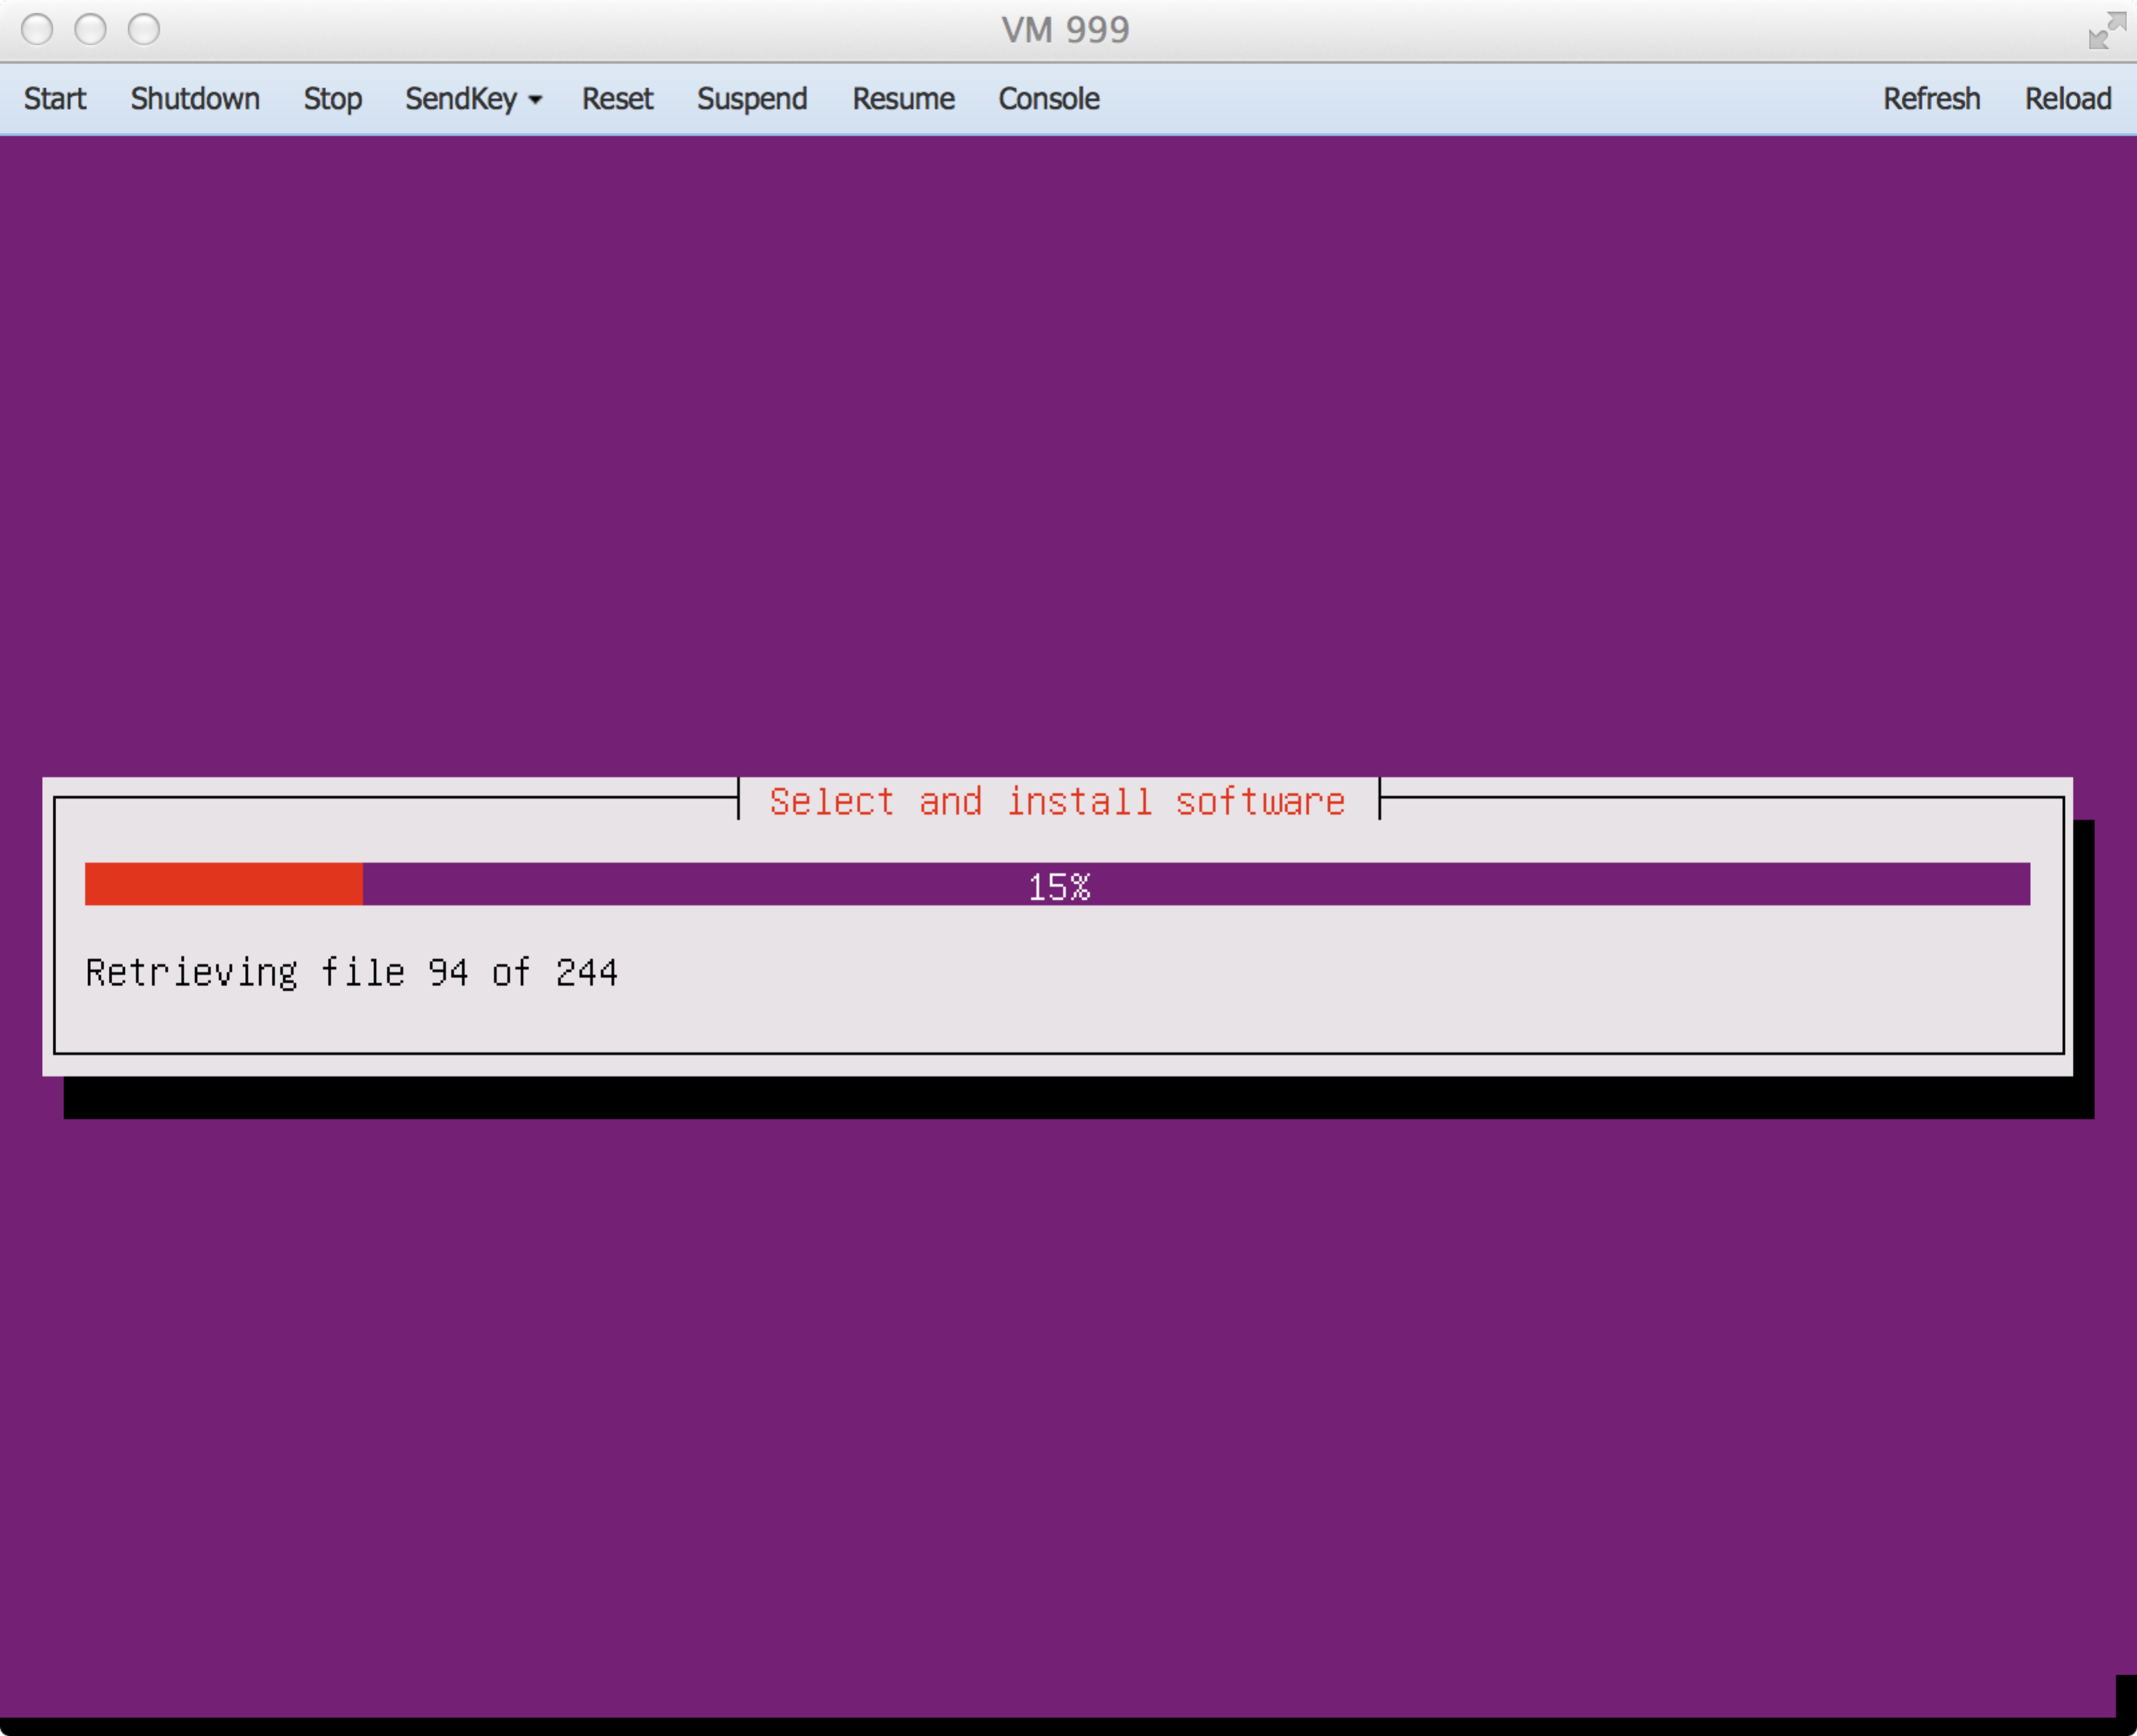

This Progress bar will complete.

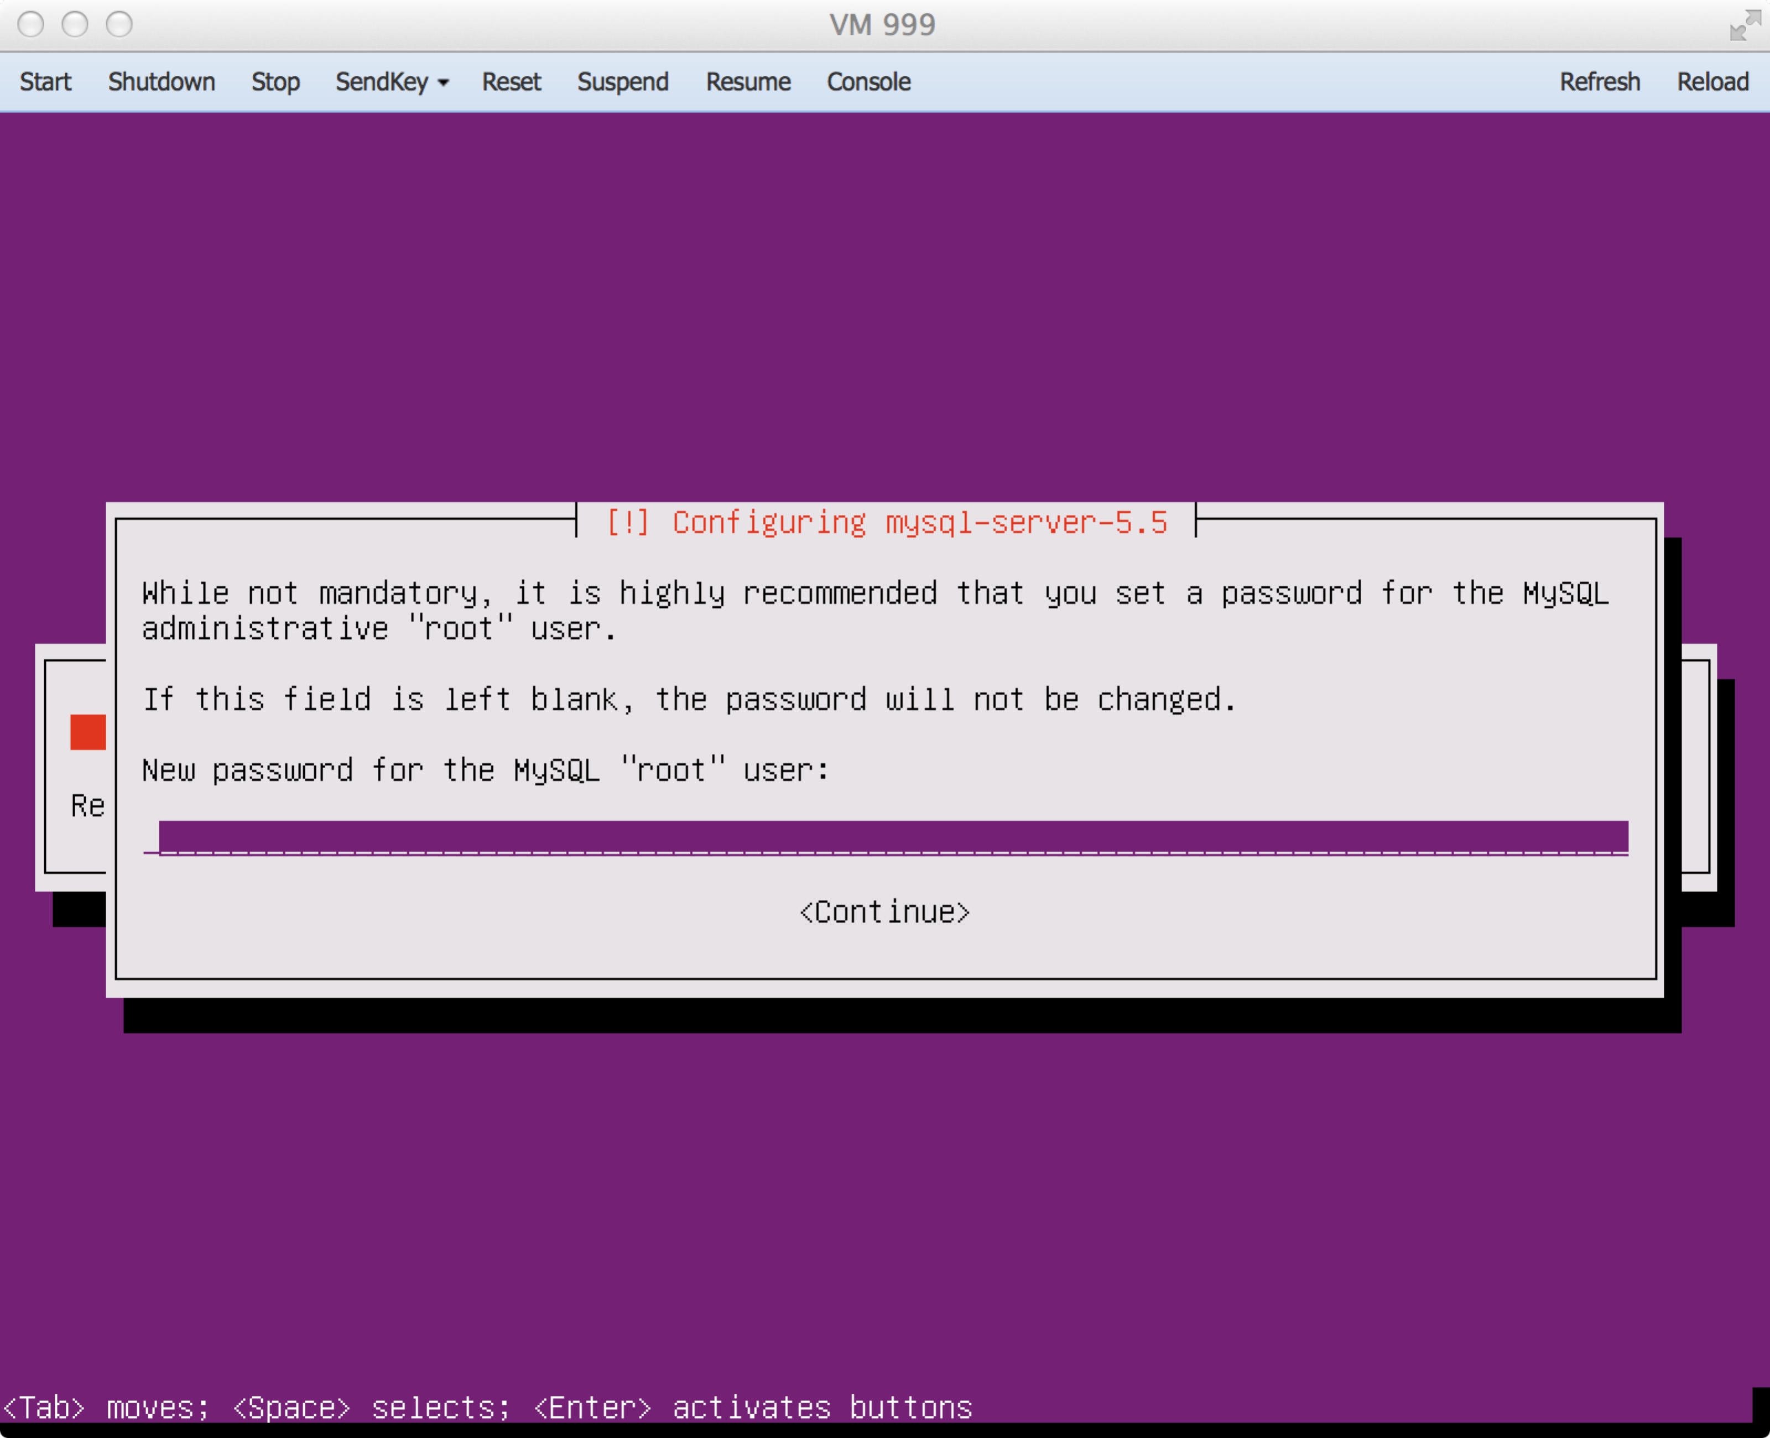We will enter the following for the MySQL root user password

Un1v3rs@lBM

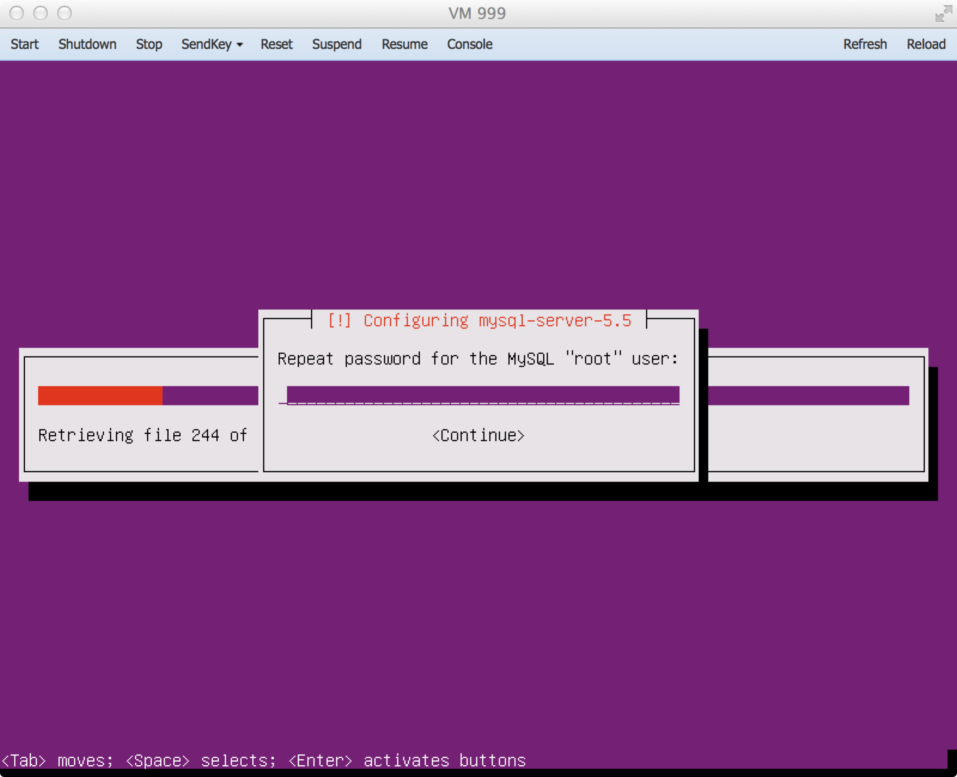

Now repeat the password and then <Continue>

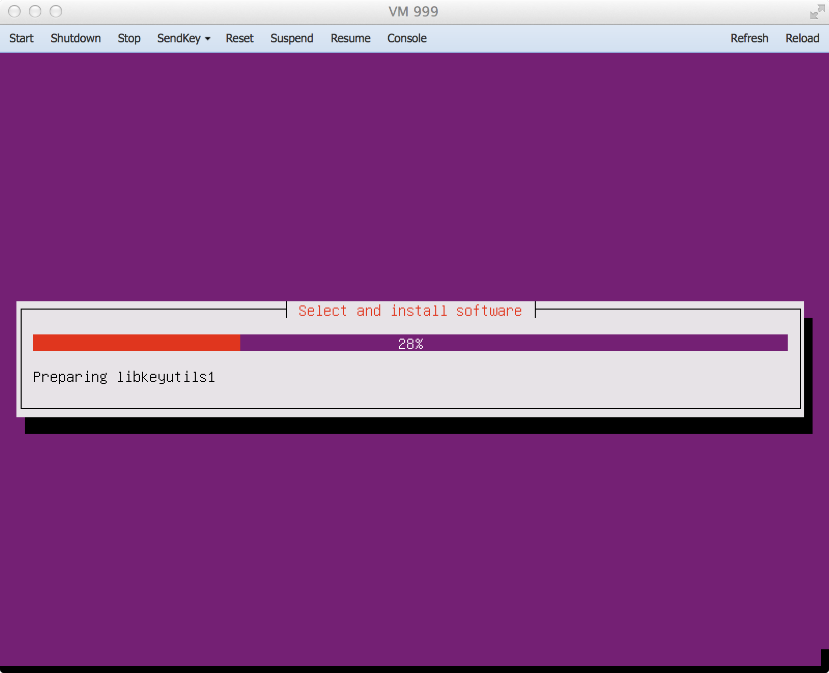

This progress bar will complete the software installation you selected.

Mysql-server-5.5 will be installed…

Apache2 will be installed…

PostgreSQL will be installed…

NTFS-3g will be installed…

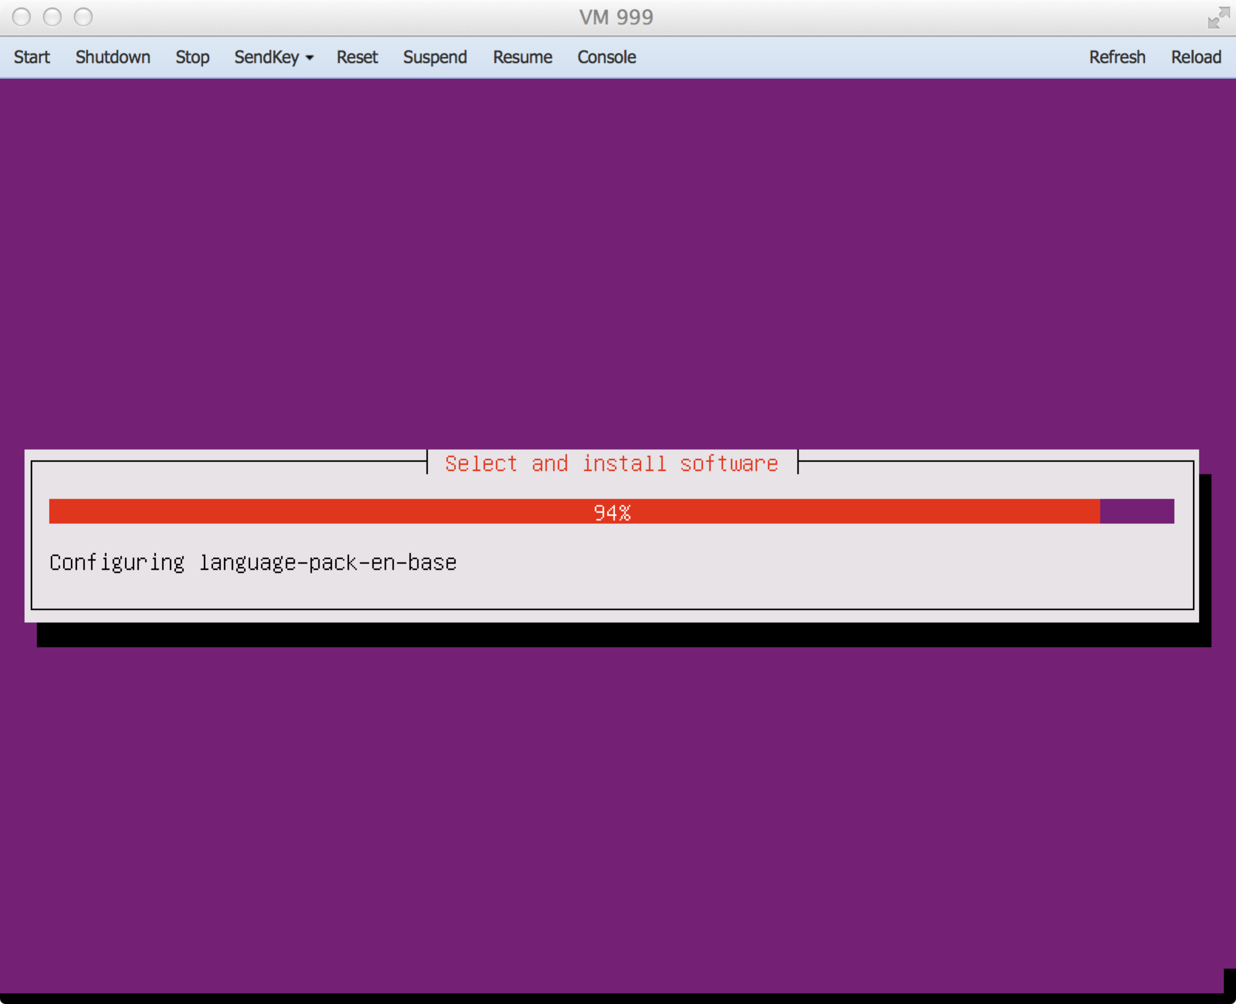

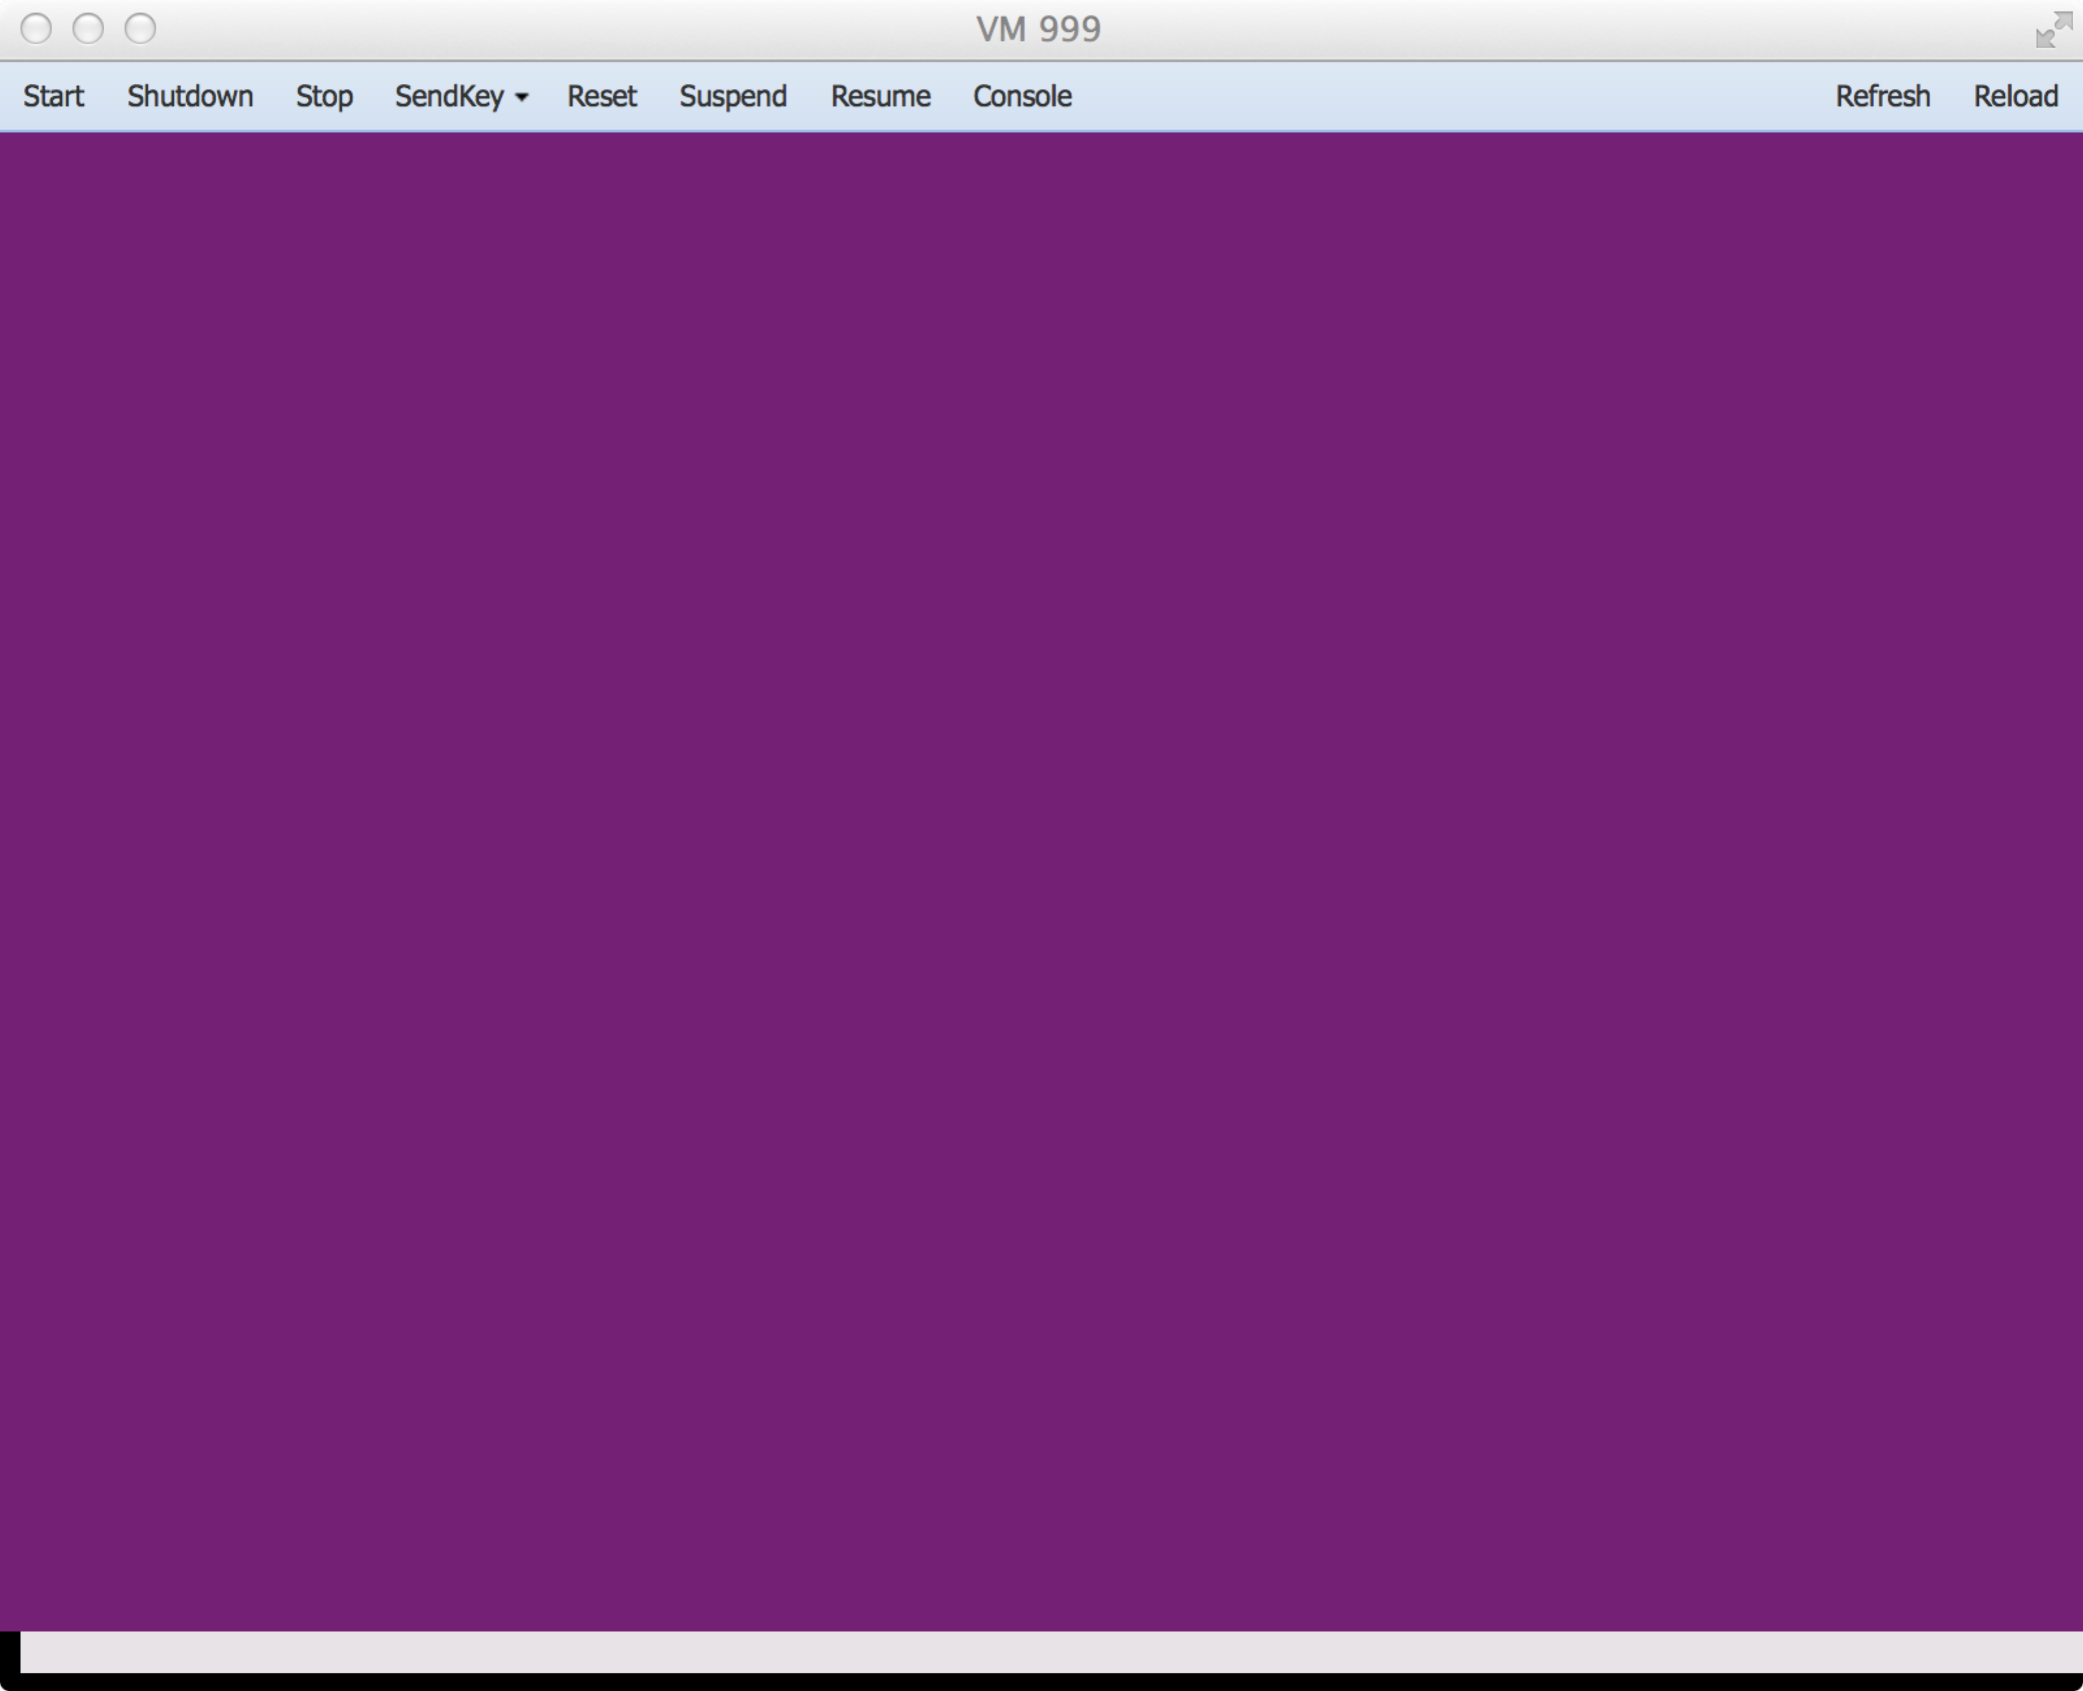

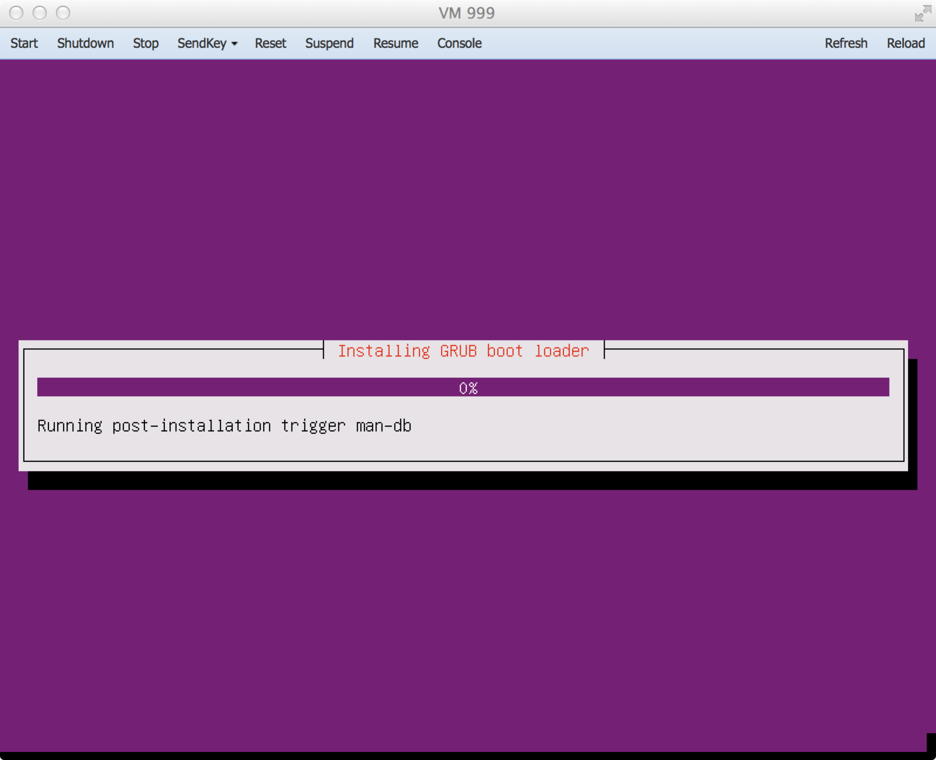

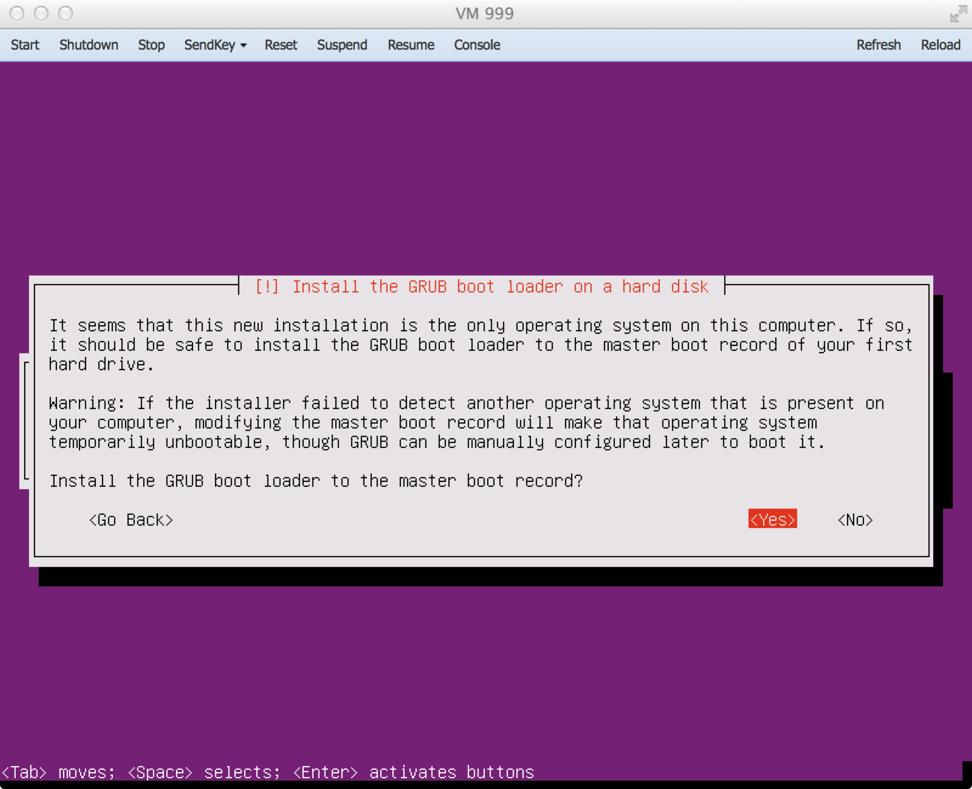

Select YES, then press enter. To install GRUB.

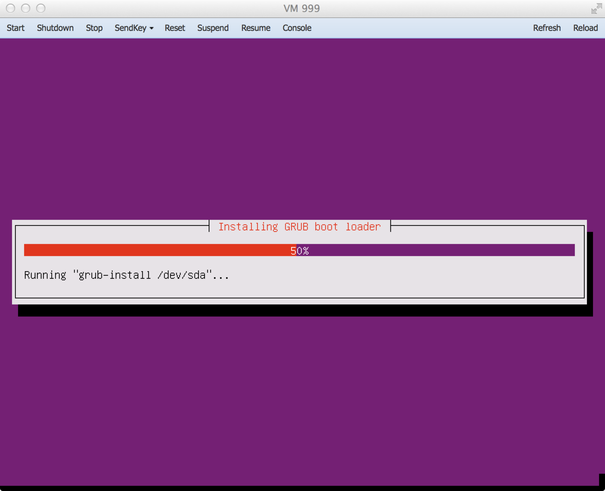

This progress bar will complete.

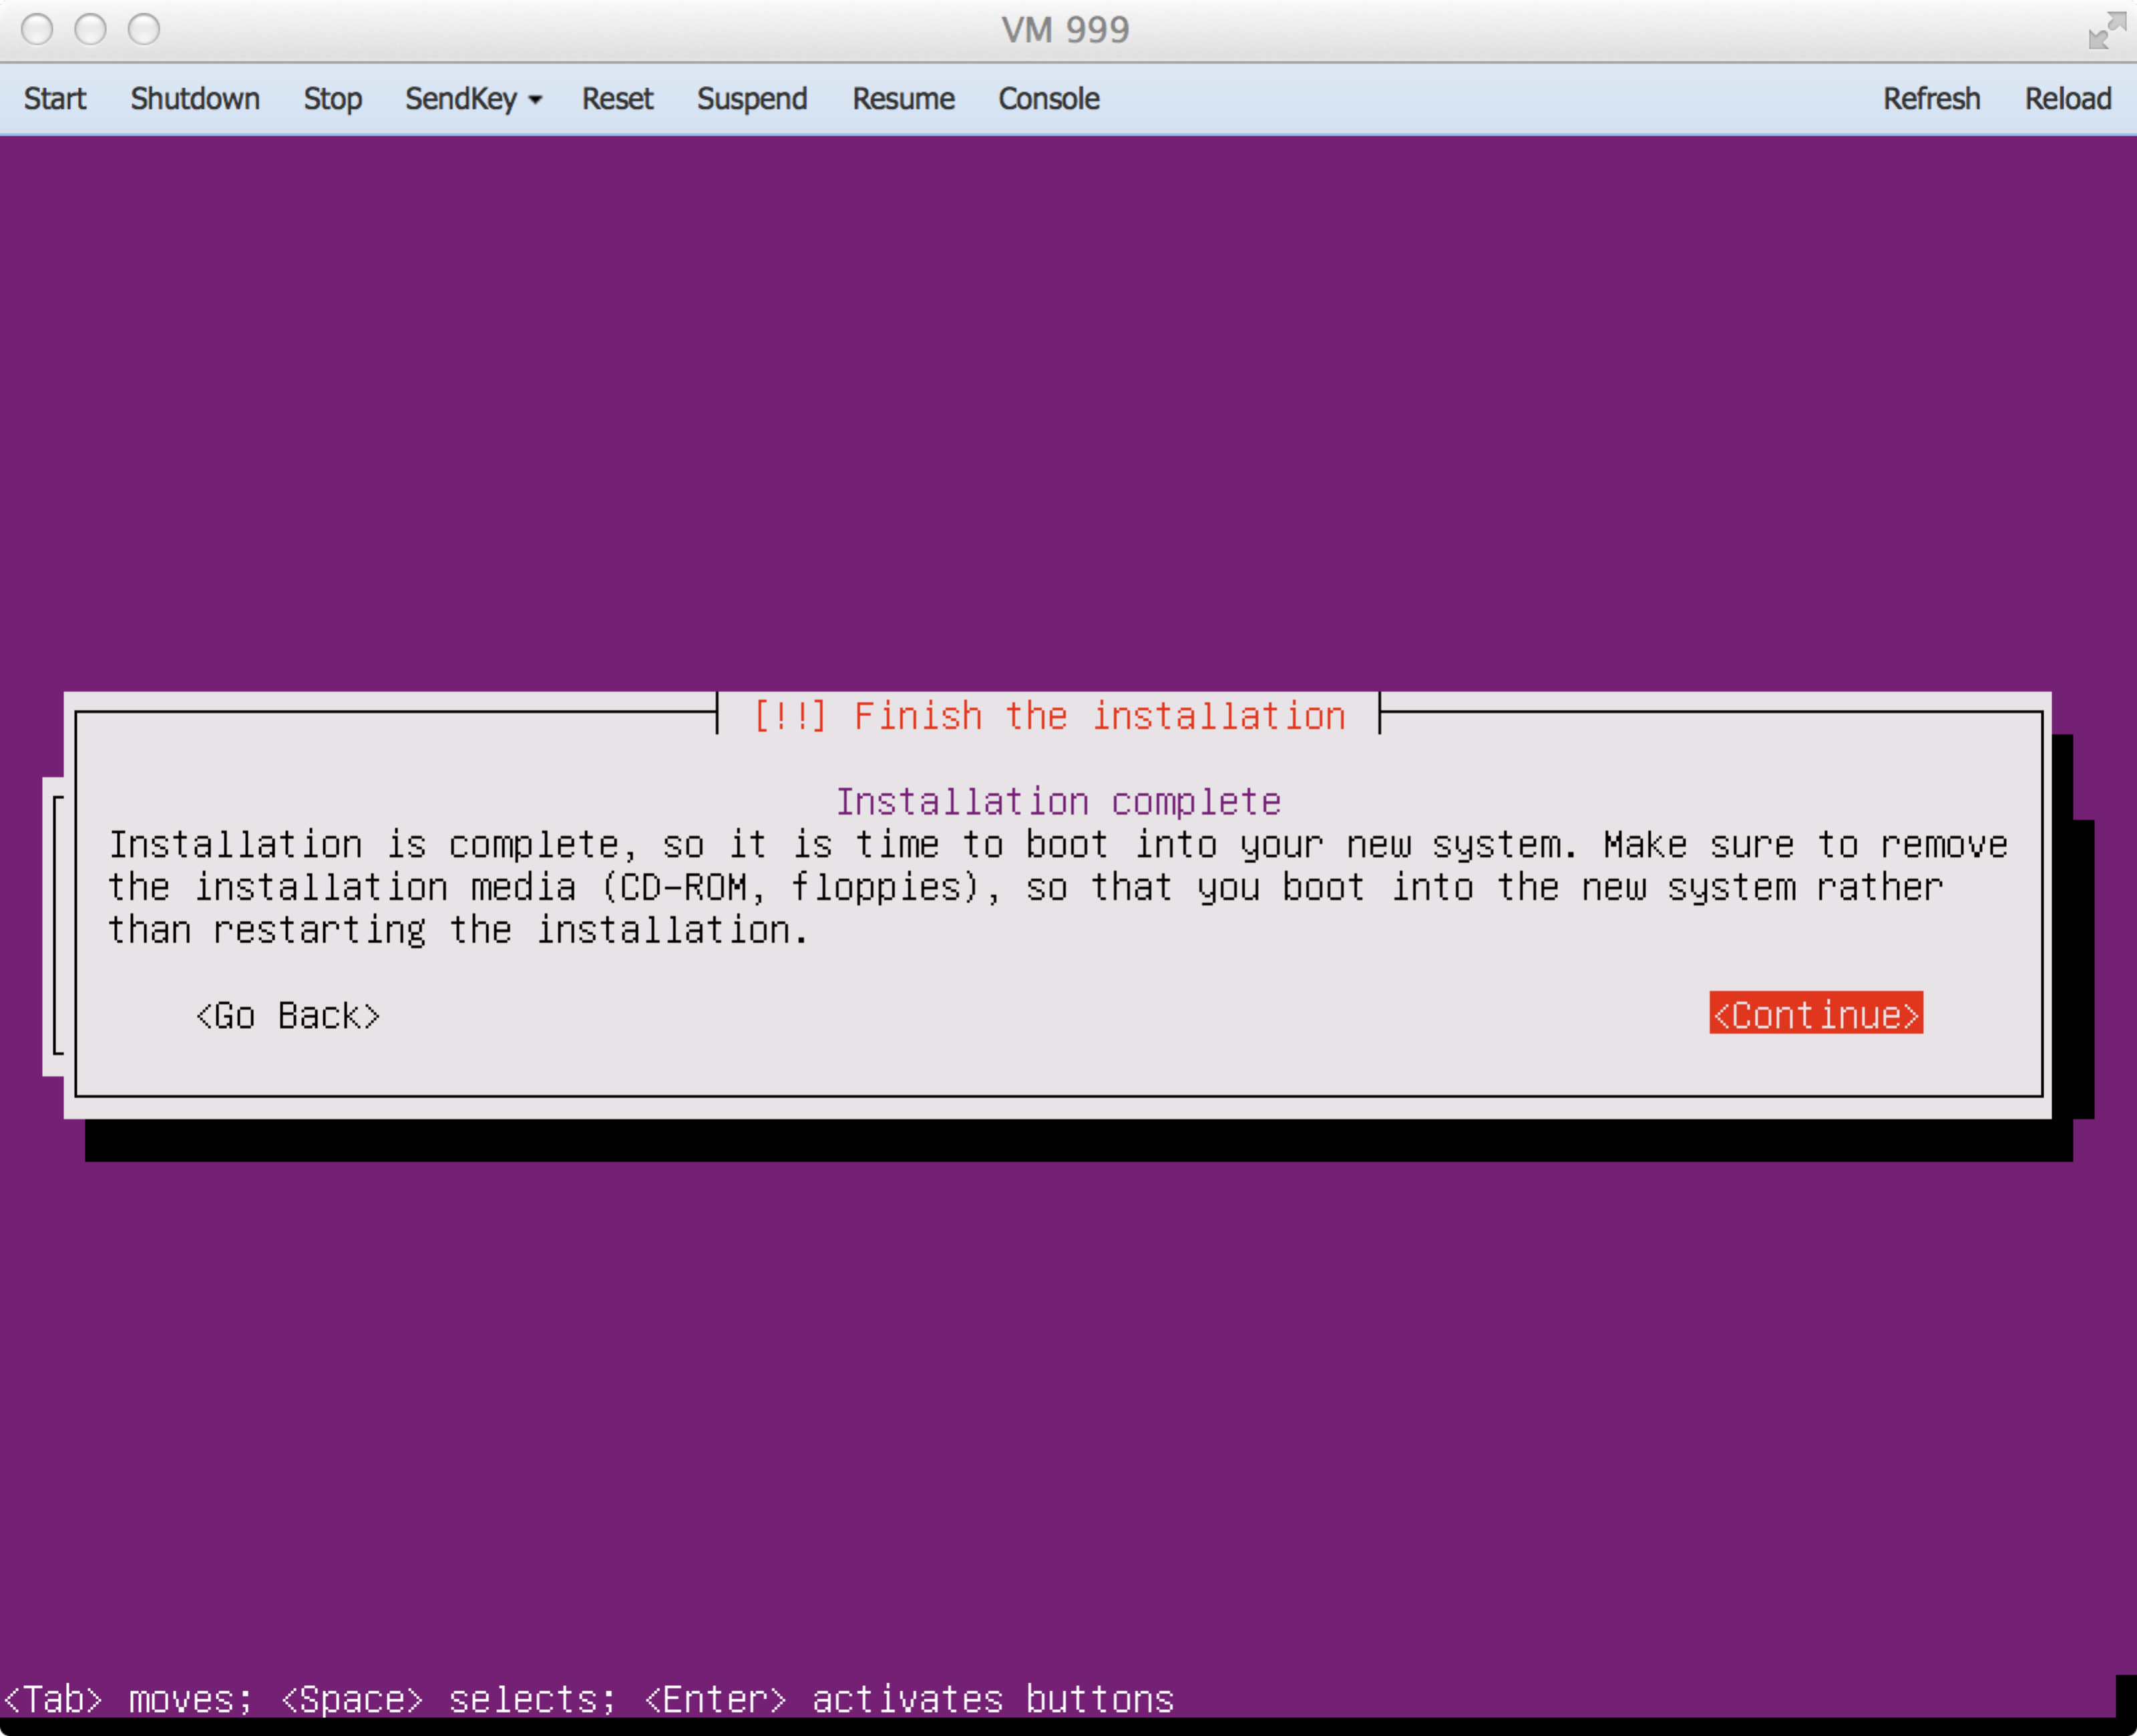

Now The Installation is finished. Now select continue, then press <Enter>

